Lab Unit 10 – Diversity in Transport
In-Lab Assignment – In Person lab

Instructions: Read the background material for this unit and then complete each of the activities listed within the In-Lab. These activities match those in the lab manual, and there is additional material on the lab website.

Diversity in Transport – Week I Activities

Open and Closed Circulatory Systems: Read background information pp. 173-174.

Activity #2: Earthworm dissection (lab manual p. 175-176)

1. Read through the Procedure for the Earthworm Dissection and locate the bolded structures during your earthworm dissection in lab.
2. If needed, view the videos on the lab website to reinforce what you learned about the structures in the circulatory system of an earthworm.
3. Investigate the organs of the earthworm digestive system and apply the terminology you learned in the Nutritional Adaptations lab (Unit 9).
4. Answer Questions 4-5 on pages 181-182. (listed below)

#4 – In the Earthworm, what circulatory structures can you see? Is this an example of an open or closed circulatory system? How do gases enter/leave this system? (1 pt)

#5 – How do the earthworm and bullfrog obtain oxygen? What similarities can you see between their circulatory systems? How are they different? (2 pt)

How does the earthworm’s diet and digestive system compare to the bullfrog? (1 pt)

Activity #3: Crayfish Dissection (lab manual p. 177-179):

1. Read through the Procedure of the Crayfish Dissection steps #1-13 and locate the bolded structures in your lab manual during your crayfish dissection.
2. If needed, view the videos on the lab website to reinforce what you learned about the structures in the circulatory system of crayfish, type of digestions, and structures involved.
3. Answer questions 6, 7 and 8 on page 182. (listed below)

#6. Compare and contrast open and closed circulatory systems. Give an example of an animal exhibiting both types (examples not seen during this lab unit). (2 pts)

#7 – Explain why blood/hemolymph circulates to and from the heart in an open circulatory system. Where is the hemolymph oxygenated? (2 pts)

#8 – Use a pen to trace blood flow in the crayfish diagram on page 182 #8 in your lab manual. Label gills, heart and ostia? Once drawn and labeled, take a picture of your work and insert into this document. Make sure the picture is large enough to clearly see the blood flow, direction and labeled structures. (2pts)

Diversity in Transport – Week II Activities

Activity 1: From Introduction & Heart Structure and Double Circulation
- Read the background material in the lab manual, pp. 183 – 184, mammal models on the side counter, and review the supporting material on the lab website.
- Insert a screenshot of the completed Interactive Label a Heart in the space below. All the labels should be green if you are correct. (1 pt)

Activity 2: Heart Function and ECG (complete questions 1-4 below)
- Read the background material in the lab manual, pp. 185 – 186, and review the material on the lab website.
- Label one ECG wave (see below) with the appropriate wave labels. Describe what is occurring at each segment of the wave making up a complete heartbeat. (2 pts)
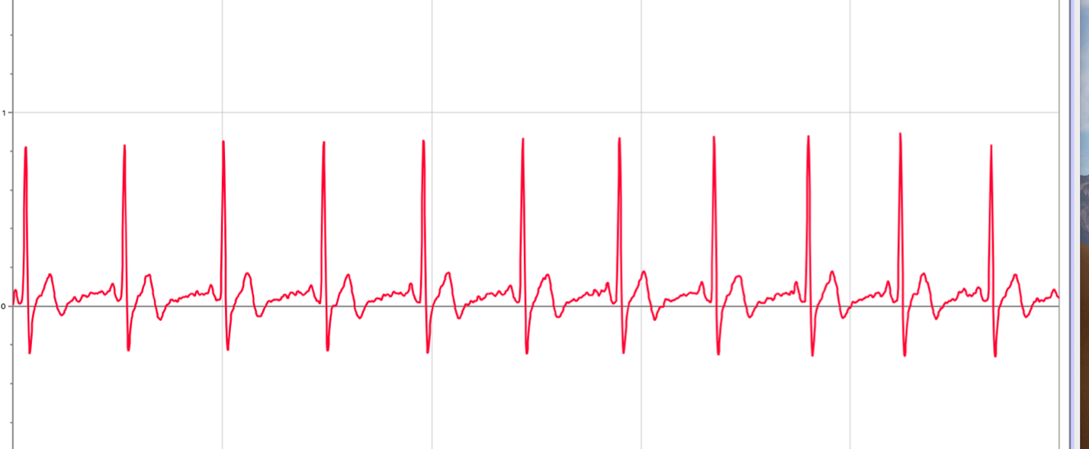

3. How did the ΔT change from resting to active in one of the test subjects in your group? (1 pt)

4. Why is this change important? (1 pt)

