Lab Unit 7 – A Survey of the Invertebrates and Fungi
Unit 7 POST-LAB Assignment:
Fungal and Invertebrate Scavenger Hunt. Carry out a photo scavenger hunt for each of the Fungal and Invertebrate Phyla listed in the lab manual. Make sure you activate the GEO tags on your phone so that it tracks the date/location for the pictures you take. As an additional picture, you can also take a selfie with your organism.
Include your reasoning for placing the organism in a given phylum/group based on the Fungal/Invert Keys provided on the lab website, and/or characteristics from the lab manual Tables 7-1 and 7-3, and other characteristics for these groups found in the lab website.
NOTE: You may use pictures you took while on vacation, hiking, etc. As long as they are your images, they will be accepted for this assignment. You may also go to parks, gardens, grocery stores, pet shops, zoos, etc., to find representatives of these groups. There are many options, so please do not take images off the internet, as they will not count, even if from our own lab website.
Also see the note at the very end of the assignment in case you are missing a few pictures.
Fungal Phyla and Related Groups:
Identify the name of each organism as best you can (scientific or common name) and the reasoning for this placement.
Below is a template for inserting your picture.
- Basidiomycetes - [insert below]:

--Reasoning:
- Ascomycota - [insert below]:
HINT: Although this one may be particularly difficult to find, you may have an example in your baking supplies!

--Reasoning:

- Zygomycetes - [insert below]:

--Reasoning:

- Lichens - [insert below]:

--Reasoning:

- Slime molds - [insert below]:
NOTE: Depending on weather conditions, this one may be particularly difficult to find. Here are two you can use just in case:
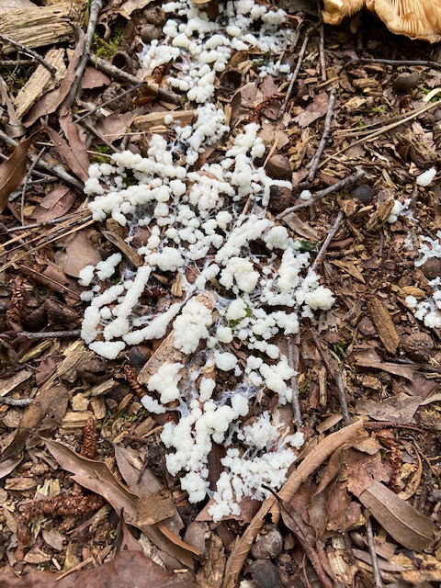  “wet” growing slime mold. Photograph by Patty Aune 2020 © | 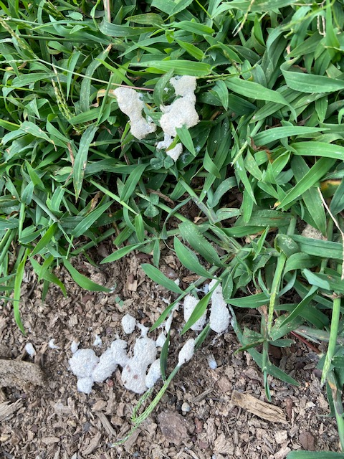  Dried out slime mold. Photograph by Patty Aune 2020 ©

--Reasoning: Form sporangia like Zygomycetes. Fungal key steps – 1b 2a

Invertebrate Phyla:
Identify the name of each organism as best you can (scientific or common name) and the reasoning for this placement.
Below is a template for inserting your pictures (insert as many as you find for each phylum):
- Porifera - [insert below]:
HINT: You may want to find a natural bath sponge for this, since it may be difficult otherwise.

--Reasoning:

- Cnidaria - [insert below]:
--Reasoning:

- Platyhelminthes - [insert below]:
NOTE: This one may be particularly difficult to find. If you do not have one, here is one you can use below.
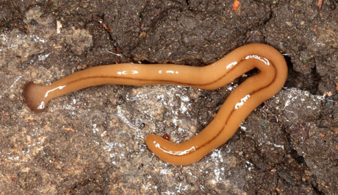  Yellow land flatworm, Bipalium adventitium  https://www.thedailygarden.us/garden-word-of-the-day/land-planarians | 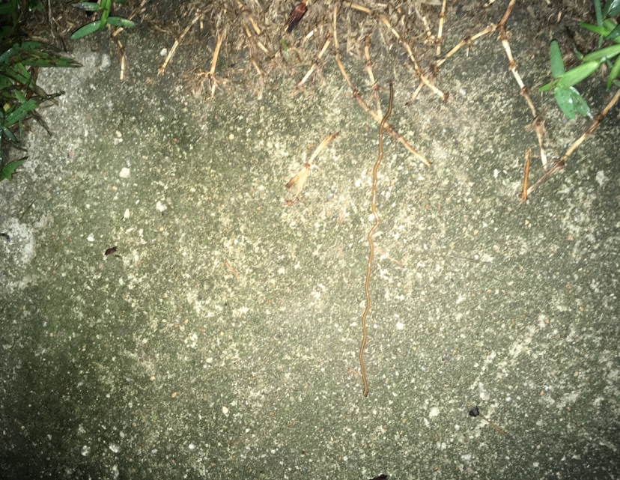  See long slim pale worm on the stone, Photograph by Matt Flint 2020©

--Reasoning:
Invert Key Steps – 1b 3b 4a. flat, slimy, moves by gliding, – Terrestrial Planaria

- Nematoda - [insert below]:
NOTE: This one may be particularly difficult to find. If you do not have one, here is one you can use below.
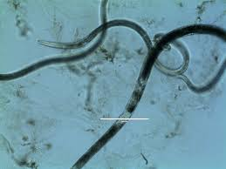
Vinegar eels, Turbitrix aceti http://cardiovasculargma.weebly.com/turbatrix-aceti-vinegar-eels.html
--Reasoning:
Invert Key Steps –
1b 3b 4b 5a 6b very small, thrash from side to side, long, slim and look round. -Vinegar Eel.
6. Annelida - [insert below]:

7. Mollusca - [insert below]:
--Reasoning:

8. Echinodermata - [insert below]:

--Reasoning:

9. Arthropoda - [insert below]:

--Reasoning:

NOTE: If you are missing any of the Invert or Fungal pictures in your Scavenger Hunt, you can provide and ID up to 2 extra Arthropoda pictures and include them below. Still 10 points MAX on the Assignment.

