Orientation to Lab and Lab Unit 1 – Post-Lab Assignment Handout

Post-Lab: Following questions refer to the In-Lab Skills learned in Activity 2, 3 and 4 in your lab manual and activities as listed on the Lab Website.
Note: all page numbers refer to your lab manual.

1. To demonstrate that you understand the process of determining Cell Size of an unknown organism (Activity 3), complete the questions below using the following images and Table where each of these small boxes measures 1mm² (similar to the activity you did in lab).
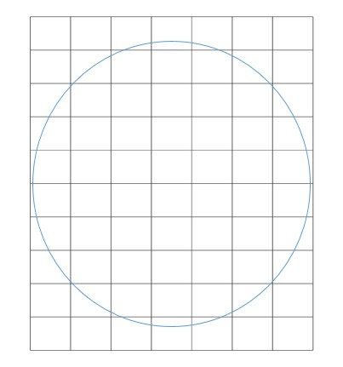
Figure 1. Observed Field of View at 40X total Magnification = _____________

2. Use the field of view you determined above at 40X Total Magnification (see Fig. 1 above) to complete the calculations in Table 1 below. Be sure to show your calculations and answers for each of the cells in Table 1.

Table 1. Calculating Field of View for each objective on an unknown microscope.
Total Magnification | Ratio - 40/Total Magnification | Calculated Field of View = (ratio)(observation at 40X) mm
(example) 40X | (40/40) = 1 | (1)(field of view from #1 above) = __________
100X
400X
1000X

3. Calculate the cell size in millimeters (mm) and micrometers/microns (µm) of the unknown cells in Figure 2 below using the field of view you calculated in Table 1. Assume the specimen shown is under a 10X objective lens with the circle representing the new field of view. Show your calculations.

Calculated Field of view below = _______________
Cell size=__________mm; __________ µm
Calculations:

Figure 2. Unknown Cells

Unit 1- Overview Questions

4. What must you know in order to calculate the total magnification when using a microscope? Give an example on how you would do this.

5. As you increase magnification, what happens to the field of view? Draw a sketch of an organism you saw under your microscope at 40X and how it would look at 100X or 400X (whichever was the most appropriate final magnification).

6. When reading the description of Organisms X from another group, what information was most useful in helping you determine the identity of the unknown? What information was not as useful?

