Laboratory Unit 4.2 - Ecological Methods: Field Sampling Techniques
Urban Ecology and Field Methods
During the Spring 2019 semester, students in BIO 181 carried out the complete Urban Ecology/Scale Insect lab on the NCSU campus near David Clark Labs. Twelve Maple trees were sampled from two locations, six trees from Area A (south side of Dan Allen Parking Deck near railroad tracks), and six trees from Area B (north side of the Dan Allen Parking Deck between University Towers and David Clark Labs). The data from 12 Red Maple trees were consolidated into the graph shown below. NOTE: Refer to the pictures of these areas on the Lab Website.

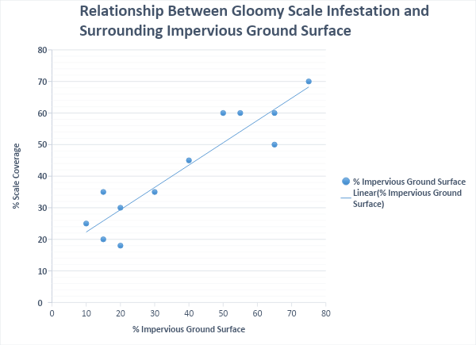
- Scale insect data graph interpretation:
  - Based on these data, what inferences can you make about scale insect infestation?
  - How would you improve this graph?
  - Describe what these findings may mean with regards to the impacts of urban tree planting practices?
  - How do trees in Area B (the more natural area) differ from Area A, and what are some of the human impacts on both of these areas?

- Now that you have analyzed the graph above, how do the qualitative (observational) and quantitative data (table input) from the trees you sampled allow you to assess the health of the trees? That is, how can you assess whether or not the trees are thriving in the areas where they are located? Use the compiled data from your group members to make this assessment as a group.
    - Each person should insert individual data in the table below. Before you start, you will need to discuss the areas each person sampled to determine how to categorize them. For example, rural, urban, suburban, natural, landscaped park, etc. Use the first column on the table to organize your data by type of area.

Type of Area | Tree Species | DBH, cm | % Impervious surface  (% Cover) | Tree Habitat  Observations | Health Ranking (Healthy, Unhealthy, Unsafe) | Native or Non-native

ii. Each Student should add a picture and species name of their URBAN trees below:

iii. Each Student should add a picture and species name of their RURAL trees below:

- Based on the group data entered in the table below, what is the group’s assessment regarding the health of the trees that were sampled? You may want to consider:
- Do you see similar/different patterns in tree health in the more rural and/or urban areas? Did tree species seem to play a factor?
- What other types of organisms did you see living on or around trees in these different areas & trees.
- Do native or non-native tree species make a difference in overall tree health in either locations? What implications might this have on other organisms, especially local insects or other wildlife? or landscape management?
Overall health of your sampled trees? Your answer should be written in at least 1-2 paragraphs.

- Based on all of the data you have analyzed, evaluate the overall implications of urban tree planting practices, microclimates, human impacts on tree health, global warming, etc. Your answer should be written in at least 2-3 paragraphs.

