Microscopes and Cells- Make Up Module

LEARNING OBJECTIVES

1. Be able to use the light microscope to draw, identify, and describe cellular structures.
2. Examine cells from eukaryotic multicellular organisms.
3. Demonstrate osmosis in plant cells.
4. Describe and interpret the animated short film The Inner Life of the Cell.

Please highlight all your answers with a yellow background or use a different color font that is easy to read. This lab will require you to sketch. You can print out this handout to include your sketches in the appropriate locations or make your sketches on paper during lab and then scan or take a picture of your sketches and insert these jpg or pdf images into your lab handout in the appropriate locations.

INTRODUCTION
The cell is the basic functional unit of all living organisms-the smallest and simplest biological structure possessing all key characteristics of life. All living organisms are composed of one or more cells, and every activity taking place in living organisms is ultimately related to the metabolic activities occurring in each cell. Thus, understanding the processes of life necessitates an understanding of the structure and function of cells.

The earliest known cells lacked nuclei and membrane-bound organelles. Present in the fossil record 3.5 billion years ago, these earliest cells were prokaryotes (Figure I). They possessed the basics: a plasma membrane, a single circular DNA, and used RNA and ribosomes to assemble needed proteins. Cells with a nucleus and membrane-bound organelles, called eukaryotes, do not appear in the fossil record for another two billion years. Figure 2 shows a typical animal and plant cell - both eukaryotic cells. Eventual evolution of the eukaryote and its internal compartmentalization led to enormous biological diversity in single cells. The evolution of loose aggregates of cells ultimately to colonies of cells paved the way for specialization, whereby certain groups of cells played differing functional roles. Some were involved in locomotion, others in reproduction, yet all worked together as a functional unit.
Multicellularity appears to have evolved more than once among Eukarya, and adaptive radiations have given rise to multicellular protists, fungi, plants, and animals. Today, unicellular organisms exist as prokaryotes in the Domains Bacteria and Archaea, and unicellular, colonial, and multicellular organisms make up Eukarya.

Today's lab activities are designed to familiarize you with cells from the Eukarya, teach you techniques that are used to study them in the lab, and explain how osmosis affects cellular chemistry.

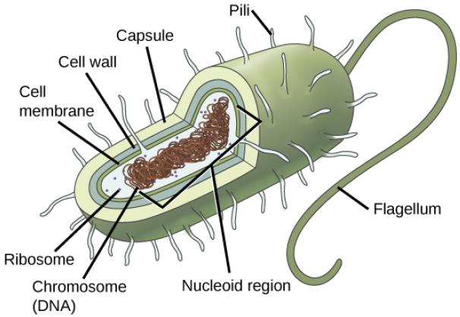
Figure 1. Generalized features of prokaryote cells

ACTIVITY 1: REVIEW OF LIGHT MICROSCOPY

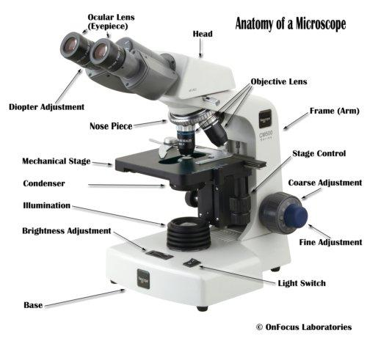
Microscopes of one kind or another are commonly used to study cells. Cell size and the limitations of the human eye necessitate the assistance of microscopes to allow us to visualize them. Light microscopes, which use visible light for illumination, are useful for viewing most eukaryotic cells. They are limited by the smallest wavelength of visible light; thus, when viewing the smaller structural features of cells or even whole prokaryotes, their use is limited. They are essential, however, for examining whole cells and their general features. Given the importance of the light microscope's role in the biological sciences, it is important for you to have a thorough understanding of its proper use. Please review key features of a compound microscope (Figure 2) before you get started on today's activities.

Figure 2. Generalized diagram of a compound microscope with mechanical stage adjustment knobs.

Please go through the Virtual Scope tutorial before you come to lab this week. The link is provided on the website.

PROCEDURE 1A: Light Microscope Online Simulation
In lab you would have practiced using a microscope to see images similar to the ones displayed on the website (under Activity 1 – Procedure 1B). Since you cannot actually use a real microscope this semester, we will review the parts and use of a light microscope by using the Virtual Microscope simulation developed by the NC Community Colleges BioNetwork.

- You will need to click on the "LEARN" button found at the bottom of the page. If you do not see 5 buttons at the bottom of your computer screen, you may need to elongate the open window on your computer’s desktop.

- Work your way through all the prompts indicated by "?" to review the names of all the major parts of the microscope and a few associated supplies needed for microscopy (microscope oil, lens paper and Kimwipes). This light microscope has a 10X ocular lens and 4 different objective lenses (4X, 10X, 40X and 100x/oil lens). This setup very closely matches the microscopes used in both BIO 181/183 labs and other life science courses.

- Click the "EXPLORE" button and click on the "?" to open the box of prepared slides.

- Select ONE of the "Bacteria slides". Use the coarse focus to find the specimen with the 4X lens. First use the coarse focus, then the fine focus adjustors to see the best image of the specimen at that magnification. You may need to adjust the level of light intensity as well. Continue to increase magnification until you can best see the cells.

- Draw a few cells while keeping their size proportional to the field of view. Indicate the name of the slide, total magnification (that is most appropriate for a particular tissue/cell), name, and label any structures you can discern.

- Repeat steps 3-5 and select one of the Human (tissues) slides, and one of the Plant (tissues) slides. Draw and label accordingly in the 3 fields of view illustrated below.

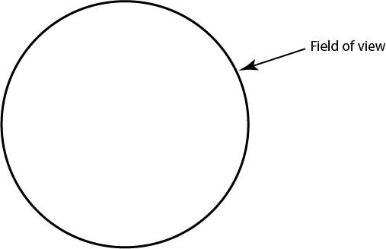
1. Bacterial slide: ______________________________

Total magnification= __________ x __________ = __________

2. Plant (tissue) slide: ______________________________

Total magnification= __________ x __________ = __________

3. Animal (tissue) slide: ______________________________

Total magnification= __________ x __________ = __________

PROCEDURE 1B: PRACTICE INTERPRETATION OF PROVIDED MICROSCOPE IMAGES
In lab you would have further practiced using a microscope to see images similar to the ones displayed on the website (under Activity 1 – Procedure 1B). Choose one of the six prepared slide images on the lab website and draw what you see in the circle below.

Below your drawing, please include the name of the organism and/or tissue and total magnification used for your sketch. How do you calculate this? Be sure to properly list the name your organism/tissue and at label at least two major structures or organelles seen at this appropriate level of magnification.

If you are unsure of what you are looking at and possible structures, you can do a quick Google search. Be sure to sketch from what you can see on your slide, and not from a google search of the image/organism. Different staining or microscopy techniques may have been used in your google search images to show structures that you cannot see in the preparation here.

Organism: ______________________________

Total magnification= __________ x __________ = __________

How are the cells you chose to draw in Procedure 1B similar to the matching Kingdom of cells you drew in Procedure 1A?

How are these cells different from the matching Kingdom of cells drawn in Procedure 1A?

PROCEDURE 1C: SIMPLE STAINING OF AN ANIMAL AND PLANT CELL
In lab you would have made your own slides of cheek and onions cells and stained both with toluidine blue. Using the light microscopes, you would have observed these cells at low, medium, and high power (4X, 10X, and 40X objective lenses).
In this exercise, we are asking you to
- Examine the images of cheek and onion cells provided on the website under ”Activity 1 – Procedure 1C”.
- Decide which magnification is most appropriate and draw both in the circles below.
- Be sure to label the structures that you can see in each of the pictures. At a minimum, you should be able to name and label 2 structures found in each of these cells.

Human Cheek Cell
Total Magnification: __________

Onion Cell
Total Magnification : __________
How do the onion cells differ from the cheek cells? List one similarity and one difference you can see between these two cells.

Similarity:
Difference:

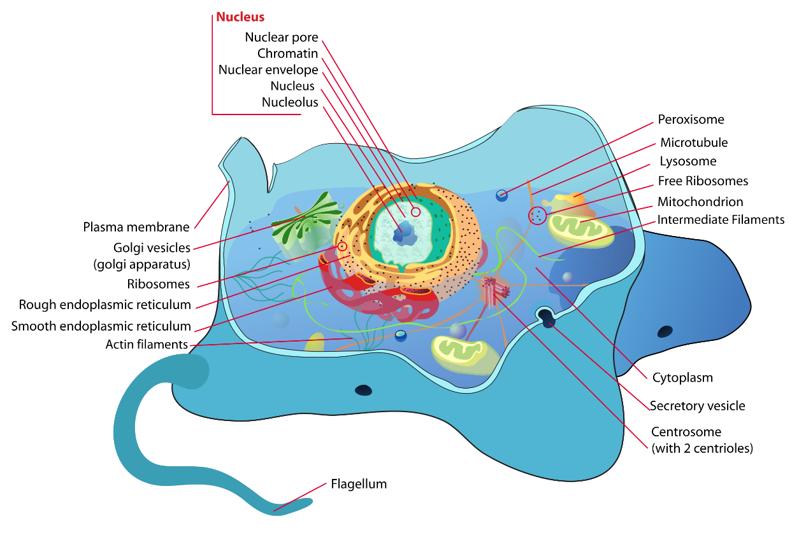
Animal Cell

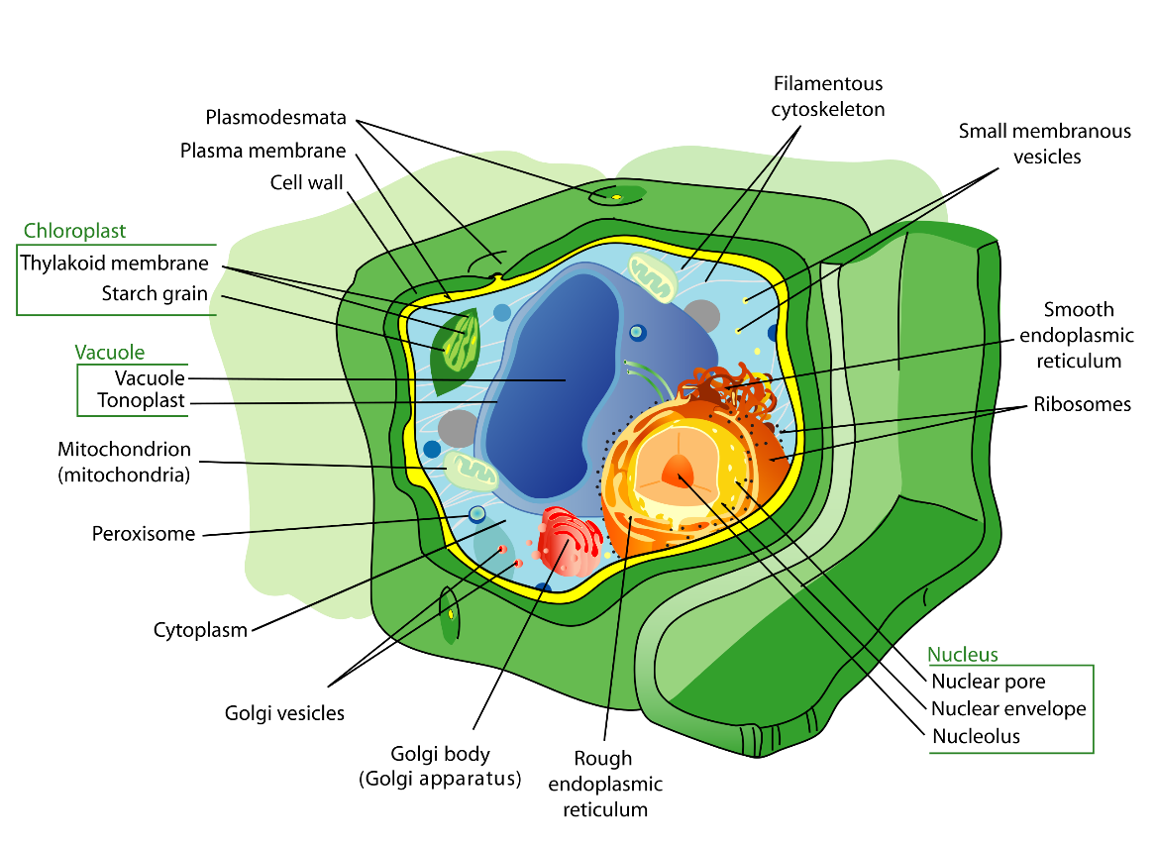
Plant Cell
Figure 3. Generalized features of Animal and Plant cells
https://en.wikipedia.org/wiki/Cell_(biology)

ACTIVITY 2: OSMOSIS IN LIVING CELLS

The internal and external chemical environment of a living cell is aqueous, and there is a concentration gradient across the lipid cell membrane that separates the two. This membrane is semi-permeable, allowing water in particular to move passively in response to the concentration differential. Typically, cells are bathed in an isotonic solution, meaning that the concentration is similar on both sides of the cell membrane. A change in external conditions can have dramatic effects.

PROCEDURE 2A: OSMOSIS IN PLANT CELLS (ELODEA)
Elodea is a freshwater aquatic plant. Images a, b, and c on the website show an Elodea leaf mounted using freshwater at low, medium, and high power.

1. Draw the Elodea cells at the appropriate magnification in the leftmost circle and record your observations below.

2. The Elodea leaf was then flushed with 5% saline (d), and then 10% saline (e). Draw the 5% and 10% cells in the middle (for 5%) and rightmost circles (for the 10%) below. Record all additional observations.

3. All cells were subsequently flushed back with freshwater. Interestingly, nothing changed when freshwater was flushed back through the cells on 10% saline, but the cells exposed to 5% saline “recovered.” Why might that be?

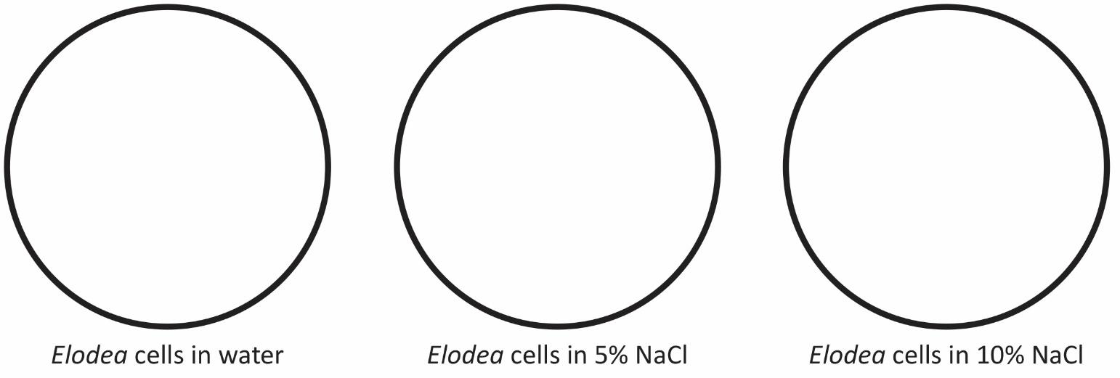

4. What differences did you see in the 5% and 10% saline treatments? What would account for this?

PROCEDURE 2B: OSMOSIS IN BLOOD CELLS (CITRATED SHEEP BLOOD)
Osmosis can also be observed when looking at animal blood cells. The provided sheep’s blood has been treated with sodium citrate, which interacts with blood calcium to prevent coagulation.

1. In lab, students will be working as a group to make their own slides of red blood cells placed in 3 different concentrations of saline solutions.

2. For this make up module, you will need to view the “Video: Osmosis in Red Blood Cells” on the Lab website. Then sketch the cells you saw and answer questions about these animal cells undergoing osmosis when placed in 3 different solutions. You will need to watch the entire 4 minute video (at least once or twice) to see and understand all 3 conditions.

3. Draw your observations in the appropriate circle (A, B or C) below.

Total Magnification = _______________

- Blood cells in 0.9% saline | - Blood cells in 10% saline | - Blood cells in dH₂O (0% saline)
Blood cells in dH2O, 0% Saline

EXPLANATIONS - Use the key osmosis words (isotonic, hypotonic and hypertonic) to describe what you see taking place in the blood cells in each of the above solutions seen in the Red Blood Cell Video on the Lab Website:

A.

B.

C.

What is the key structural difference between the plant (Elodea) and animal (blood) cells observed in Activity 2A and Activity 2B?,

How does this difference relate to cell size/condition in the hyper/hypo/isotonic environments?

MICROSCOPE CAPABILITIES
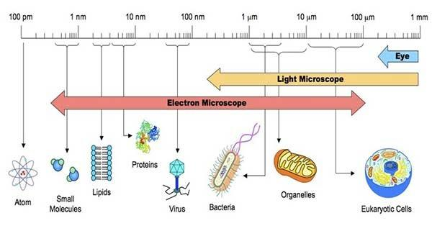
Figure 4. Resolving powers of the human eye and microscopes.
https://sciencewithu.weebly.com/uploads/5/7/6/6/57666125/160833248.jpg

The electron microscope magnifies objects approximately 1000x larger than a light microscope can (up to 1,000,000x). This difference is due to the resolving power of the electron microscope. Resolving power refers to the ability of the viewer to see two objects of comparable size that are close together and still be able to recognize that they are two objects rather than one (see Figure 4). The resolving power of light microscopes depends on the wavelength of light passed through the specimen; the shorter the wavelength, the greater the resolution. This is also what limits their use - you cannot use a light microscope to visualize objects smaller than the shortest wavelength of visible light. Because electron microscopes use electrons as a source of illumination, and electrons have a much shorter wavelength than visible light, the resolving power of electron microscopes is much greater than that of light microscopes. Two types of electron microscopes are commonly used, and both use electrons to generate images. The transmission electron microscope (TEM), which produces two-dimensional images, is useful for viewing details of organelles such as the endoplasmic reticulum and the nucleus that reside within the cell, while the scanning electron microscope (SEM) provides three-dimensional viewing.

Both technologies and others are available at NCSU through the Cellular and Molecular Imaging Facility (CMIF in Gardner Hall) and the Analytical Instrumentation Facility (AIF on Centennial Campus). Courses are available for students interested in learning more about these and other types of microscopy. These facilities also provide services to NCSU faculty and graduate students who require specialized microscopes for research purposes. Many of the images you will see in your textbook throughout the semester (indeed, many you have already seen) were taken with either a TEM or an SEM. Check out the Gallery links found on our lab website.

ACTIVITY 3: ANIMATED FILM-THE INNER LIFE OF THE CELL

While microscopy has been essential to the visualization of cells for hundreds of years, microscopes have always been limited in their ability to show cell activities occurring at the molecular level. New technologies have opened up other ways to visualize cellular metabolic processes. For instance, various video-microscopy techniques and the use of TEM and fluorescence microscopes allow researchers to visualize movement of molecules and structures within a cell. Computer animation can actually provide a medium for showing cell metabolism in a way never before seen, allowing the viewer to visualize important details such as cell-to-cell recognition, protein synthesis, and even transport of proteins from the endoplasmic reticulum to the Golgi apparatus.

A research team at Harvard University designed the short computer animated film you will find on the laboratory website. This film was produced with the aid of cell and molecular biologists, and it demonstrates the reaction of a white blood cell within a blood vessel to chemical signals sent from an injury adjacent to the vessel wall. Each process that is shown has been painstakingly determined through countless hours of research efforts from many scientists. Watch the video a couple of times and enjoy the amazing animations.

Video Background: This video starts with a view of the inside of a blood vessel. You will see the red blood cells rushing past and the much larger white blood cells rolling along the wall of the blood vessel. The white blood cell receives an extracellular signal and the majority of the video shows what happens inside the white blood cell as it responds to that signal. The final scene shows the white blood cell reshaping (due to the conformational changes of the cytoskeleton) and slipping through the endothelial cells of the blood vessel wall to the site of inflammation.

As you watch the video, try to recognize structures and organelles that we described in lecture. Look for structures such as protein filaments, lipid rafts, plasma membrane, actin filaments, microtubules, motor proteins, transport vesicles, mitochondria, centrosomes, nucleus, nuclear pore, mRNA, ribosomes making proteins, ER, Golgi apparatus, and vesicles transported to the plasma membrane surface.

You may want to watch this film again on your own-here is the web address:
http:/ /multimedia.mcb.harvard.edu or on YouTube https://www.youtube.com/watch?v=wJyUtbn0O5Y

On the Harvard website, you can scroll down to see other animations showing mitochondrial and ATP synthase function, and protein packaging.

DISCUSSION QUESTIONS

1. Why were some of the slide preparations stained in this lab? What would these structures have looked like without the stain?

2. If you could repeat the osmosis experiment with animal cells instead of Elodea cells, what might you observe? Would this be different from the plant cells? Explain your answer.

3. From what you viewed in The Inner Life of the Cell video, list at least two functions performed by proteins in a living cell.

4. Referring to The Inner Life of the Cell video, describe one example of how we saw “information” move within the cell.

