Microscopes and Cells

LEARNING OBJECTIVES

1. Be able to use the light microscope to draw, identify, and describe cell structures.
2. Examine cells from eukaryotic multicellular organisms.
3. Demonstrate osmosis in plant cells.
4. Describe and interpret the animated short film The Inner Life of the Cell.

Please highlight all your answers with a yellow background or use a different color font that is easy to read.

This lab requires that you sketch. You can print out this handout to include your sketches on paper during lab and then scan or take pictures of your sketches and insert these jpg images into your lab handout in the appropriate locations.

INTRODUCTION
The cell is the basic functional unit of all living organisms-the smallest and simplest biological structure possessing all key characteristics of life. All living organisms are composed of one or more cells, and every activity raking place in living organisms is ultimately related to the metabolic activities occurring in each cell. Thus, understanding the processes of life necessitates an understanding of the structure and function of cells.

The earliest known cells lacked nuclei and membrane-bound organelles. Present in the fossil record 3.5 billion years ago, these earliest cells were prokaryotes (Figure I). They possessed the basics: a plasma membrane, a single circular DNA, and used RNA and ribosomes to assemble needed proteins. Cells with a nucleus and membrane-bound organelles, called eukaryotes, do not appear in the fossil record for another two billion years. Figure 2 shows a typical animal and plant cell - both eukaryotic cells. Eventual evolution of the eukaryote and its internal compartmentalization led to enormous biological diversity in single cells. The evolution of loose aggregates of cells ultimately to colonies of cells paved the way for specialization, whereby certain groups of cells played differing functional roles. Some were involved in locomotion, others in reproduction, yet all worked together as a functional unit.

Multicellularity appears to have evolved more than once among Eukarya, and adaptive radiations have given rise to multicellular protists, fungi, plants, and animals. Today, unicellular organisms exist as prokaryotes in the Domains Bacteria and Archaea, and unicellular, colonial, and multicellular organisms make up Eukarya.

Today's lab activities are designed to familiarize you with cells from the Eukarya, teach you techniques that are used to study them in the lab, and explain how osmosis affects cell chemistry.
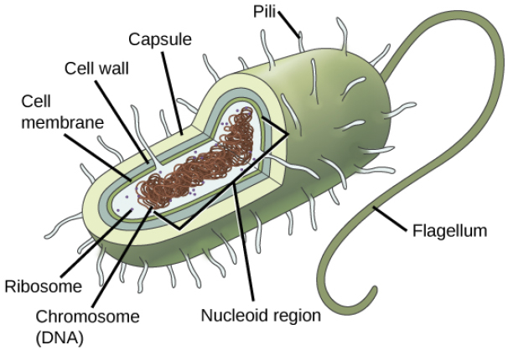

Figure 1. Generalized features of prokaryote cells

ACTIVITY 1: REVIEW OF LIGHT MICROSCOPY
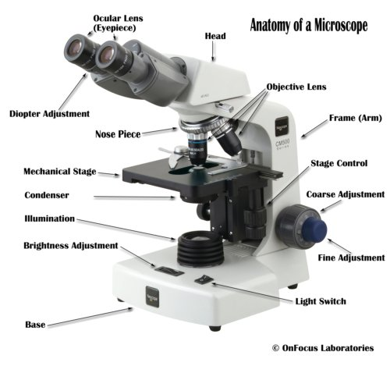
Microscopes of one kind or another are used to study cells. Cell size and the limitations of the human eye necessitate the assistance of microscopes to allow us to visualize them. Light microscopes, which use visible light for illumination, are useful for viewing most eukaryote cells. They are limited by the smallest wavelength of visible light; thus, when viewing the smaller structural features of cells or even whole prokaryotes, their use is limited. They are essential, however, for examining whole cells and their general features. Given the importance of the light microscope's role in the biological sciences, it is important for you to have a thorough understanding of its proper use. Please review key features of a compound microscope (Figure 2) before you get started on today's activities.

Figure 2. Generalized diagram of a compound microscope with mechanical stage adjustment knobs.

PROCEDURE 1A: PRACTICE USE OF THE COMPOUND MICROSCOPE USING A PREPARED SLIDE

Please, follow the Microscope Cleaning Precautions outlined by your TA and posted on each lab table.

1. Obtain one of the prepared slides at your table. Each student should work with their own slide and microscope.
2. Place the prepared slide on the microscope stage with the lowest objective lens (4x) in place over the slide. Use the mechanical stage adjustment knobs to center the specimen under the 4x lens. Turn on the light switch so that you can see light shining through the specimen on the slide (generally the area under the coverslip).
3. Always start to focus using the 4x objective lens and use the coarse focus knob to bring the specimen into focus. Once your image is focused, you can use the small fine focus knob to fine tune the needed focus.
4. Most likely you will want to increase the magnification to better see your specimen or to look for finer details not obvious with the 4x lens. The lenses on your microscope are parfocal, so that you can rotate the objective lens to the next power lens, 10x, and the image should be somewhat close to focus. You may need to move the stage to re-center and find the specimen using the stage adjustment knobs, but do not raise or lower the stage. You should only use the smaller fine focus knob at any magnification higher than the 4x lens or you risk damaging the expensive lens and/or breaking the slide.
5. Now look at your specimen using the 10x, then the 40x objective lenses. Again, remember to only use the smaller fine focus knob to better focus on the specimen. Do not use the 100x objective lens, since special immersion oil is necessary for that level of magnification. Our specimen in lab will all be too large to examine with the 100x lens.
6. In the circle that follows, provide a sketch of the cells, tissue, or organism found on your slide. You will need to determine the best level of magnification to make your drawing.
- Please include the total magnification used for your sketch. How do you calculate this?
- Be sure to properly label your drawing indicating the Genus (and species, if possible) or description name as it appears on the slide label, the Kingdom, and at least two major structures or organelles seen at this appropriate level of magnification.
- If you are unsure of what you are looking at and possible structures, you can do a quick Google search. Be sure to sketch from what you see on your slide, and not from the internet image. Different staining or microscopy may be used to show structures you cannot see in the preparation here.
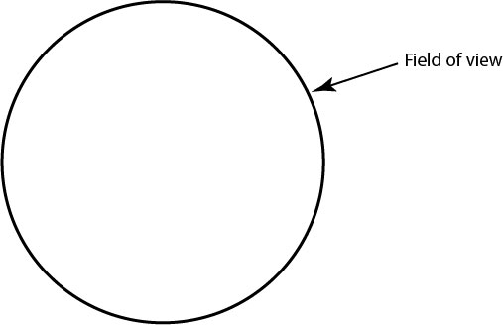
(remember to name and label at least 2 major structures seen in your slide)

Organism: ______________________________
Kingdom: ______________________________
Total magnification = __________ x __________ = __________

PROCEDURE 1B: SIMPLE STAINING OF AN ANIMAL AND PLANT CELL

In order to better visualize key features of some cells, we will employ simple staining. Simple staining is the use of one stain to help visualize a key structure(s). Simple stains generally adhere to specific types of molecules found in or on the surface of cells.
PREPARING SLIDES OF HUMAN CHEEK CELLS
Cheek cells form the epithelial tissue that lines the mouth of the human and other mammals. They are a good representative of a generalized animal cell and naturally slough off in your mouth.
I. Gently scrape the inside surface of your cheek with the flat side of a toothpick.
2. Place 1-2 drops of toluidine blue stain on the slide.
3. Roll the tip of the toothpick in the stain on the glass slide in order to transfer the cells to the slide and then apply a coverslip. To avoid trapping air bubbles in our slide, place one side of the coverslip to the side of the stain, then gently let the raised end down to cover the stain and your specimen.
4. Examine the prepared cells with the compound microscope. Again, start with the 4x lens and focus with the coarse adjustment knob, then fine focus. Then rotate to 10x and 40x using only the fine focus knob. Which is the best magnification to view your cheek cells? Draw your cheek cells in the provided “field of view” below at the most appropriate level of magnification.
5. Locate the prominent nucleus in each cell. The presence of a nucleus is a critical feature that distinguishes the eukaryotic cell from the prokaryotic cell.
6. Use the circles on the following page to illustrate your findings. Please include total magnification and label all structures and organelles you can see in your cells.
7. Do you notice any other structures, organelles, or cells on your slide? What inhabitants of your mouth might you be observing?

PREPARING SLIDES OF ONION EPIDERMAL CELLS
1. Obtain a piece of cut onion bulb. Note the slightly curved shape of the piece. With your fingernails or a dissecting needle, peel off the thin transparent layer of onion epidermis from the inner surface of the onion piece.
2. Place the onion epidermis on a glass slide. Be careful not to wrinkle or fold this too much.
3. Add 2 drops of toluidine blue and apply a coverslip. To avoid trapping air bubbles in our slide, place one side of the coverslip to the side of the stain, then gently let the raised end down to cover the stain and your specimen.
4. Examine the prepared cells/tissue with the compound microscope. Again, start with the 4x lens and focus with the coarse adjustment knob, then fine focus. Then rotate to 10x and 40x using only the fine focus knob. Which is the best magnification at which to view your onion cells? Draw your onion cells in the provided “field of view” below at the most appropriate level of magnification.
5. Locate all recognizable structures and organelles in and around the cells.
6. Use the “field of view” circles on the following page to illustrate your findings. Please include total magnification and label all structures and organelles you can see in your cells.
7. Given that this is a plant cell, is there anything missing that you would expect in a typical plant cell? Explain your answer.
8. How do the onion cells differ from the cheek cells? List one similarity and one difference you can see between the cheek cells and the onion cells.
Similarity:
Difference:

9. Compare the cheek and onion cells to the cells you drew in Procedure 1A? How are they alike? (Be sure to indicate what cells you examined in 1A)

10. Compare the cheek and onion cells to the cells you drew in Procedure 1A? How are they different?

Human Cheek Cell
Total Magnification: __________

Onion Cell
Total Magnification : __________

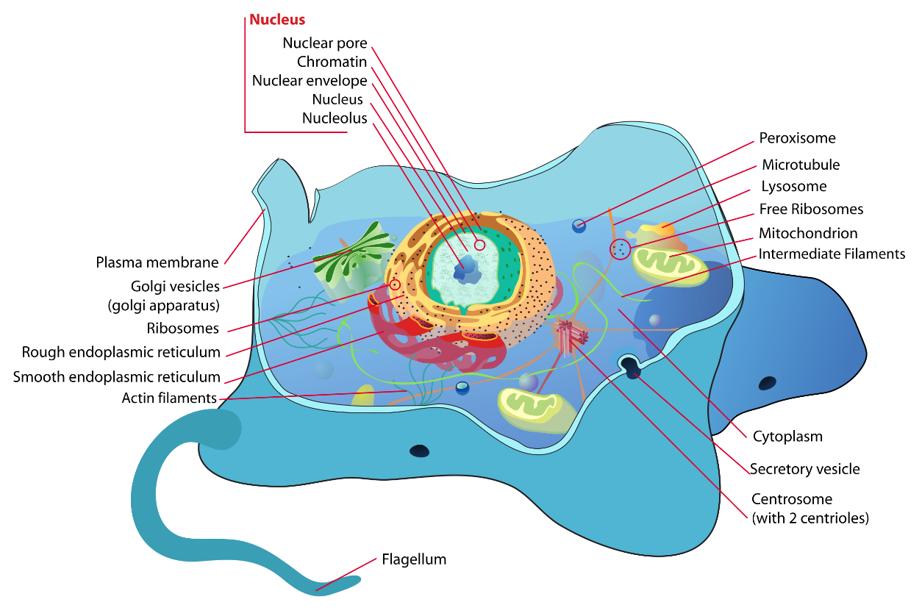
Animal Cell
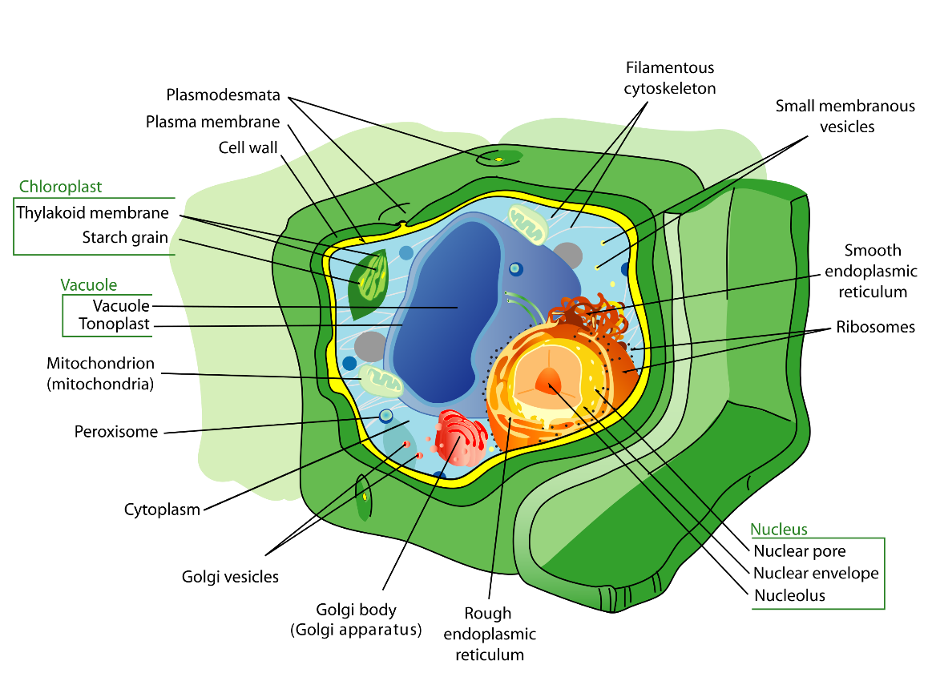
Plant Cell
Figure 3. Generalized features of Animal and plant cells
https://en.wikipedia.org/wiki/Cell_(biology)

ACTIVITY 2: OSMOSIS IN LIVING CELLS

The internal and external chemical environment of a living cell is aqueous, and there is a concentration gradient across the lipid cell membrane that separates the two. This membrane is semi-permeable, allowing water in particular to move passively in response to the concentration differential. Typically, cells are bathed in an isotonic solution, meaning that the concentration is similar on both sides of the cell membrane. A change in external conditions can have dramatic effects.

PROCEDURE 2A: OSMOSIS IN PLANT CELLS (ELODEA)

1. Prepare a wet mount of an Elodea leaf using the deionized water (dH₂O) at your table. Take care not to fold the leaf or introduce air bubbles under the coverslip.

2. Observe the leaf first at low power (4x lens), then at medium and high power (10x and 40x lenses). You will need to decide the most appropriate level of magnification to best see these cells. Record your observations in #7. Draw and label the visible organelles and structures observed.

3. Place 1-2 drops of either the 5% or 10% saline (NaCl) solution at the edge of the coverslip. One pair of students at each table should use the 5% solution and the other pair should use the 10% solution.

4. Using a small piece of paper towel, carefully touch the liquid at the opposite edge of the coverslip in order to draw the salt solution through your leaf under the coverslip. The paper towel should "wick" up the added solution. Refer to Figure 4.

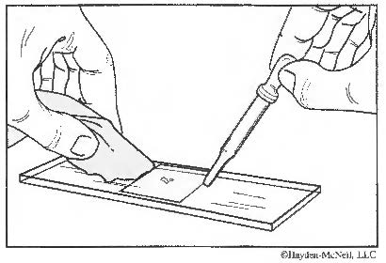
Figure 4. Slide preparation

5. Watch carefully. Record and draw your observations in #7. What changes do you observe? Explain why this occurred in the cells.

6. Repeat the process, only this time use dH₂O and wick the fresh water back through the Elodea leaf.

7. Again, draw and record your observations. Now that the cells are bathed in fresh water again, what differences do you see in the cells? Have they returned to their original appearance? Explain what occurred in each of the drawings below.

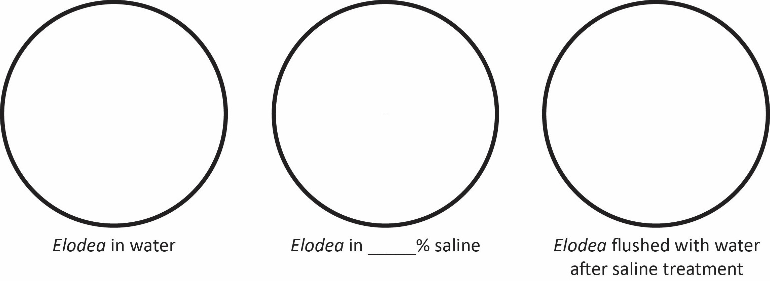

8. What differences did you see in the 5% and 10% saline treatments? What would account for this?

9. When the Elodea cells were bathed in fresh water, was the recovery the same in both the 5% and 10% treated cells? Explain why or why not.

PROCEDURE 2B: OSMOSIS IN BLOOD CELLS (CITRATED SHEEP BLOOD)
Osmosis can also be observed when looking at animal blood cells. The provided sheep’s blood has been treated with sodium citrate, which interacts with blood calcium to prevent coagulation.

1. Each student at the table will make 1 of the following blood slides as they work in pairs. Blood cells will be observed under 3 different experimental conditions: dH₂O, 0.87% saline and 5% saline.

2. One pair of students will make the following 2 slides: blood cells in 0.87% saline and blood cells in 5% saline.

3. The other pair of students will make the 2 following slides: blood cells in 0.87% saline and blood cells in dH₂O (0% solutes in water).

4. Students will need to look at each other’s slides using these directions, sketch the results below, and write explanations for the changes they observe in the 3 different experimental conditions.
- Each student should prepare a slide with a tiny drop of their assigned solution (see the bolded solution in #2 and #3 above).
- Your TA will circulate around the room, and add 0.1 μL of blood to each slide with your assigned saline solution (see #2 and #3 above).
- Place a coverslip at a 45° angle to the drop of saline/blood, and lower it at an angle to reduce the formation of air bubbles.
- View and determine the appropriate magnification to clearly see the cells. Draw your observations in the appropriate circle (A, B or C) below.
- Then, observe your partner’s slide, and draw it in the appropriate circle (A, B, or C) below.
- You may need to watch slide C closely, as the anatomical cellular changes may happen quickly.

Total Magnification = _______________

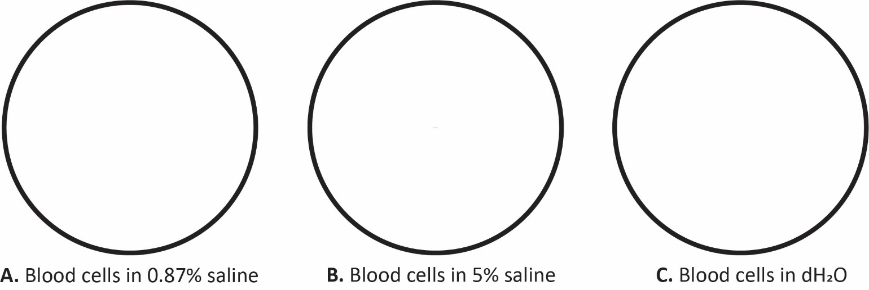

EXPLANATIONS - Use the key osmosis words (isotonic, hypotonic and hypertonic) to describe what you see taking place in the blood cells above:
Blood cells in dH2O, 0% Saline
A.

B.

C.

What is the key structural difference between the plant (Elodea) and animal (blood) cells observed in Activity 2A and Activity 2B?

How does this difference relate to cell size/condition in hyper/hypo/isotonic environments?

MICROSCOPE CAPABILITIES
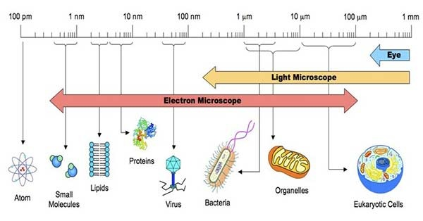
Figure 5. Resolving powers of the human eye and microscopes.
https://sciencewithu.weebly.com/uploads/5/7/6/6/57666125/160833248.jpg

The electron microscope magnifies objects approximately 1000x larger than a light microscope can (up to 1,000,000x). This difference is due to the resolving power of the electron microscope. Resolving power refers to the ability of the viewer to see two objects of comparable size that are close together and still be able to recognize that they are two objects rather than one (see Figure 5). The resolving power of light microscopes depends on the wavelength of light passed through the specimen; the shorter the wavelength, the greater the resolution. This is also what limits their use - you cannot use a light microscope to visualize objects smaller than the shortest wavelength of visible light. Because electron microscopes use electrons as a source of illumination, and electrons have a much shorter wavelength than visible light, the resolving power of electron microscopes is much greater than that of light microscopes. Two types of electron microscopes are commonly used, and both use electrons to generate images. The transmission electron microscope (TEM), which produces two-dimensional images, is useful for viewing details of organelles such as the endoplasmic reticulum and the nucleus that reside within the cell, while the scanning electron microscope (SEM) provides three-dimensional viewing.

Both technologies are available through the NCSU Cellular and Molecular Imaging Facilities (CMIF in Gardner Hall) and the Analytical Instrumentation Facility (AIF on Centennial Campus). Courses are available for students interested in learning more about these microscopy techniques, and these Centers provide services to NCSU faculty and graduate students who require electron microscopy for research purposes.

Many of the images you will see in your textbook throughout the semester (indeed, many you have already seen) were taken with either a TEM or an SEM. Check out the Gallery link on the EM center website to see both SEM and TEM images/micrographs.

ACTIVITY 3: ANIMATED FILM-THE INNER LIFE OF THE CELL

While microscopy has been essential to the visualization of cells for hundreds of years, microscopes have always been limited in their ability to show cell activities occurring at the molecular level. New technologies have opened up other ways to visualize cellular metabolic processes. For instance, video-microscopy techniques and the use of TEM and fluorescence microscopes allow researchers to visualize movement of molecules and structures within a cell. Computer animation can actually provide a medium for showing cell metabolism in a way never before seen, allowing the viewer to visualize important details such as cell-to-cell recognition, protein synthesis, and even transport of proteins from the endoplasmic reticulum to the Golgi apparatus.

A research team at Harvard University designed the short computer animated film you will find on the laboratory website. This film was produced with the aid of cell and molecular biologists, and it demonstrates the reaction of a white blood cell within a blood vessel to chemical signals sent from an injury adjacent to the vessel wall. Each process that is shown has been painstakingly determined through countless hours of research efforts from many scientists. Watch the video a couple of times, and enjoy the amazing animations.

Video Background: This video starts with a view of the inside of a blood vessel. You will see the red blood cells rushing past and the much larger white blood cells rolling along the wall of the blood vessel. The white blood cell receives an extracellular signal and the majority of the video shows what happens inside the white blood cell as it responds to that signal. The final scene shows the white blood cell reshaping (due to the conformational changes of the cytoskeleton) and slipping through the endothelial cells of the blood vessel wall to the site of inflammation.

As you watch the video, try to recognize structures and organelles that we described in lecture. Look for structures such as protein filaments, lipid rafts, plasma membrane, actin filaments, microtubules, motor proteins, transport vesicles, mitochondria, centrosomes, nucleus, nuclear pore, mRNA, ribosomes making proteins, ER, Golgi apparatus, and vesicles transported back to the plasma membrane surface.

You may want to watch The Inner Life of the Cell again on your own-here is the web address:
https://www.youtube.com/watch?v=wJyUtbn0O5Y

DISCUSSION QUESTIONS

1. Why were some of the slide preparations stained in this lab? What would these structures have looked like without the stain?

2. From what you viewed in The Inner Life of the Cell video, list at least two roles proteins play in a living cell.

3. Referring to The Inner Life of the Cell video, describe one example of how we saw “information” move within the cell.

