Cellular Respiration-Online lab
LEARNING OBJECTIVES
1. Predict and determine the rate of cellular respiration in an organism.
2. Design and implement an experimental procedure to determine factors that affect the rate of respiration in an organism.
3. Analyze and interpret experimental data using cellular respiration primary literature.
INTRODUCTION AND REVIEW OF CELL RESPIRATION PROCESSES
All of the chemical processes of an organism together are known as metabolism. Processes involving chemical reactions in which complex molecules are built up from simpler ones are the component of metabolism known as anabolism. For example, complex carbohydrates such as glycogen (in animals) and starch (in plants) are assembled in anabolic reactions that bond simpler sugar molecules together. Photosynthesis is an important anabolic process that builds complex sugar molecules from simple CO₂ and H₂0 molecules. While anabolic processes are building complex molecules in a cell, other reactions are breaking down complex molecules into simpler ones with the release of energy. These reactions are the component of metabolism known as catabolism. Examples are the breakdown of sugar and lipid molecules, releasing energy that the cell can use for doing work.
Respiration is a series of catabolic reactions in which energy is released from the chemical bonds of molecules such as glucose. This energy that is released is used to produce molecules of adenosine triphosphate (ATP). The purpose of respiration is to produce ATP, the universal source of energy for doing work in cells. All types of cells use ATP to perform the many activities that are necessary to their growth, maintenance, function, and reproduction. Accordingly, respiration is a process that is essential to the very life of the cell.
The catabolic process of respiration is a series of oxidation and reduction reactions.
The summary reaction of respiration is usually written as:

C₆H₁₂O₆ + 6O₂ 6CO₂ + 6H₂O + 34-38 ATP
(Glucose)

The reactions of respiration occur in four stages:
1. Glycolysis
2. Pyruvate oxidation
3. Citric acid cycle
4. Electron transport chain

Glycolysis takes place in the cytoplasm of the cell, where the required enzymes are contained in solution. The next three stages operate in and on membranous surfaces that house their respective enzymes. In bacterial (prokaryotic) cells, these membranous surfaces are in the forms of numerous infoldings of the cell membrane itself. In eukaryotic cells, the membranous surfaces are contained within the mitochondria.

1. Glycolysis: Glycolysis is the process by which glucose (a 6--carbon structure) is broken down into two 3-carbon pyruvate molecules. In addition, two net ATP are produced via substrate level phosphorylation and two NADH molecules. See Figure 1 .

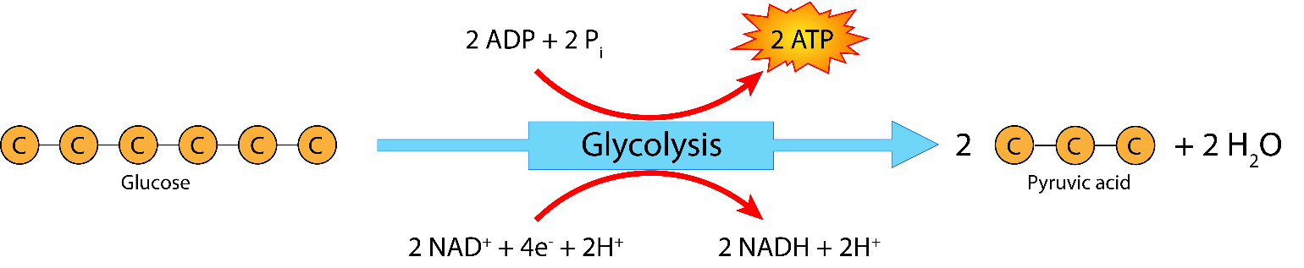

Figure 1. Glycolysis.

2. Pyruvate oxidation: Two 3-carbon pyruvate molecules are converted to two 2-carbon acetyl groups with the release of one CO₂ per pyruvate and two NADH. No ATP is produced in this stage. See Figure 2.

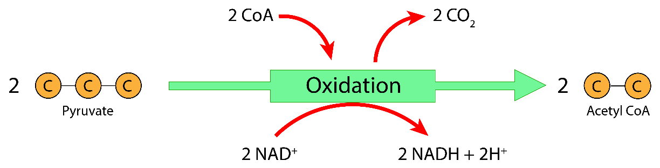

Figure 2. Pyruvate Oxidation.

3. Citric acid cycle: Two acetyl groups enter the cycle and each are broken down to 2C0₂. Three NADH molecules, one FADH2 molecule, and one ATP molecule (by substrate-level phosphorylation) are produced per acetyl group. See Figure 3.

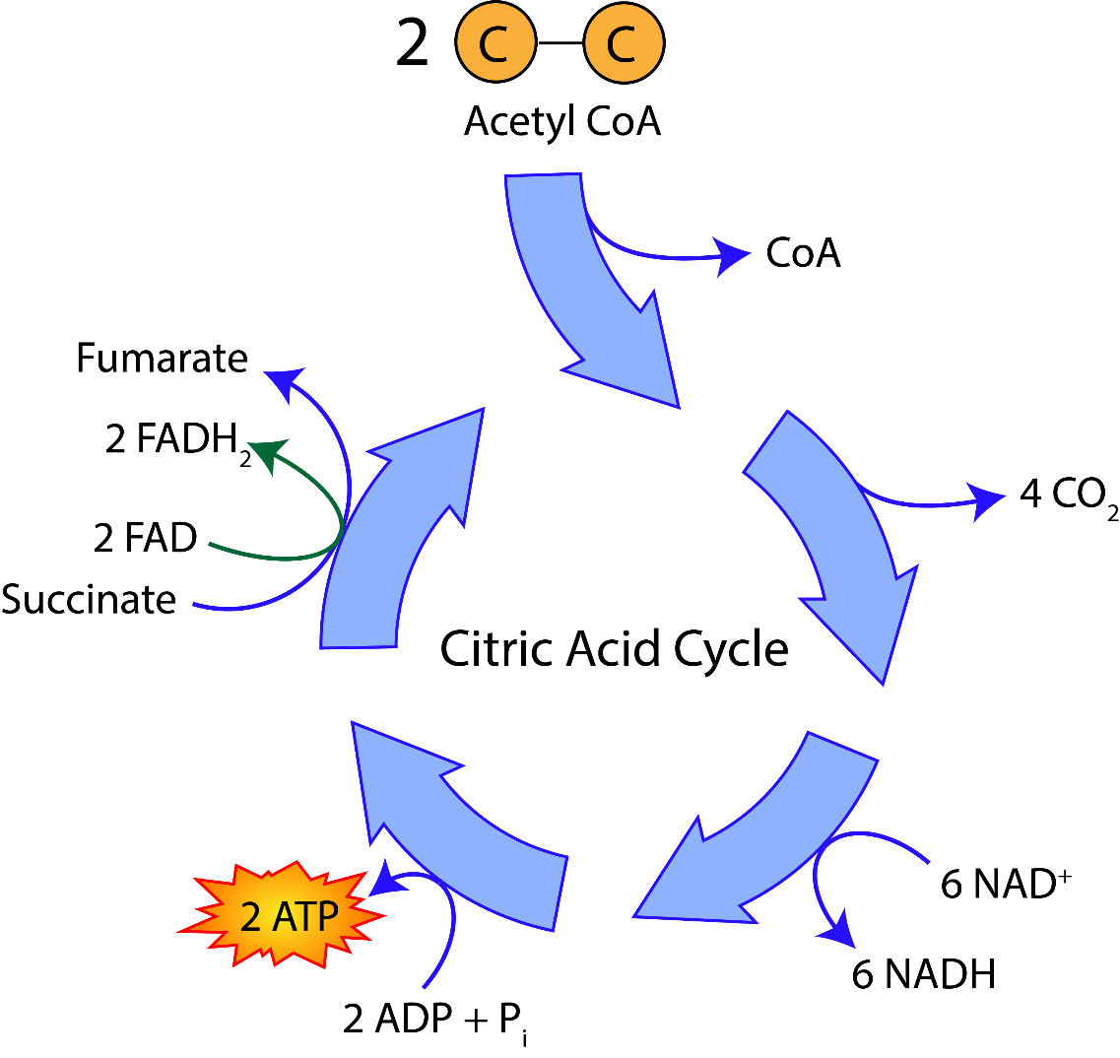

Figure 3. Citric Acid Cycle.

4. Electron transport chain (oxidative phosphorylation): The 10 NADH and 2 FADH₂ molecules produced in the first three stages contain high-energy electrons that can be transferred to other molecules. This energy is released and used to drive the production of 30-34 ATP via chemiosmosis. See Figure 4.

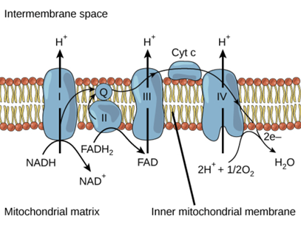

Figure 4. Electron Transport Chain.

Looking back at the summary reaction of respiration, we are reminded that the reactants are glucose (C₆H₁₂0₆) and oxygen (0₂), and the products are carbon dioxide (CO₂), water (H₂0), and ATP. Glucose reacts with oxygen and releases the electrons (energy) of its chemical bonds. The oxidized carbon atoms combine with oxygen atoms to produce CO₂. The released electrons provide the energy that yields ATP. Finally, these electrons themselves combine with oxygen to form H₂0. In this manner, respiration has served its purpose of producing 34-38 ATP per glucose molecule.

Please highlight all your answers with a yellow background or use a different color font that is easy to read.

This week, we are again asking you to read the following procedures and to pretend that you ran these experiments yourself.

ACTIVITY 1: GUIDED AEROBIC RESPIRATION EXPERIMENT
PROCEDURE: SAMPLE COLLECTION AND PREPARATION
A. CONTROL
1. Select enough glass beads to equal the volume of approximately 20 seedlings (about a tablespoon). Why
are these considered the control?
2. Using a balance, obtain the mass of these beads and record in your lab manual.
Mass: __________
3. Place the beads into the sample chamber.
B. ONE-DAY SEEDLINGS
(You may want to get your seeds once you are ready to run the samples, but not too far in advance or you may dry out/stress the seeds.)
1. Scoop 1 tablespoon of seeds (approximately 20 seeds).
2. Be sure the seedlings are clean and dry and then use a balance to obtain their mass and record.
Mass: __________
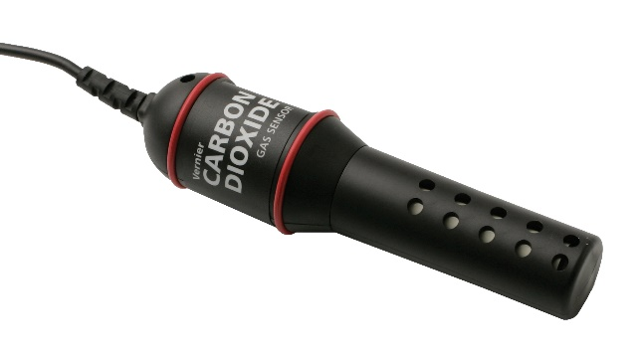
3. Keep these seeds on a damp paper towel until you are ready to use the CO₂ sensor.
Figure 5. CO₂ Gas Sensor ©Vernier Software and Technology.

C. SET UP YOUR SENSOR
1. Double click on the LoggerPro icon from the desktop launcher. Check that your CO₂ Gas Sensor is set to the low (0-10,000 ppm) setting.
2. Under the clock icon next to the green arrow, set the duration to 300 seconds (5 minutes, but keep units in seconds for more data points, rather than data each minute).
3. Allow 90 seconds for the sensor to warm up.

D. RUN EXPERIMENT
Control
1. Place your glass beads in the respiration chamber.
2. Place the CO₂ Gas Sensor in the opening of the respiration chamber so that it fits snugly. Lay the chamber flat, as shown in Figure 5.
3. Wait 60 seconds and then start the data collection by clicking on the green arrow. The graph will add the
data and lines automatically for the specified time duration.

4. After data collection is complete, use the linear regression function (Analyze ➔ Linear Fit) to determine the respiration rate (slope). Record the respiration rate in CO₂ ppm/sec.

What was the respiration rate of the glass beads? Was this expected? Why or why not?

Seeds
5. Before you start to record the CO2 from your seeds, change data collection duration to 600 seconds (10
minutes; keep the data collection in seconds).
6. To add new data to this existing graph, under Experiment, select "Store Latest Run." Then repeat steps D 1-4 using your weighed seeds. Collect data for 600 seconds (10 minutes).
7. Follow the directions in Step 4 to determine the rate of respiration of your seeds.
8. What was the respiration rate? Why do germinating seeds undergo cell respiration?

9. List three factors that could possibly affect cell respiration rate.

1.
2.
3.

ACTIVITY 2: EXPLORATORY AEROBIC RESPIRATION EXPERIMENT
A. NOW DESIGN YOUR OWN EXPERIMENT
You will again select "Experiment ➔ Store Latest Run" before clicking on the green arrow to collect the new data.
Use the space below to write up your experimental question (hypothesis and prediction) and mini protocol. Your TA will let you know what type of experimental variables are available and will suggest a few options for a sound, feasible experiments. You will need to run two I0-minute experiments with two different variables. Before beginning your experiment, your group will need to get your TA's approval. Be prepared to explain why you chose these treatments. What is the main idea your experiment is testing and what do you expect your results to be?

Data from previous student group experiments
YOu will choose ONE of these data sets to work with your make up lab. Write a plausable hypothesis for your experiment and explain the design below as best you can.

Pinto Beans in Light, Early Alaska Peas in Light and Dark
Pinto Beans in Freshwater, 1% NaCl and 3% NaCl
Pinto Beans, Kidney Beans and Early Alaska Peas
Pinto Beans, Early Alaska and Little Marvel Peas
Pinto Beans – Whole, Seed Coat Removed and Crushed seeds
Pinto Beans, Mealworms and Superworms

Hypothesis:

Experimental Design:

B. WHEN YOU HAVE COMPLETED ALL OF YOUR DATA COLLECTION ON THE ONE GRAPH, YOU WILL
NEED TO DO THE FOLLOWING
1. Export your data as a CSV (File ➔ Export As ➔ CSV).
2. Open and "Save As" an EXCEL data sheet in ".xlsx" or ".xls" format.
3. In the Excel spreadsheet, divide each column by the gram weight of the sample. This will give you
respiration rate per gram weight.
4. You should graph all your data and provide all appropriate titles, labels, and legends. You should also
insert a trendline and text to include the slopes of each line, including your trendline (see laboratory
website for instructions on how to include this information).

C. EMAIL THIS EXCEL GRAPH AND ALL DATA TO EVERYONE AT YOUR TABLE
You will need to include this graph and data in your lab notebook. You may also need this information to complete an assignment associated with this lab unit. The graph should show your original results with the glass beads, the seeds, and your two experimental variables.
1. Explain your results. Were there differences? If so, explain why you think there were differences in the respiration rates between the three treatments.

D. FOR YOUR ENERGY ASSIGNMENT, YOU WILL NEED TO FIND AND USE TWO PRIMARY LITERATURE ARTICLES THAT ARE RELEVANT TO YOUR CELL RESPIRATION OR PHOTOSYNTHESIS EXPERIMENT AND CAN HELP EXPLAIN, SUPPORT, OR COMPARE YOUR RESULTS TO RELEVANT RESEARCH.

