DNA Fingerprinting

Please highlight all your answers with a yellow background or use a different color font that is easy to read.

LEARNING OBJECTIVES
1. Describe the structure and function of DNA.
2. Describe the procedure of agarose gel electrophoresis and its application to DNA separation.
3. Perform selective DNA digestion using restriction enzymes.
4. Separate the DNA by electrophoresis and estimate the size of a DNA fragment.
5. Evaluate and interpret various scenarios by which DNA fingerprinting is used as a biotechnology tool to identify individuals and show whether individuals or animals are related to each other.

INTRODUCTION
This experiment introduces the basic concepts of DNA fingerprinting, a method used in various medical and forensics procedures, as well as in paternity determinations. This protocol will demonstrate the similarities and differences in organisms at the genetic level. The basic concept of any DNA fingerprinting protocol includes the extraction of DNA from any cell, the restriction or cutting of the DNA by enzymes called endonucleases, and the analysis of the resulting DNA fragments using agarose gel electrophoresis.
Two basic techniques exist that allow analysis of DNA. Polymerase Chain Reaction (PCR) is commonly used in molecular and genetic research. Restriction Fragment Length Polymorphism (RFLP) analysis is another technique used to compare differences and similarities between individuals at the genetic level. We will use this
second technique in our investigation. Many forensic scientists, including those involved with criminal investigations, use RFLP analysis in order to eliminate potential suspects related to a crime scene. For
our experiment, you will be given five DNA samples, consisting of DNA collected from a crime scene and DNA collected from five different suspects. Your task will be to identify the true criminal using the RFLP analysis technique.

DNA FINGERPRINTING (RFLP ANALYSIS)
Each person has similarities and differences in their DNA sequences. This means that if we look at a population of people, we will see variation in the sequence of nucleotides of a particular locus on a chromosome. RFLP analysis uses this variation as a method to identify individuals based on their particular variation. The size of
the fragments is reflected by the variations in individuals' DNA.

AGAROSE GEL ELECTROPHORESIS
Electrophoresis separates DNA fragments according to their relative size. DNA fragments are loaded into an agarose gel, which is placed into a chamber filled with a conductive liquid buffer solution (Tris/ Acetic Acid/EDTA or TAE). See Figure 1.

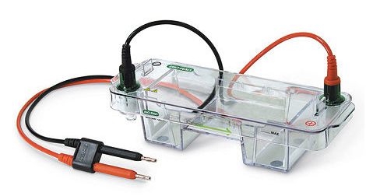
Figure 1. Electrophoresis chamber.

RESTRICTION DIGESTION OF DNA
Because they cut DNA, restriction enzymes are the "chemical scissors" of the molecular biologist. When a particular restriction enzyme "recognizes" a particular four- or six-base pair (hp) recognition sequence on a segment of DNA, it cuts the DNA molecule at that point. This can leave blunt ends (AluI, for example) or sticky
ends (HindIII). In some cases, this is done so that researchers can insert a new piece of DNA into the sequence. In our case, we will be cutting the DNA into various sizes in order to match the crime scene DNA with a suspect. Both of those DNA samples should have the same size pieces when we run our gel. See Figure 2 for examples of
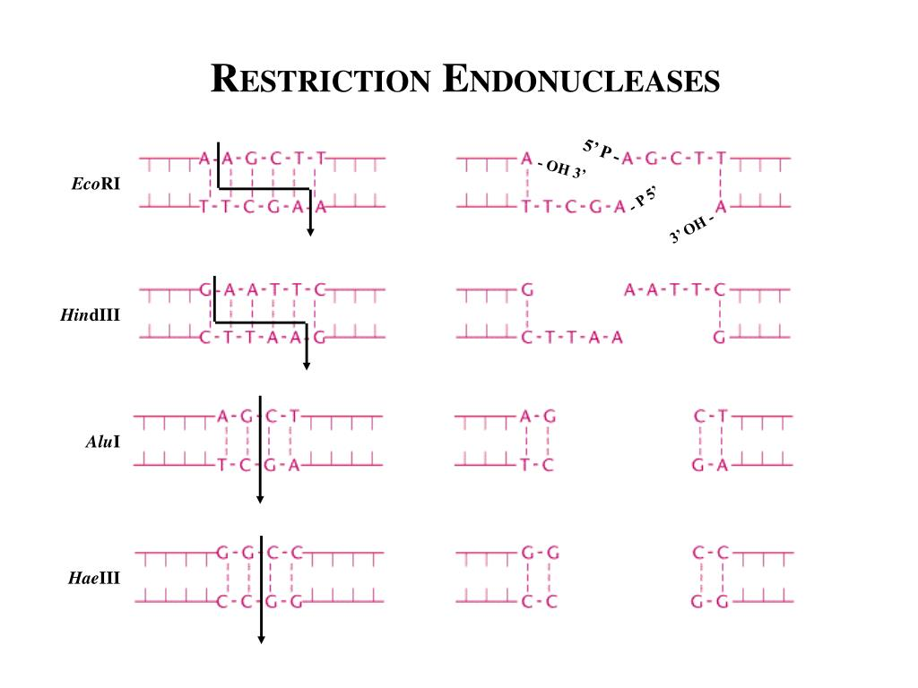
restriction enzyme recognition sites.
Figure 2. Restriction digestion of DNA.

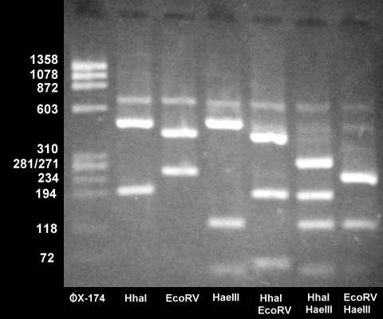

Figure 3. DNA restriction fragments in agarose gel.

Agarose is a natural substance that, upon being dissolved in liquid, will solidify into a matrix-like arrangement. This matrix creates channels through the gel in which small molecules can pass. A direct current is passed between wire electrodes at each end of the chamber, causing a current to pass through the gel from one end to the other. DNA fragments are negatively charged and, when placed in an electric field, will be drawn toward the positive pole and repelled by the negative pole. The matrix of the agarose gel acts as a molecular sieve through which smaller DNA fragments can move more easily than large ones. Over a period of time, smaller fragments will travel farther than larger ones. Fragments of the same size will stay together and migrate in single "bands" of DNA. Figure 3 shows the product after electrophoresis of Lambda DNA that has been digested with the HindIII restriction enzyme.

ACTIVITY 1: PRACTICE PIPETTING
Your lab instructor will show you how to use a micropipette (see Figure 4). It is very important that you pay close attention to this and that all people at your table practice this skill.
Be sure to always use a tip when pipetting. Pipetting can be difficult, particularly when pipetting such small portions. Use the yellow tips and the container of colored water or loading dye for practice.
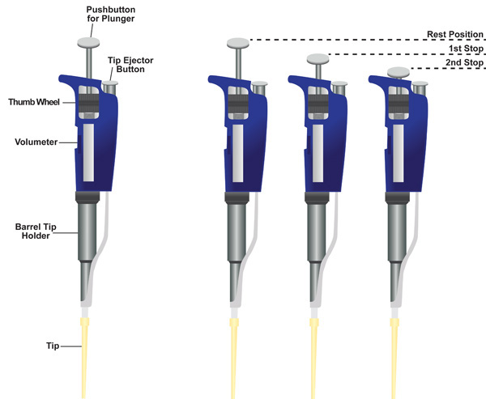
Practice adjusting the pipettor settings. Do not turn to a setting below or above its range. Use the practice loading dye to see what 5 μL, 10 μL, and 20 μL look like in the tip. It is important to be able to accurately measure each sample. Using too little sample will result in minimal digestion. Using too much sample will result in not having enough components to complete all of the tubes at your table.

Figure 4. Micropipettor.
https://www.jove.com/video/2754/aseptic-laboratory-techniques-volume-transfers-with-serological

ACTIVITY 2: RESTRICTION DIGESTION OF DNA SAMPLES

PROCEDURE

1. Make sure that the following materials are present at your lab table prior to beginning the lab.
DNA Electrophoretic unit with
Gel tray
8-well comb
Gel casting stand
Sterile pipette tips
Pipette (0.5-10 μL)
Foam rack for 1.5 mL bullet tubes (see Figure 5)
Ice bucket with the following:
EcoRI/Pstl Enzyme Mix (labeled "ENZ") -1 tube (15 μL)
Loading Dye "LD"-1 tube
2 Sharpie markers
600 mL beaker for used tips and tubes
Colored water for pipetting practice

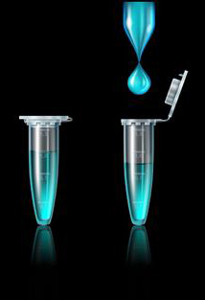
Figure 5. Bullet tubes.
https://www.dreamstime.com/illustration/eppendorf-tube.html

2. On the side counter you should be able to locate an ice bucket with ice containing:
1 tube of each of the following:
Crime scene DNA
Suspect DNA 1, 2, 3, 4, and 5

3. Label the colored bullet tubes with the appropriate label indicating the DNA samples. NOTE: Label the cap of the bullet tube.
Green CS ( crime scene)
Blue SI (suspect 1)
Orange S2 (suspect 2)
Violet S3 (suspect 3)
Red (pink) S4 (suspect 4)
Yellow S5 (suspect 5)

4. Locate the DNA samples on the side counter and transfer 10 μL of each sample from the stock tube into the correspondingly labeled colored bullet tube. Make sure the sample is transferred to the bottom of the tube. To avoid confusion, your TA may move these stock tubes from table to table. NOTE: Be sure the pipette (0.5-10 μL) is set at 10 μL. Dispose of the tips in the beaker labeled "Used Tips."

5. Using a new tip, transfer 10 µL of the Enzyme Mix, labeled "ENZ" to the bullet tubes containing the DNA. Again, make sure the sample is transferred to the bottom of the tube.
At this point, your DNA sample should contain: DNA sample (10 μL) + EcoRI/PstI Enzyme Mix (10 μL) to yield a total reaction volume of 20 μL.

6. Cap the bullet tubes and mix the contents by gently flicking the tubes with your finger. In the microcentrifuge, pulse-spin the tubes for two seconds to force the liquid into the bottom of the tube to mix and combine reactants. Be sure that all tubes are in a BALANCED arrangement in the rotor of the centrifuge before
beginning.

7. After the centrifuge has stopped, remove the bullet tubes and place them in a foam rack. Label the rack with labeling tape so that you can identify your set of tubes. Place the rack into the incubator in the back of the room. Be sure the incubator or hot block is set at 37° C. The samples should incubate for at least 45 minutes.

Record the time that you will need to remove the DNA: __________

NOTE: We will prepare the agarose gel, set up the electrophoresis unit, and collect bean beetle data or work on the DNA exercise during the 45-minute incubation period.

ACTIVITY 3: PREPARATION OF THE 0.8% AGAROSE GEL AND ELECTROPHORESIS UNIT

PROCEDURE

1. Locate the following materials on the side counter of the laboratory prior to beginning this segment of the lab:
Electronic balance
Agarose (Bio-Rad)
2 clean spatulas
Weigh boats
500 mL plastic graduated cylinder
500 mL Erlenmeyer flask
Ix TAE electrophoresis buffer (with other chemicals)
.25x TAE electrophoresis buffer
Magnetic hot plate with stir bar
Insulated gloves

NOTE: You will need one 0.8% agarose gel for each setup today. Determine the amount of powdered agarose needed to make a 50 mL gel: __________ grams. To pour six gels for the class, how much powdered agarose should be used? __________ (in 300 mL of TAE buffer).

Show how you determined how you would make these agarose solutions:

2. The TA will add a magnetic stir bar to the flask and place the flask on a magnetic hot plate. Heat the solution to boiling while stirring. Boil the solution until all of the small translucent agarose particles are dissolved (approximately 15 minutes). CAUTION: Boiling molten agarose or the vessels containing hot agarose can cause SEVERE burns if allowed to contact the skin. Use extreme caution and wear protective glasses and insulated gloves at all times when handling hot agarose. Because the agarose can easily boil over, one person should constantly monitor the flask until it is removed from the hot plate.

3. Using an insulated glove, remove the flask from the hot plate and allow it to cool resting on a paper towel.

4. Alert your TA once the solution has cooled to 60° C. (At this temperature you should be able to handle the flask comfortably.)

5. You will need to set up your electrophoretic unit before you can pour the cooled agarose.

PREPARATION OF THE ELECTROPHORESIS UNIT
1. At your table locate the following electrophoretic equipment:
Gel casting stand
Gel tray
Gel well comb
Gel box
Box lid
Power supply

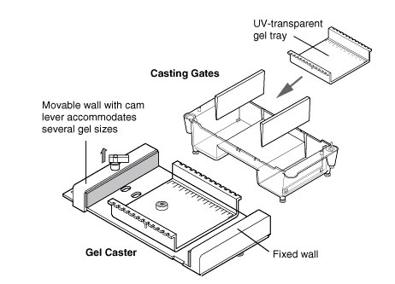
Clamp the gel tray securely into the casting stand (see Figure 6). Place the casting stand on a paper towel in the working tray on your table. Level the gel tray using a leveling bubble. Leveling can be accomplished by adjusting the three feet on the gel casting stand.

Figure 6. Agarose gel tray.
https://www.bio-rad.com/en-us/category/horizontal-electrophoresis-systems?ID=6712bcc6-458e-43f7-9d93-3cdacdc741ac

2. Insert a gel comb into the gel tray. The gel comb will form the wells in the hardened agarose gel. The comb will fit into the notches of the gel tray. Be sure the comb is set securely in the notch. Wearing gloves and safety glasses, pour ~40 mL of the cooled agarose solution into each tray. The depth of the agarose solution
should be about halfway up the comb teeth. NOTE: Allow extra agarose to solidify and dispose of in the biohazard waste container. Rinse the flask with distilled water and return it to the side counter to dry.

3. Allow the gel to solidify at room temperature for 15 minutes. NOTE: The gel will appear cloudy, or opaque, when ready to use. Be careful not to disturb the gel while it solidifies.

4. After the agarose gel has solidified (have your TA check the gel before proceeding), carefully remove the gel tray from the casting stand and remove the gel comb from the gel.

5. Place the tray into the electrophoresis unit so that the sample wells are at the cathode (black) end of the base. The DNA samples will migrate toward the anode (red) end of the base during electrophoresis.

6. Add .25x TAE buffer to the chamber containing the gel. Enough TAE should be added to completely cover the gel.

ACTIVITY 4: PREPARING THE DNA SAMPLES AND LOADING THE GEL

PROCEDURE
1. After the 45-minute incubation, remove the DNA samples from the incubator or hot block and place them on ice.

2. In the ice bucket on your table you should find Loading Dye, "LD." Using a new tip each time, add 5.0 μL of LD to each DNA tube. Close the cap and mix contents by gently flicking the tube with your finger. Pulse-spin the tubes for two seconds to force the liquid to the bottom of the tube. Be sure that all tubes are
in a BALANCED arrangement in the rotor of the centrifuge.

3. After the pulse-spin, place the DNA samples in a foam rack until you are ready to load the gel.

4. On the side counter you should be able to locate the Lambda HindIII size standards labeled "M."

5. Begin loading the gel in the order presented in #6 below. Be sure each person in your group loads one of the wells. NOTE: The standard markers "M" contain DNA digested with Lambda HindIII and loading dye. The DNA fragments produced have predetermined/known molecular weights.

6. Using a separate tip for each sample, load the appropriate amounts into the wells of the gel in the following order:
Lane I-Blank
Lane 2-Lambda HindIII DNA size standards "M"-15.0-20.0 µL
Lane 3-Crime Scene DNA "CS" (Green)-20.0 µL
Lane 4-Suspect One DNA "Sl" (Blue)-20.0 μL
Lane 5-Suspect Two DNA "S2" (Orange)-20.0 µL
Lane 6-Suspect Three DNA "S3" (Violet)-20.0 µL
Lane 7-Suspect Four DNA "S4" (Red)-20.0 µL
Lane 8-Suspect Five DNA "S5" (Yellow)-20.0 μL

ELECTROPHORESIS OF DNA SAMPLES

1. Alert your TA once all DNA samples are loaded into the gel and you are ready to run your gel.
2. Secure the lid on the gel box and connect electrical leads to the power supply. The power supply will be set for 200V and the samples will electrophorese for 20 minutes. Be sure to check that you can see tiny bubbles rising from the wire electrodes when the power is running. Alert your TA if you don't see this occurring.
3. Check with your TA when you think your gel has finished running. Then, turn off the power on the power supply and disconnect the electrophoresis unit from the power supply; the lid may be removed.

STAINING THE SEPARATED DNA SAMPLES

1. Slide the gel off the casting tray into the plastic weigh boat at your table. Cover the gel with the Fast Blast blue stain. Leave the gel in stain for 2-3 minutes, but no more than three minutes. Pour the stain back into the Fast Blast beaker. It can be reused.

2. Transfer the gel into the plastic rinsing tray containing warm tap water. Gently swirl the tray for 10 seconds to rinse the gel. Discard the water and refill the tray with clean warm water. Gently swirl the tray once a minute for five minutes. Change the water a third time and swirl once again every minute for five minutes.

3. Place the gel in a new weigh boat. Initially the bands will be a little fuzzy, but will become sharper in about 10-15 minutes after the final rinse. You may want to use a white light box to better visualize the bands.

ACTIVITY 5: ANALYZING THE DNA PATTERNS

1. Make a rough sketch of your gel in the space provided below. NOTE: Keep in mind the lane assignments of each gel. (Online 2021 semester sketch and label the provided stained BIORAD gel on the lab website)

2. In the ONLINE semester, you will also perform a paper simulation of DNA electrophoresis. Follow the direction on the lab website for the “Who Stole the Crown Jewels?” Activity. Include the completed paper simulation and questions work along with this Handout when you turn in your DNA Lab Handouts for review.

DISCUSSION QUESTIONS
BIORAD GEL ANALYSIS – for online labs, answer #s 2-5 based on the stained BIORAD gel image found on the lab website.

1. Why was the loading dye added to the DNA samples before electrophoresis?
Answer provided for online lab Loading dye is added to the DNA samples so that you can see how fast/far the samples in the gel have run. The loading dye will move along at the front of the moving fragments. Without it added to the samples, the DNA might run off the gel and you would not know it until you stained the gel and did not find any DNA.

2. How can you estimate the actual sizes/molecular weight of these DNA fragments based on the BIORAD gel seen on the lab website?

3. Based on your observations of the DNA fragment banding pattern of the crime scene and suspect DNA, who do you predict is the criminal?

4. Defend your choice by explaining the rationale behind it.

5. What limitations does DNA analysis have in criminal investigations?

ACKNOWLEDGEMENT
This protocol is modified from Bio-Rad's "Biotechnology Explorer DNA Fingerprinting Kit"-Catalog Number 166-0007-EDU. Thanks to Scott Mozingo and NCSU BIO 125 lab manual for the initial production of this introduction and protocol.

