Gene Transformation-Part 1
For this exercise, please read the additional background information BEFORE beginning the lab.

Please highlight all your answers with a yellow background or use a different color font that is easy to read.

LEARNING OBJECTIVES
1. Describe the concept of genetic transformation.
2. Determine the degree of success in your efforts to genetically alter an organism by calculating transformation efficiency.
3. Design and justify an experiment using gene transformation to solve a current environmental, health, or industrial problem.

ADDITIONAL BACKGROUND INFORMATION

GENE REGULATION, FROM GENES TO PROTEINS

Our bodies contain thousands of different proteins that perform many different jobs. Digestive enzymes are proteins; some of the hormone signals that run through our bodies and the antibodies protecting us from disease are proteins. The information for assembling a protein is carried in our DNA. The section
of DNA that contains the code for making a protein is called a gene. The gene that makes a digestive enzyme in your mouth is different from one that makes an antibody, or the pigments that color your eyes.
Organisms regulate expression of their genes, and ultimately the amounts and kinds of proteins present within their cells, for a myriad of reasons, including developmental, cellular specialization, and adaptation to the environment. Gene regulation not only allows for adaptation to differing conditions, but also prevents wasteful
overproduction of unneeded proteins that would put the organism at a competitive disadvantage. The genes involved in the transport and breakdown (catabolism) of food are good examples of highly regulated genes. For example, the sugar arabinose is both a source of energy and a source of carbon. E. coli bacteria produce
three enzymes (proteins) needed to digest arabinose as a food source. The genes that code for these enzymes are not expressed when arabinose is absent, but they are expressed when arabinose is present in their environment. How is this so?

Regulation of the expression of proteins often occurs at the level of transcription from DNA into RNA. This regulation takes place at a very specific location on the DNA template, called a promoter, where RNA polymerase sits down on the DNA and begins transcription of the gene. In bacteria, groups of related genes are often clustered together and transcribed into RNA from one promoter. These clusters of genes controlled by a single promoter are called operons.

The three genes (araB, araA, and araD) that code for three digestive enzymes involved in the breakdown of arabinose are clustered together in what is known as the arabinose operon.³ These three proteins are dependent on initiation of transcription from a single promoter, P_{BAD}. Transcription of these three genes requires the simultaneous presence of the DNA template (promoter and operon), RNA polymerase, a DNA binding protein called AraC, and arabinose. AraC binds to the DNA at the binding site for the RNA polymerase (the beginning of the arabinose operon). When arabinose is present in the environment, bacteria take it up. Once inside, the arabinose interacts directly with AraC, which is bound to the DNA. The interaction
causes AraC to change its shape, which in turn promotes (actually helps) the binding of RNA polymerase and the three genes B, A, and D are transcribed (see top of Figure 7). Three enzymes are produced, they do their job, and eventually the arabinose runs out. In the absence of arabinose, the araC returns to its original
shape and transcription is shut off.

The DNA code of the pGLO plasmid has been engineered to incorporate aspects of the arabinose operon. Both the promoter (P_{BAD}) and the araC gene are present. However, the genes that code for arabinose catabolism, araB, A, and D, have been replaced by the single gene that codes for the green fluorescent protein (GFP) (see
bottom of Figure 7). Therefore, in the presence of arabinose, the AraC protein promotes the binding of RNA polymerase, and GFP is produced. Cells fluoresce a brilliant green color as they produce more and more protein. In the absence of arabinose, araC no longer facilitates the binding of RNA polymerase and the GFP gene is not transcribed. When the GFP protein is not made, bacteria colonies will appear to have a wild-type (natural) phenotype of white colonies with no fluorescence.

This is an excellent example of the central molecular framework of biology in action:
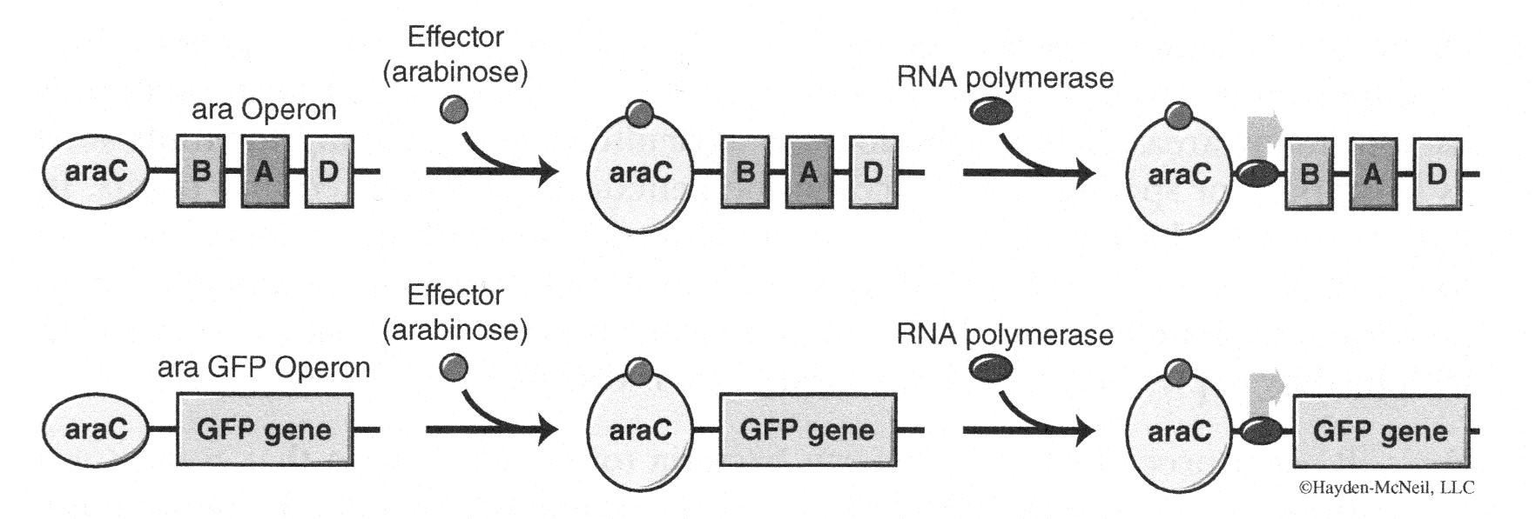
DNA➔ RNA➔ PROTEIN ➔ TRAIT
Figure 7. The arabinose/GFP operon.

REFERENCES
1. Hanahan, Douglas, Studies on transformation of Escherichia coli with plasmids. J. Mol. Biol., 166, 557 (1983).
2. Hanahan, Douglas, Techniques for transformation of E. coli. In DNA cloning: A practical approach (Ed. D.M. Glover), Vol. 1. IRL Press, Oxford (1987).
3. Two positively regulated systems, ara and mal, Robert Schleif, In Escherichia coli and Salmonella, Cellular and Molecular Biology, Frederick Neidhardt, Editor in Chief, ASM Press, Washington, D.C. 1996.

INTRODUCTION
In this lab you will perform a procedure known as genetic transformation. Remember that a gene is a piece of DNA that provides the instructions for making (coding for) a protein that gives an organism a particular trait. Genetic transformation literally means "change caused by genes," and involves the insertion of a gene(s) into
an organism in order to change the organism's trait(s). Genetic transformation is used in many areas of biotechnology. In agriculture, genes coding for traits such as frost, pest, or spoilage resistance can be genetically transformed into plants. In bioremediation, bacteria can be genetically transformed with genes enabling them
to digest oil spills. In medicine, diseases caused by defective genes are beginning to be treated by gene therapy; that is, by genetically transforming a sick person's cells with healthy copies of the gene involved in their disease.
You will use a procedure to transform bacteria to include a gene that codes for a green fluorescent protein (GFP). The real-life source of this gene is the bioluminescent jellyfish Aequorea victoria. The gene codes for a green fluorescent protein, which causes the jellyfish to fluoresce and glow in the dark. Following the transformation procedure, the bacteria express their newly acquired jellyfish gene and produce the fluorescent protein, causing them to glow a brilliant green color under ultraviolet light.

In this activity, you will learn about the process of transferring genes from one organism to another with the aid of a plasmid. In addition to one large chromosome, bacteria naturally contain one or more small circular pieces of DNA called plasmids. Plasmid DNA usually contains genes for one or more traits that may be beneficial to bacterial survival. For instance, some bacteria require certain sugars such as lactose or fructose to survive and proliferate. In nature, bacteria can transfer plasmids back and forth, allowing them to share these beneficial genes. This natural mechanism, termed "transformation," allows bacteria to adapt to new environments. For
instance, the occurrence of bacterial resistance to antibiotics is partly due to the transmission of plasmids.
A unique pGLO plasmid developed by Bio-Rad contains three genes of interest to us (see Figure 8). The GFP gene encodes for the green fluorescent protein. The bla gene encodes for beta-lactamase, an enzyme that breaks down the antibiotic ampicillin. And finally, the araC gene encodes for the AraC protein, which can regulate the expression of the GFP gene. When the sugar arabinose is present in the cell's nutrient medium, AraC and arabinose form a complex that binds to the promoter region of the GFP gene and promotes its expression. Conversely, in the absence of arabinose, AraC alone is unable to drive the expression of the GFP gene (see bottom of Figure 7). Selection for cells that have been transformed with pGLO DNA is accomplished by growth on antibiotic plates. That is, bacteria that incorporate the pGLO plasmid will become resistant to ampicillin, and therefore will grow on a medium containing the antibiotic. If bacteria do not incorporate the pGLO plasmid, then those bacteria will not grow on ampicillin plates. Also, in the presence of ampicillin,
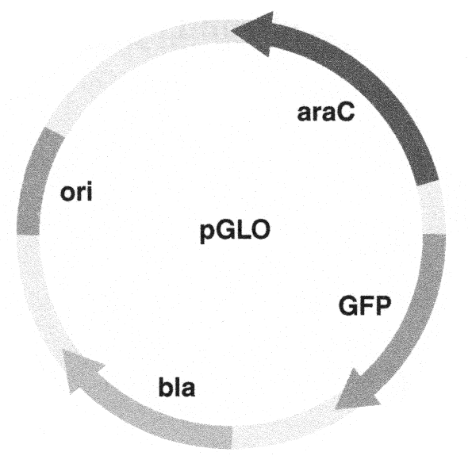
transformed cells (those containing pGLO plasmid) will appear white (wildtype phenotype) on plates not containing arabinose (the GFP is not expressed). In the presence of ampicillin, transformed cells will fluoresce green when arabinose is included in the nutrient agar.
Figure 8. Basic map of the pGLO plasmid.

ACTIVITY 1: PROTOCOL DISCUSSION
Before we begin our bacterial transformation, it is important to understand what is going on in our bullet tubes. Why are we putting solution "A" into tube "B" and incubating, or centrifuging? Your TA will have limited time to discuss this procedure while you are doing it, and many of the steps must be precisely timed. Before proceeding, answer questions 1-4.
1. What is transformation?

2. What is a plasmid?

3. How can a plasmid change the traits of your bacteria?

4. Draw and label a typical bacterium and include the plasmid we are adding with this experiment.

As your TA goes over the procedure for Activity 2, they will stop and discuss the purpose of the critical steps. Be sure you answer these questions before you continue with Activity 2.

5. What is the purpose of the CaCl₂?

6. What is the purpose of the ampicillin in our agar plates?

7. What is the purpose of the arabinose on our agar plates?

8. On which the provided agar plates do you expect to see growth? What characteristics do you expect the bacteria to have on each plate?

9. How can Gene Transformation benefit industry, research, pharmaceutical, or agricultural interests?

ACTIVITY 2: TRANSFORMATION
This transformation procedure involves three main steps. These steps are intended to introduce the plasmid DNA into the E. coli cells and provide an environment for the cells to express their newly acquired genes.
To move the plasmid DNA pGLO through the cell membrane, you will:

1. Use a transformation solution of CaCl₂ (calcium chloride).
2. Carry out a procedure referred to as "heat shock."

For transformed cells to grow in the presence of ampicillin, you must:

3. Provide them with nutrients and a short incubation period to recover from heat shock and begin expressing their newly acquired genes.

PROCEDURE
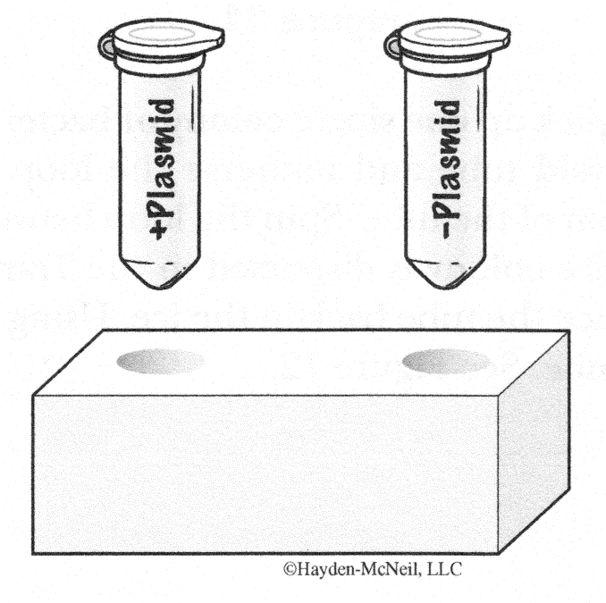
1. Using two new clear bullet tubes, label one closed bullet tube (+)plasmid and another (-)plasmid. Label both tubes with your group's name. Place them in the foam tube rack at your table. See Figure 9.

Figure 9.

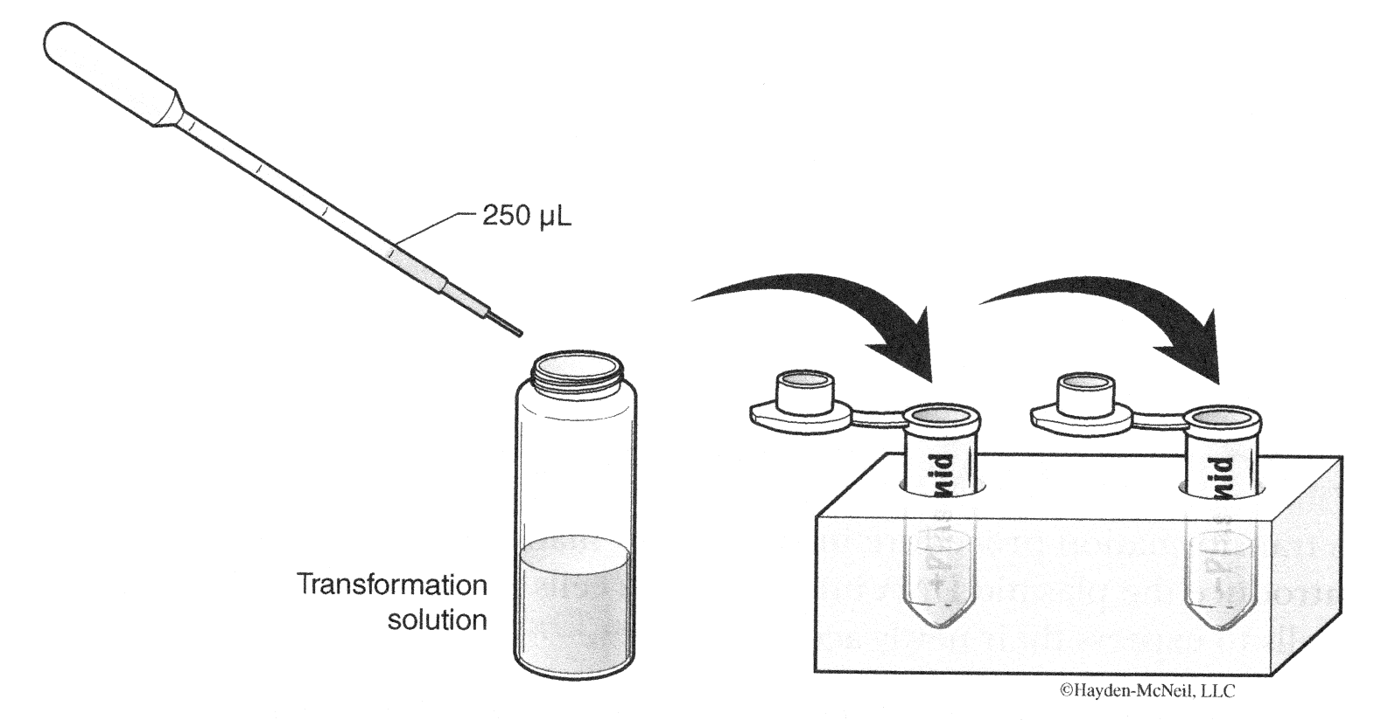
2. Open the tubes and, using a sterile transfer pipette, transfer 250 μL of Transformation Solution (CaCl₂) into each tube. See Figure 10.

Figure 10.

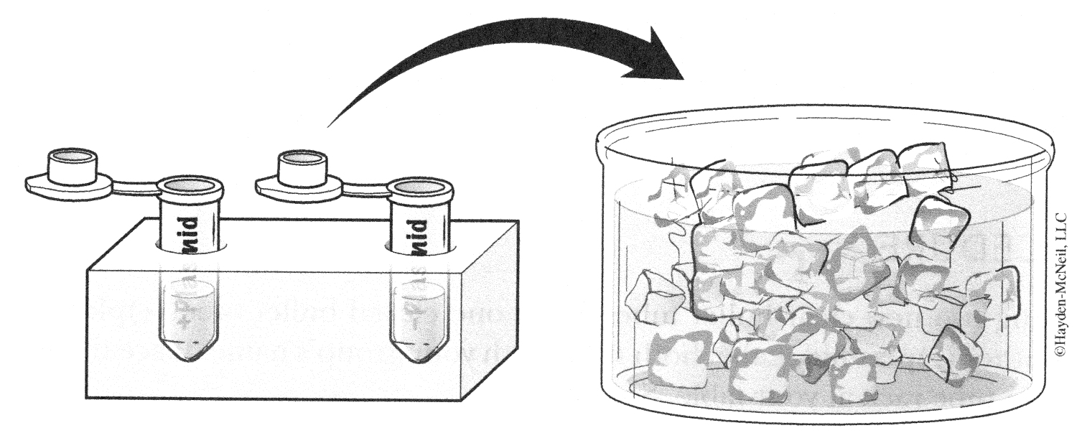
3. Place the tubes on ice at your table. See Figure 11.
Figure 11.

4. Use a sterile loop to pick up one single colony of bacteria from your starter plate. Pick up the (+)plasmid tube and immerse the loop into the Transformation Solution at the bottom of the tube. Spin the loop between your index finger and thumb until the entire colony is dispersed in the Transformation Solution (no floating chunks). Place the tube back in the ice. Using a new sterile loop, repeat for the (-)plasmid tube. See Figure 12.
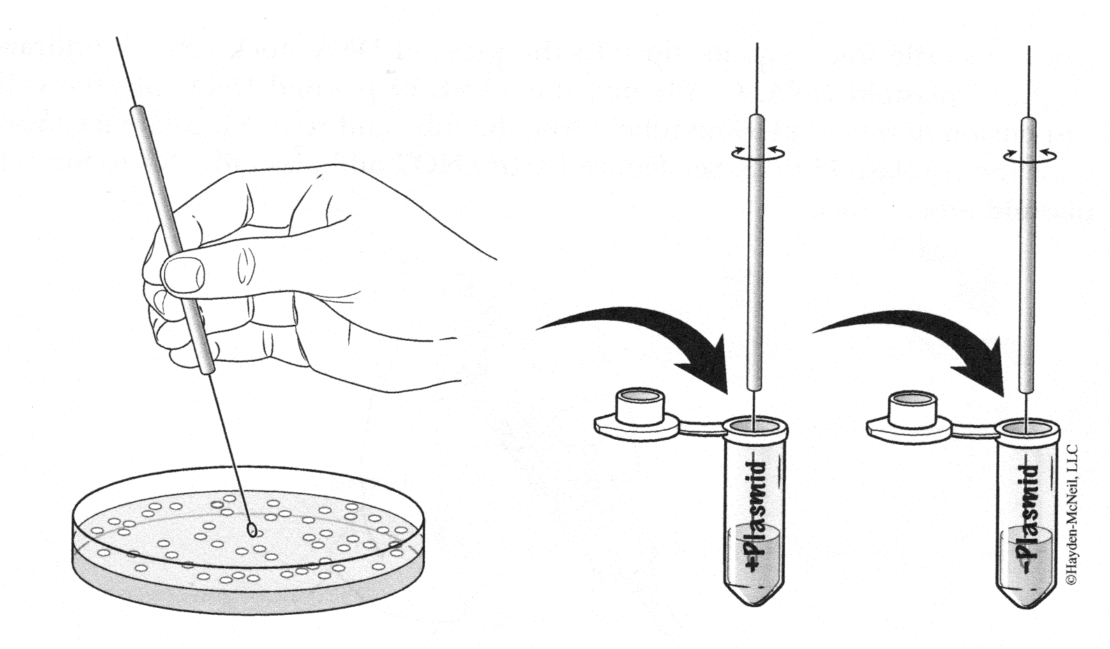
Figure 12.

5. Examine the pGLO plasmid solution with the UV lamp. Note your observations.

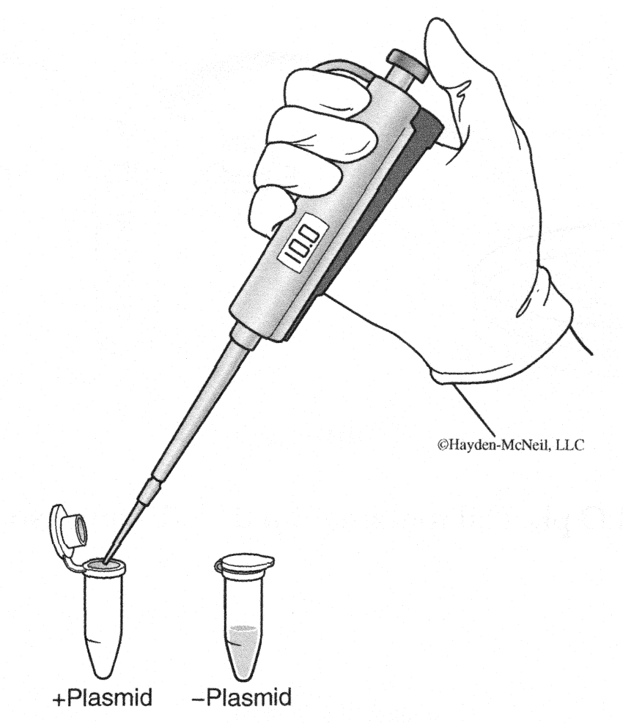
6. Insert a sterile micropipette tip into the plasmid DNA stock tube. Withdraw 10 µL of plasmid DNA. Gently mix the 10 µL of plasmid DNA into the cell suspension of the (+)plasmid tube. Close the tube and return it to the ice. Also close the (-)plasmid tube. See Figure 13. DO NOT add plasmid DNA to the (-)plasmid tube. Why not?

Figure 13.

7. Incubate the tubes on ice for 10 minutes. Make sure to push the tubes all the way down in the ice.
8. Heat shock. Transfer both the (+) and (-) tubes into the hot block set at 42° C for exactly 50 seconds. When the 50 seconds are done, place both tubes back on ice. For the best transformation results, the change from the ice (0° C) to 42° C and then back to the ice must be rapid. Incubate tubes on ice for at least two minutes.
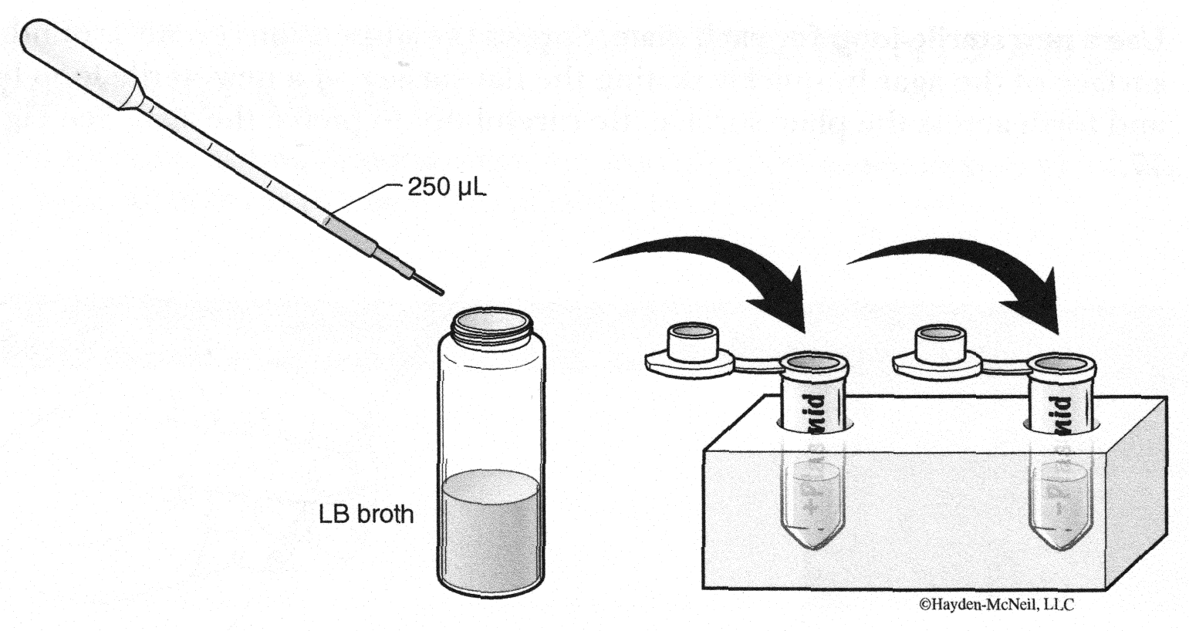
9. Remove the tubes from the ice and place on the bench top in a foam rack. Open a tube and, using a new sterile pipette, add 250 µL of LB broth to the tube and re-close it. Repeat with a new sterile pipette for the other tube. Incubate the tubes for 30 minutes at 37° C. See Figure 14.

Figure 14.

10. While the tubes are incubating, label your four agar plates on the bottom (not the lid) as follows ( see Figure 15):
• Label one LB/amp plate: +plasmid
• Label the LB/amp/ara plate: +plasmid
• Label the other LB/amp plate: -plasmid
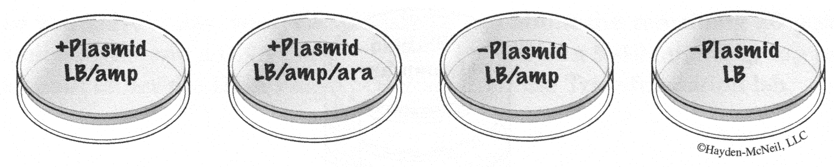
• Label the LB plate: -plasmid
Figure 15.

11. Tap the closed tubes with your finger to mix. Using a new sterile pipette for each tube, pipette 100 μL of the transformation and control suspensions onto the appropriate plates. See Figure 16.
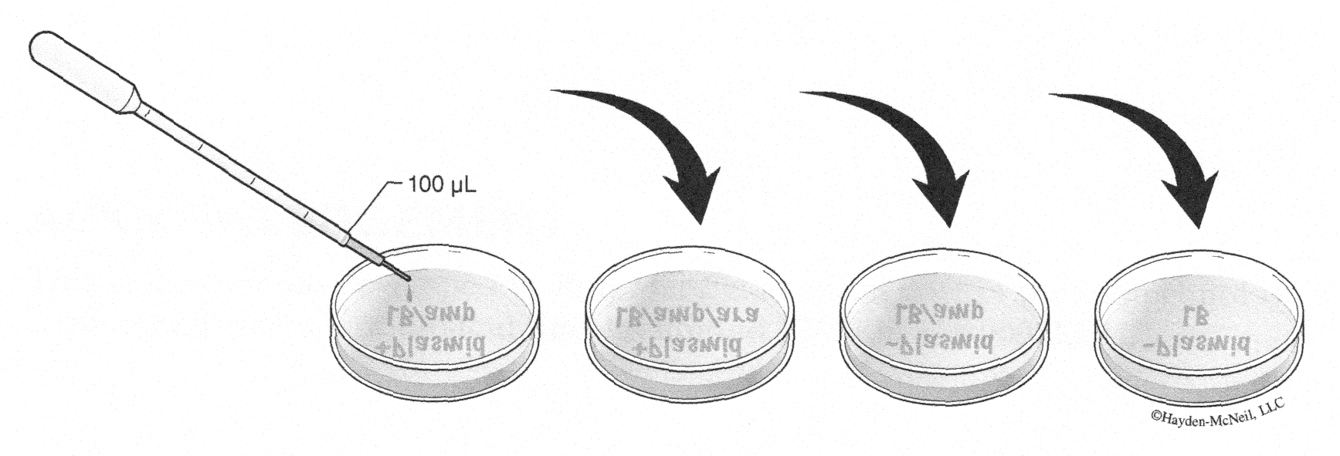
Figure 16.

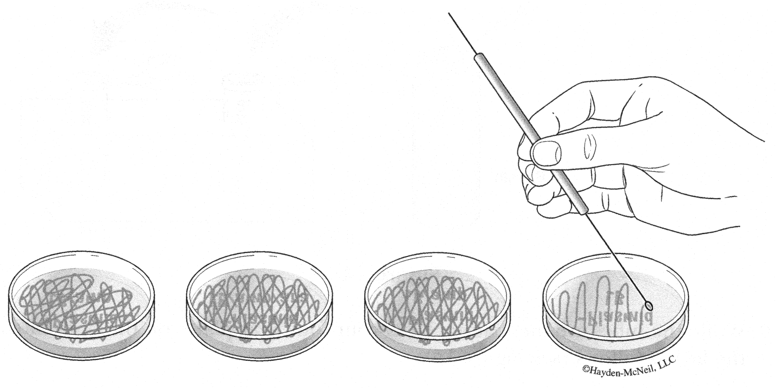
12. Use a new sterile loop for each plate. Spread the suspensions evenly around the surface of the agar by quickly skating the flat surface of a new sterile loop back and forth across the plate surface. Be careful not to pierce the agar. See Figure 17.

Figure 17.

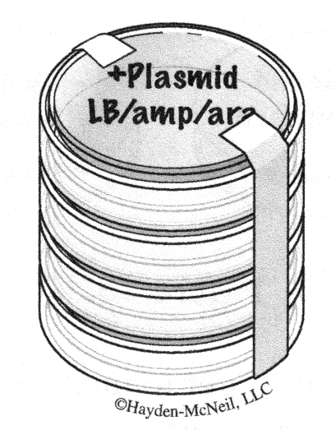
13. Stack up your plates and tape them together. Put your group name and lab section # on the bottom of the stack and place it upside down. These will grow in the incubator at 37 ° C for 1-2 days. See Figure 18.

Figure 18.

ACTIVITY 3: EXPERIMENTAL TREATMENTS AND PROPOSED RESULTS
Fill in the table below, drawing what you would expect to see next week in lab. Include a written explanation as to why you expect this to occur for each. Though you will not inoculate the agar plates shaded in gray, also write what you would expect to happen in those plates too.

Agar Plate Content | -Plasmid | +Plasmid
LB

LB/amp

LB/amp/ara

Before you leave today, your TA will talk to you about the remaining unit assignment: DNA presentations. This will be a 7-12 minute group presentation about either the DNA Fingerprinting lab or the Transformation lab.

ACKNOWLEDGEMENT
This laboratory was developed by Ron Mardigian and is part of the Biotechnology Explorer curriculum of Bio-Rad, Inc. Richmond, CA. Kit: 166-0003EDU.

