Exploring Properties of Enzymes – In Person Lab

LEARNING OBJECTIVES

1. Define the properties and role of enzymes in biological systems.
2. Evaluate data and construct an argument for why the activity of the enzyme changes under multiple experimental conditions.
3. Design an experiment to determine the effects of various experimental conditions on the enzyme catalase.
4. Use a spectrophotometer to collect and evaluate results from the catalase experiment.
5. Construct proper graphs using Excel.
6. Practice scientific writing through reporting of experimental design and results.

INTRODUCTION
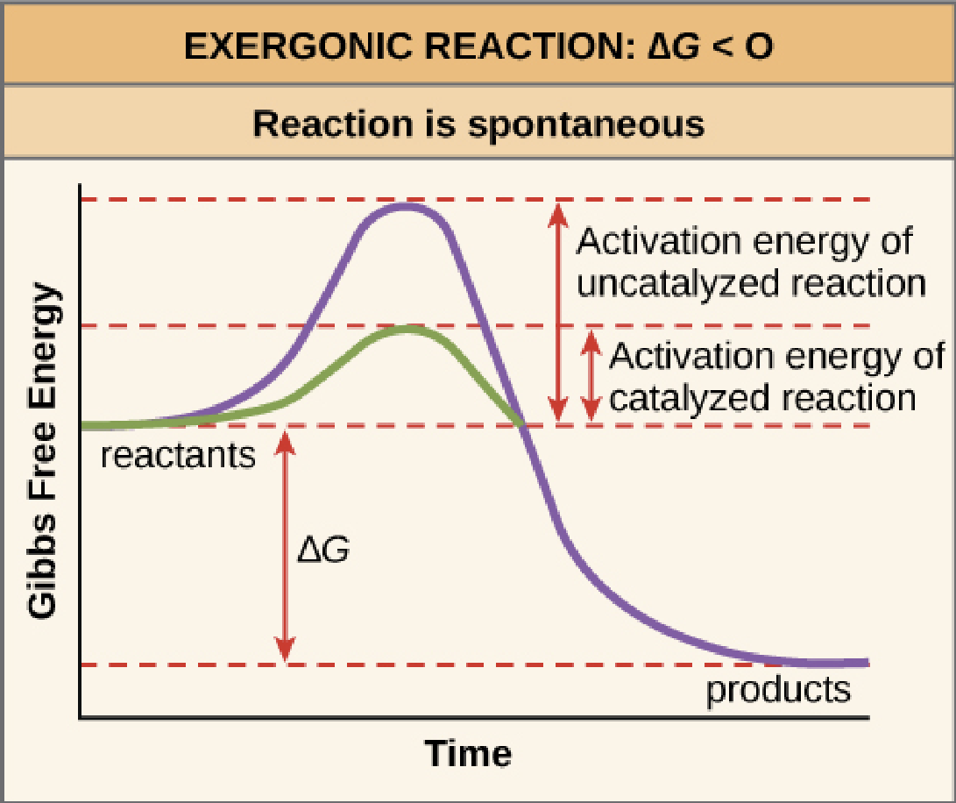
Enzymes are biological catalysts that increase the rate of chemical reactions by lowering the activation energy needed for these reactions to proceed. They help carry out thousands of chemical reactions at a rate of up to 1,000,000 times that of the same reaction without the enzyme present. As such, they are vital to the complex metabolic processes of living cells.

Figure 1: Activation energy for uncatalyzed and catalyzed reactions
https://openstax.org/books/biology-2e/pages/6-2-potential-kinetic-free-and-activation-energy

Enzymes are generally large globular proteins made up of several hundred amino acids. They are often associated with a non-protein prosthetic group that is important in the catalytic function of the enzyme. Enzymes act on substances called substrates to produce one or more products. A substrate could be a small molecule such as a sugar or lipid, or a large macromolecule such as a protein or nucleic acid. Substrates will bind to an active site forming an enzyme-substrate complex, held together by non-covalent bonds such as hydrogen bonds, hydrophobic interactions, or ionic bonds. If there is a prosthetic group present, it will form part of the active site. The substrate may undergo one or several changes (which may involve covalent bonds) before it is converted to the final product and released into solution.
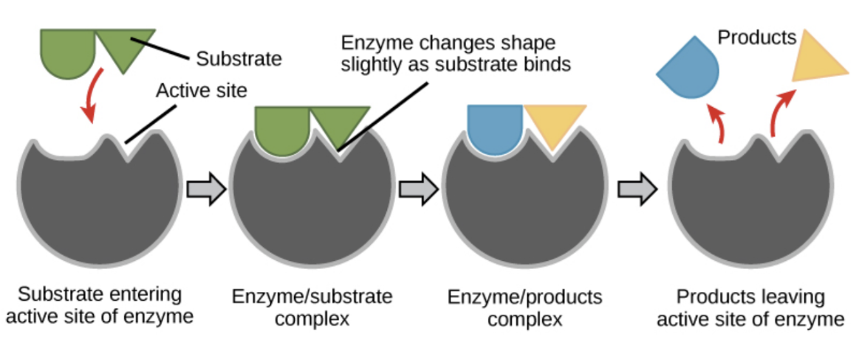
Figure 2: Enzyme structure showing active site, substrate, and products
https://openstax.org/books/biology-2e/pages/6-5-enzymes

The enzyme itself is then free to engage with another substrate. In this way enzymes are recycled and may undergo thousands of chemical conversions at relatively low concentrations within cells. If a substance binds to and blocks the active site, it will interfere with the activity and efficiency of the enzyme. These substances can bind irreversibly, shutting down the enzyme permanently, or reversibly, meaning they will dissociate under the appropriate environmental conditions. These substances are called inhibitors.
Enzymes often bind only to certain molecules or regions on larger molecules. This property, specificity, allows the thousands of different enzymes to perform differing functional roles. Sucrase, for instance, binds only to the disaccharide sucrose, while another, elastase, binds only to regions on a protein where certain non-polar amino acids are located. The concentration of the substrate will have an effect on the activity of the enzyme too. The structure of an enzyme can be affected by environmental conditions. pH, temperature, and the concentration of salt and other small molecules can affect the activity of an enzyme, either slowing or speeding its rate. Physical alteration can also denature a protein, meaning conditions have sufficiently altered the structure of the protein such that it can no longer function as an enzyme.
In lab today, we will explore the properties of enzymes. First, we will use a simple qualitative test to explore a variety of environmental conditions on enzymes. Then, we will apply what we learn to run a quantitative test for enzyme activity and design experiments to further study these environmental effects.

ACTIVITY 1: A QUALITATIVE STUDY OF CATALASE ACTIVITY

In this exercise, we will explore the activity of the enzyme catalase which occurs naturally in the cells of many plants, animals, fungi, and bacteria. Catalase accelerates the breakdown of hydrogen peroxide (H₂O₂), a common by-product of oxidative metabolism, into water and oxygen. This catalase-mediated reaction is extremely important to cells because it prevents the accumulation of hydrogen peroxide, a strong oxidizing agent that can be harmful as concentrations build up. Your instructor prepared an enzyme solution by cutting a potato into 8-10 pieces and putting them in a blender with 600 mL of cold dH₂O. The potato was
blended for about 30 seconds and then filtered through four layers of cheesecloth. The filtered solution was then placed on ice. This solution contains many cellular extracts from the potato; catalase is just one of the many enzymes in this solution.
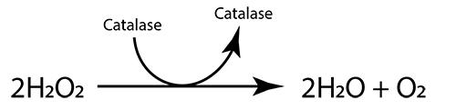
The basic catalase reaction:
You can tell if this reaction is occurring if you can see 0₂ gas (small bubbles) rise and collect as foam at the top of the solution in the test tube. You may need to wait a few minutes to see this and hold the test tube against a dark background.

PROCEDURE A: TESTING THE ACTIVITY OF CATALASE.

Please highlight all your answers with a yellow background or use a different color font that is easy to read.

1. Before you begin this experiment, look at the components for each test tube in Table 2 below and fill in columns 1 and 2.
2. Label your test tubes 1-4. Add the first component to each of the tubes.
3. Add 5.0 mL of H₂O₂ to tube 1 and observe carefully for 5 minutes. Record your results in column 3 in Table 2 below, before moving onto tubes 2, 3, and 4. Be sure to swirl your tubes to mix all the components together. Record your results for each tube initially and check them frequently over the next 5 minutes. Record any differences that you can see and briefly explain why you are seeing these results in column 3. Keep these tubes as reference while you move onto Procedure B.

Table 1. General catalase experimental tests performed by all groups of students.

Tube # | Contents | Column 1:  What is being tested here? | Column 2:  What do you think will happen? | Column 3:  What happened?  Why?
1 | 1mL H₂O + 5.0mL 3% H₂O₂
2 | ¼ x ¼” potato cube + 5.0mL 3%H₂O₂
3 | 1mL Enz. + 5.0mL 3%H₂O₂
4 | 1mL boiled* Enz. + 5.0mL 3% H₂O₂
*The boiled enzyme should be prepared by filling a test tube about 1/4 with the filtered catalase solution. Then place the tube in a beaker of boiling water on a hot plate for at least 5-10 minutes. Let the boiled tube cool in a test tube rack for 5 minutes before using.

PROCEDURE B: TESTING THE ACTIVITY OF CATALASE UNDER SIX DIFFERENT ENVIRONMENTAL CONDITIONS

Each group will now further explore an environmental condition that may affect enzyme activity. This factor will be pre-assigned, and all the materials you need will be at your table except for the different temperature areas, which can be found on the side counter. Besides temperature, we will also explore the effects of substrate
concentration, hydroxylamine, pH, copper sulfate, and salt concentration on enzyme activity.

GROUP I: EFFECTS OF SUBSTRATE CONCENTRATION ON CATALASE

How might changing the concentration of the substrate affect the activity of the enzyme and the overall reaction? Propose a plausible hypothesis before you perform the following experiment.
Hypothesis:

You will prepare and explore two additional substrate concentrations.
1. Before you set up these two tubes below, fill in columns 1 and 2 in Table 2.
2. Obtain two test tubes and label one A and the other B.
3. Add 1 mL of the enzyme to each of the tubes.
4. You will need to make the 1.5% and 0.75% solutions of the substrate by diluting the 3% H₂0₂
5. In a separate tube add 5 mL of 3% H₂0₂ + 5 mL of dH20 (deionized water). Label this tube "1.5% Sub."
6. In another tube add 2.5 mL of the 1.5% H₂0₂ (that you just made) to 2.5 mL of dH₂0 (deionized water). Label
this tube "0.75% Sub."
7. Add 5 mL of 1.5% H₂0₂ to tube A and 5.0 mL of 0.75% H₂0₂ to tube B.
8. Carefully observe these tubes for 3-5 minutes. Do the tubes look different in the first minutes from how they
look after minute 4-5? Why might this be?

9. Record what you see at 5 minutes and explain why in column 3 of Table 2.

Table 2. Effects of substrate concentration on catalase.

Tube # | Contents | Column 1:  What is being tested here? | Column 2:  What do you think will happen? | Column 3:  What happened?  Why?
A | 1mL Enz. + 5.0mL 1.5% H₂O₂
B | 1mL Enz. + 5.0mL 0.75% H₂O₂

10. How do these results compare to tubes 1-4 in Table 1?

11. What can you determine about the effects of substrate concentration on catalase activity and the overall reaction? Does this support your hypothesis? Explain why or why not.

12. As a group, take 5-10 minutes to discuss and search the Internet in order to understand the mechanics of substrate concentration in enzymatic reactions. Be prepared to present your experiment, results, and explanation to the class before leaving lab today.

GROUP II: EFFECTS OF HYDROXYLAMINE AND SUBSTRATE CONCENTRATION ON CATALASE

How might an inhibitor, like hydroxylamine, affect the activity of the enzyme and the overall reaction?
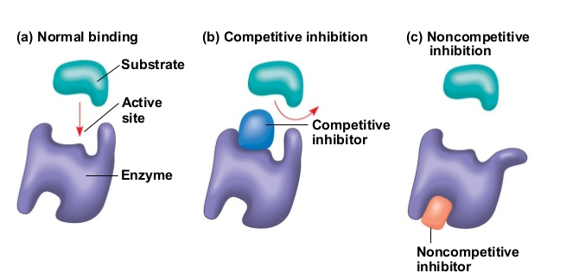

Figure 3: Types of enzyme inhibitors.
https://www.toppr.com/ask/question/write-briefly-about-enzyme-inhibitors/

Propose a plausible hypothesis before you perform the following experiment.
Hypothesis:

1. Before you set up these two tubes, fill in columns 1 and 2 in Table 3.
2. Obtain two test tubes and label one A and the other B.
3. Add 1 mL of the enzyme to each of the tubes.
4. Add 1 drop of the inhibitor (1 % hydroxylamine) to each tube A and B. Swirl the tubes to mix.
5. Add 5 mL of 3.0% H₂0₂ to tube A and 5 mL of 1.5% H₂0₂ to tube B. See step 5 in the Group I section to see
how to make the 1.5% solution.
6. Carefully observe these tubes for 3-5 minutes. Do the tubes look different in the first minutes from how they
look at minute 4-5? Why might this be?

7. Record what you see at 5 minutes and explain why in column 3 of Table 3.

Table 3. Effects of hydroxylamine with various substrate concentrations on catalase.

Tube # | Contents | Column 1:  What is being tested here? | Column 2:  What do you think will happen? | Column 3:  What happened?  Why?
A | 1mL Enz. + 1 drop inhibitor + 5.0mL 3% H₂O₂
B | 1mL Enz. + 1 drop inhibitor + 5.0mL 1.5% H₂O₂
8. How do these results compare to tubes 1-4 in Table 1?

9. How can you determine whether this is a competitive or non-competitive inhibitor?

10. What can you determine about the effects of an inhibitor on catalase activity and the overall reaction? Does
this support your hypothesis? Explain why or why not.

11. As a group, take 5-10 minutes to discuss and search the internet in order to understand the mechanics of
competitive and non-competitive inhibitors in enzymatic reactions. Be prepared to present your
experiment, results, and explanation to the class before leaving lab today.

GROUP III: EFFECTS OF SALT CONCENTRATION ON CATALASE

How might adding a salt solution affect the activity of the enzyme and the overall reaction? Propose a plausible hypothesis before you perform the following experiment.
Hypothesis:

1. Before you set up these two tubes, fill in columns 1 and 2 in Table 4.
2. Obtain two test tubes and label one A and the other B.
3. Add 1 mL of the enzyme to each of the tubes.
4. Add 2 drops of 5 M NaCl to tube A and 5 drops of 5 M NaCl to tube B. Swirl the tubes to mix.
5. Add 5 mL of the indicated substrate (3.0% H₂0₂ ) to each tube.
6. Carefully observe these tubes for 3-5 minutes. Do the tubes look different in the first minutes from how they
look at minute 4-5? Why might this be?

7. Record what you see at 5 minutes and explain why in column 3 of Table 4.

Table 4. Effects of increasing salt concentration on catalase.

Tube # | Contents | Column 1:  What is being tested here? | Column 2:  What do you think will happen? | Column 3:  What happened?  Why?
A | 1mL Enz. + 2 drops 5M NaCl + 5.0mL 3% H₂O₂
B | 1mL Enz. + 5 drops 5MNaCl + 5.0mL 3% H₂O₂

8. How do these results compare to tubes 1-4 in Table 1?

9. What can you determine about the effects of salt concentration on catalase activity and the overall reaction?
Does this support your hypothesis? Explain why or why not.

10. As a group, take 5-10 minutes to discuss and search the internet in order to understand the mechanics of added salt/ salinity in enzymatic reactions. Be prepared to present your experiment, results, and explanation to the class before leaving lab.

GROUP IV: EFFECTS OF THE METAL COPPER SULFATE (CuSO₄) ON CATALASE

How might adding a low concentration of a metal affect the activity of the enzyme and the overall reaction? Propose a plausible hypothesis before you perform the following experiment.
Hypothesis:

1. Before you set up these two tubes, fill in columns 1 and 2 in Table 5.
2. Obtain two test tubes and label one A and one B.
3. Add 1 mL of the enzyme to each of the tubes.
4. Add 2 drops of 1 % CuSO₄ to tube A and 5 drops of 1 % CuSO₄ to tube B. Swirl the tubes to mix.
5. Add 5 mL of the indicated substrate (3.0% H₂0₂) to each enzyme tube.
6. Carefully observe these tubes for 3-5 minutes. Do the tubes look different in the first minutes from how they
look at minute 4-5? Why might this be?

7. Record what you see at 5 minutes and explain why in column 3 of Table 5.

Table 5. Effects of copper sulfate on catalase.

Tube # | Contents | Column 1:  What is being tested here? | Column 2:  What do you think will happen? | Column 3:  What happened?  Why?
A | 1mL Enz. + 2 drops CuSO₄ + 5.0mL 3% H₂O₂
B | 1mL Enz. + 5 drops CuSO₄ + 5.0mL 3% H₂O₂

8. How do these results compare to tubes 1-4 in Table 1?

9. What can you determine about the effects of copper sulfate on catalase activity and the overall reaction?
Does this support your hypothesis? Explain why or why not.

10. As a group, take 5-10 minutes to discuss and search the internet in order to understand the mechanics of
added metals in enzymatic reactions. Be prepared to present your experiment, results, and explanation to
the class before leaving lab.

GROUP V: EFFECTS OF pH ON CATALASE

How might changing pH affect the activity of the enzyme and the overall reaction? Propose a plausible hypothesis before you perform the following experiment.
Hypothesis:

1. Before you set up these two tubes, fill in columns 1 and 2 in Table 6.
2. Obtain two test tubes and label one A, for acid, and the other B, for base.
3. Add 1 mL of the enzyme to each of the tubes. Use a small piece of the pH paper to test the pH of the enzyme
solution. Record the pH here: pH=__________
4. Wear green nitrile non-disposable gloves and safety glasses when using the 0.1 M HCl (hydrochloric acid) or
0.1 M NaOH. These solutions can burn your skin and eyes.
5. To tube A, add 2 drops of the 0.1 M HCI. Swirl the tube and determine the pH of the acidic enzyme solution.
You may need to use a small piece of aluminum foil to invert the tube, then touch the pH paper to the inside
of the tube. Record this in Table 6.
6. To tube B, add 2 drops of the 0.1 M NaOH (sodium hydroxide, a base). Swirl the tube and use pH paper to
determine the pH of the basic enzyme solution. Again, use a small piece of foil to invert the tube, then touch
the pH paper to the inside of the tube. Record this in Table 6.
7. Add 5 mL of the indicated substrate (3.0% H₂0₂) to each tube.
8. Carefully observe these tubes for 1-5 minutes. Do the tubes look different in the first minutes from how they
look at minute 4-5? If yes or no, why might this be?

9. Record what you see at 5 minutes and explain why in column 3 of Table 6.

Table 6. Effects of pH change on catalase.

Tube # | Contents | Column 1:  What is being tested here? | Column 2:  What do you think will happen? | Column 3:  What happened?  Why?
A | 1mL Enz. + 2 drops 0.1M HCl + 5.0mL 3% H₂O₂  pH=_____
B | 1mL Enz. + 2 drops 0.1M NaOH + 5.0mL 3% H₂O₂  pH=_____

10. How do these results compare to tubes 1-4 in Table 1?

11. What can you determine about the effects of pH on catalase activity and the overall reaction? Does this
support your hypothesis? Explain why or why not.

12. As a group, take 5-10 minutes to discuss and search the internet in order to understand the mechanics of pH
in enzymatic reactions. Be prepared to present your experiment, results, and explanation to the class before
leaving lab.

GROUP VI: EFFECTS OF TEMPERATURE ON CATALASE
How might changing temperature affect the activity of the enzyme and the overall reaction? Propose a plausible hypothesis before you perform the following experiment.
Hypothesis:

1. Before you set up these two tubes below, fill in columns 1 and 2 in Table 7.
2. Obtain two test tubes and label one "A Enz" and the other "B Enz."
3. Add 1 mL of the enzyme to each of the tubes.
4. Add 5 mL of the substrate (3.0 % H₂0₂) into two other tubes and label these "A Sub" and "B Sub."
5. Place both of the A tubes ("A Enz" and "A Sub" tubes) in your ice bucket in the ice deep enough to cover the
solution. Then place both B tubes in the 65°C water bath. Let these tubes equilibrate to their assigned
temperature for at least 5 minutes.
6. Record the temperature of the substrate left on ice for 5 minutes. Record this in the following chart.
7. For each temperature, add 5 mL of the indicated substrate (3.0% H₂0₂) to the same temperature enzyme
tube. Keep the reaction tubes at the assigned temperature. Why might this be important?

8. Carefully observe these tubes for 3-5 minutes. Do the tubes look different in the first 1-2 minutes from how
they look at minute 4-5? Why might this be?

9. Record what you see at 5 minutes and explain why in column 3 of Table 7.

10. Then bring your temperature tubes back to your own table. Do the results of either tube change after
another 10 minutes? Explain why this would or would not occur.

Table 7. Effects of temperature on catalase.

Tube # | Contents  (Both substrate and enzyme need to be at the same temperature) | Column 1:  What is being tested here? | Column 2:  What do you think will happen? | Column 3:  What happened?  Why?
A | 1mL Enz. On ice + 5.0mL 3% H₂O₂ – Temperature of H₂O₂ on ice =_____°C
B | 1mL Enz. At 65°C + 5.0mL 3% H₂O₂ – Temperature of H₂O₂ in water bath =_____°C

11. How do these results compare to tubes 1-4 in Table 1?

12. What can you determine about the effects of temperature on catalase activity and the overall reaction?
Does this support your hypothesis? Explain why or why not.

13. As a group, take 5-10 minutes to discuss and search the internet in order to understand the mechanics of
temperature in enzymatic reactions. Be prepared to present your experiment, results, and explanation to
the class before leaving lab.

DISCUSSION QUESTIONS AND NOTES FOR ALL GROUPS
PROCEDURES A AND B

1. Why are the tests conducted above considered qualitative tests?

2. What is the advantage of these sorts of tests? When would you want to use this method?

3. What is a limitation of this sort of test? When would you not want to use this method?

4. Though you only worked with one of the environmental treatments, be sure you understand what effects
were seen on enzyme activity with each and why. Each group will share their results and explanations in
Tables 3 through 8. Be sure to take notes below or in your lab notebook for each of these treatments.

Substrate concentration-

Inhibitor with different substrate concentrations-

Salt concentration-

Copper sulfate/metal-

pH-

Temperature-

ACTIVITY 2: A QUANTITATIVE STUDY OF CATALASE ACTIVITY

PROCEDURE C: USING A SPECTROPHOTOMETER TO MONITOR BASELINE CATALASE ACTIVITY

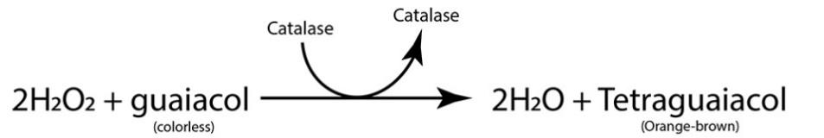
To measure enzyme activity, we could monitor the decrease in substrate or the amount of products formed. With clear solutions, we cannot discern between the H₂0₂ (substrate) or H₂0 + 0₂ (products) produced as the overall volume of solution in our test tubes stays the same. We can add an indicator (guaiacol) to this same reaction, which will bind with the oxygen produced to form tetraguaiacol. Tetraguaiacol is orange-brown in color. Guaiacol is quite sensitive and readily changes color with very small amounts of oxygen gas in the solution. As such, we will need to use a more dilute 0.1 % hydrogen peroxide solution, not the 3% we used in Procedures A and B. Otherwise the reaction would proceed too quickly to monitor the color change.

We will measure the rate of this reaction by using a spectrophotometer to quantify the change in color over time. As the solution gets darker, it will absorb more of the light shining through it in the spectrophotometer. The spectrophotometer is able to measure the slightest changes in color not apparent to the human eye. In this
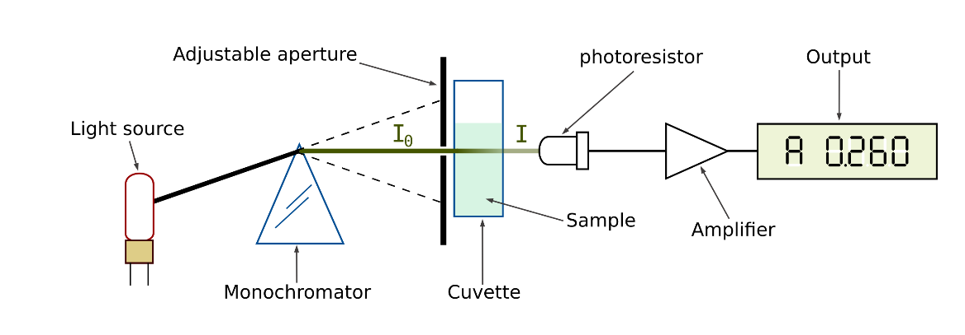
way, absorbance can be measured over time to monitor catalase activity of the main (baseline) reaction.
Figure 4: Single beam scanning spectrophotometer
https://en.wikipedia.org/wiki/Spectrophotometry

Your instructor will further refine the catalase solution used in Procedures A and B by additional filtering of the catalase solution through #4 filter paper. This will remove additional cellular debris from the catalase that may otherwise interfere with your absorbance readings.

1. Label two new test tubes B (blank) and 1. Label near the top of the tube.
2. Before you begin this experiment, look at the components of these tubes below. What role does each of
these play in the reaction?

Catalase:

dH₂O:

Guaiacol:

0.1% H₂O₂:

3. Be careful to use the 0.1 % H₂0₂ for this experiment, not the 3% you used in Procedures A and B earlier in
this lab.
4. Since we will be using a spectrophotometer to measure the change in color, we will need to make a blank to
use to compare the color change in our reacting tubes to a non-changing sample containing all the same
components, except the enzyme.

Blank= 6.0 mL dH₂0 + 100 μL guaiacol + 150 μL H₂0₂

5. Cover with foil and invert to mix.
6. Fill a cuvette with your blank solution to the fill line (approx. 3.5 mL; save the rest of your blank solution in
case you need it). Follow the directions at the spectrophotometer for setting up the blank inside the
spectrophotometer. You will be recording absorbance values at 470 nm. The spectrophotometer will
automatically measure the blank and then "subtract" it from the #1 cuvette.
7. Add the components of tube 1 listed in Table 8 in the order stated. Be sure to add the substrate (H₂0₂ ) last,
then quickly mix and pour the mixture into a new cuvette. Place this new cuvette in the spectrophotometer
cell labeled "1 ."
8. Quickly take your first reading in the spectrophotometer. Record your data as t=0 in Table 9. t=0 should be
recorded as soon as possible once everything is added to the test tube.

Why is it important to add the substrate last?

What is actually absorbing the light in your sample tube?

Why should you record the t=0 data soon after mixing together all the reaction components?

9. You can keep the cuvettes in the spectrophotometer while the reaction proceeds.
10. Measure the absorbance each minute for 5 minutes and record this in Table 9. Go ahead and graph your
data while you are collecting it. Attach this graph to this handout.
11. After 5 minutes, look again at the cuvettes and/ or test tubes of leftover solution. Record any differences
that you can see and briefly explain why you are seeing these results.

Table 8. Components for baseline catalase reaction measurements.

Tube # | Tube Contents | How will this tube change over time?
Blank | 6.0mL dH₂O + 100µL guaiacol + 150µL H₂O₂
1 | 1.0mL catalase + 5.0mL dH₂O + 100µL guaiacol + 150µL H₂O₂

Table 9. Absorbance data collection for baseline catalase activity-week 1.

Time, in Minutes | 0 | 1 | 2 | 3 | 4 | 5
Absorbance at 470nm

Exploring Properties of Enzymes – Week 2

Please highlight all your answers with a yellow background or use a different color font that is easy to read.

PROCEDURE D: USING A SPECTROPHOTOMETER TO MONITOR THE ACTIVITY OF CATALASE UNDER SIX DIFFERENT ENVIRONMENTAL FACTORS

Each group will again explore an assigned environmental factor that affects catalase activity. Each group will design their own experiment given the materials at their table or side counter. Use the baseline procedure in Procedure C to alter your assigned environmental condition in three or four different ways that will demonstrate
a range of responses of that condition on catalase.
Be sure to write down detailed notes on how you alter and measure these 3-4 additional conditions. A few "notes and hints" are included at the end of Procedure D for each assigned environmental condition. You should consider these comments before you design your experiment. Write down your hypotheses, materials and methods, and get the OK from your instructor before proceeding.
Is it important to collect a new baseline this week? Explain why or why not in your experimental design below. If you do collect new baseline data, record that below in Table 10.

Table 10. Absorbance data collection for baseline catalase activity-week 2 (if needed).

Time, in Minutes | 0 | 1 | 2 | 3 | 4 | 5
Absorbance at 470nm

EXPERIMENTAL PLAN/NOTES

Hypotheses:

Materials and methods:

Treatment cuvette(s): indicate contents and reasons for this

Blank(s): indicate contents and reasons for this

Other notes on collecting data and/ or on the treatments themselves:

Observations, Data Table(s), Results, and Graphs:

1. What can you conclude from your data?

2. What are two things that could/ should be explored further if you had more time and resources? Be specific in your answer.

NOTES AND HINTS ON ASSIGNED ENVIRONMENTAL CONDITIONS

ALL GROUPS:
When treating your enzyme tube, first add the enzyme, then the treatment and let sit for at least 1 minute before you proceed with adding any other solutions. Then add the dH₂O to dilute the treated enzyme solution.

GROUP I: EFFECTS OF SUBSTRATE CONCENTRATION ON CATALASE
Make two additional substrate concentrations to alter the baseline reaction. Do you need to make a new blank from what was used in Procedure C?

GROUP II: EFFECTS OF AN INHIBITOR AND SUBSTRATE CONCENTRATION ON CATALASE
Remember to first add the inhibitor to the enzyme before proceeding with the reaction. You will also need to make at least one additional substrate concentration besides the substrate used in your baseline. Do you need to make a new blank from what was used in Procedure C?

GROUP III: EFFECTS OF SALT CONCENTRATION ON CATALASE
Alter the amount of added salt solution twice from the baseline reaction. Do you need to make a new blank from what was used in Procedure C?

GROUP IV: EFFECTS OF THE METAL COPPER SULFATE (CuSO4) ON CATALASE
You will need to include the same amount of CuSO₄ in your blank as you use in your treatment cuvettes. Do you need to make a new blank from what was used in Procedure C?

GROUP V: EFFECTS OF pH ON CATALASE
Select two additional pH treatments for the enzyme to alter the basic reaction. You will need to use the provided buffered red solutions to change the pH of the enzyme when using such a dilute substrate. You will do this by replacing the 5 mL dH₂O added with 5 mL of the buffered pH solution. Do you need to make a new blank from what was used in Procedure C?

GROUP VI: EFFECTS OF TEMPERATURE ON CATALASE
Remember to get the 6. 0 mL dH₂O set to your desired temperature for at least 30 minutes prior to adding it to your tube contents. Your instructor may have already set this up for you. Ideally, the enzyme (1.0 mL) and substrate (100 µL) should also be at this temperature, but their volumes are comparably minimal that you can use what you already have at your table. It may not be feasible to check the absorbance each minute. (Why ?) Propose a new timeline for data collection with your instructor for approval. Also be sure to wipe the cuvette surf aces with a Kimwipe to remove any fog or condensation on the outside of the cuvettes related to the change in temperature. Do you need to make a new blank from what was used in Procedure C?

DISCUSSION QUESTIONS
PROCEDURES C AND D

1. Why are the tests conducted in Procedure C considered quantitative tests?

2. What is the advantage of these sorts of tests? When would you want to use this method?

3. What is a limitation of this sort of test? When would you not want to use this method?

4. How did your treatment of catalase impact the reaction compared to your baseline reaction?
Your treatment = _____________________

5. How did your results from Procedure D compare to the results from Procedure B (qualitative test with this treatment)? Explain why.

ACKNOWLEDGEMENTS
NCSU, Biological Sciences, 2016. BIO 183 Introductory Biology II Laboratory Manual, Hayden-McNeil Publishing: Plymouth, MI
The College Board, 2012. AP Biology Investigative Labs: An Inquiry-Based Approach Student Manual, The College Board, New York, NY

