Pigments and Photosynthesis
LEARNING OBJECTIVES
1. Apply the procedure of paper chromatography in the separation of the photosynthetic pigments of plants and relate the pigments to their photosynthetic ability.
2. Discuss how experimentation with the Hill reaction provides evidence of the operation of the light reactions.
3. Design and implement an experimental procedure to determine factors that affect the rate of photosynthesis in an organism.
4. Analyze and interpret experimental data from the Hill reaction.

INTRODUCTION
Photosynthesis is the process by which light energy is converted to chemical bond energy. Autotrophic organisms are responsible for primary production, and photosynthesis is the process by which such production is affected. In terrestrial communities, plants are the most significant photosynthetic organisms. In aquatic communities, phytoplankton contribute the most to primary production.
Photosynthesis comprises numerous vital and complex reactions that take place in the cells of organisms capable of carrying out this process. The process can be summarized with this chemical equation:

6 CO₂ + 12H₂O + Light Energy C₆H₁₂O₆ + 6O₂ + 6H₂O

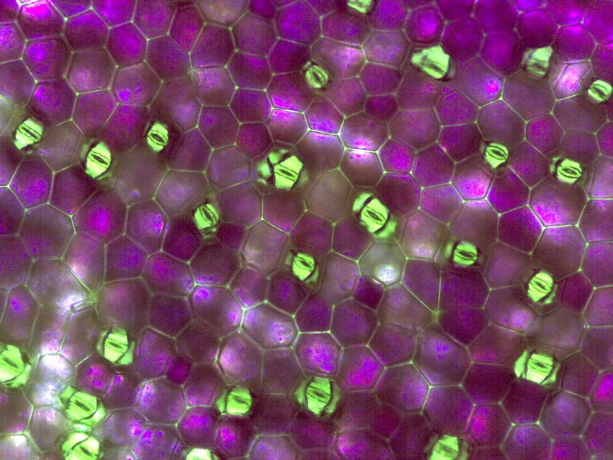
The stomata (small openings in the epidermis of the plant) allow CO₂ and H₂0 to leave the plant and 0₂ to enter the plant. Guard cells surround the stomata and control the opening and closing of the stomata. When guard cells take on water, they pull apart and allow gas exchange to occur and water vapor to escape. See Figure 6.

Figure 6. Guard cells (purple) surrounding stomata (green)

CELLULAR STRUCTURES
Before considering the molecules that are involved in the photosynthetic reactions, let's examine the cellular structures in which these molecules are contained. Most photosynthetic organisms are eukaryotic, and the photosynthetic reactions take place in cytoplasmic organelles known as chloroplasts. Although photosynthetic
eukaryotes such as plants and algae are more common, photosynthetic bacteria are also abundant. Since bacteria are prokaryotic, their cells do not contain organelles, but they do have membrane layers organized into thylakoids that perform functions analogous to chloroplasts.

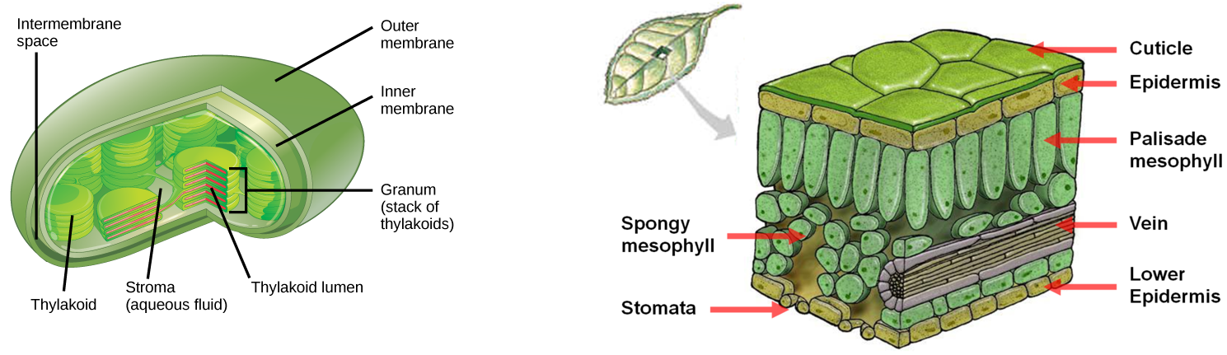
The chloroplast houses the photosynthetic process in eukaryotic cells. In each chloroplast, a double membrane surrounds a fluid-filled compartment known as the stroma. Enzymes, electron carriers, and numerous other molecules essential to photosynthesis are dissolved in this fluid. Also within the stroma are abundant thylakoids. Each thylakoid is a tiny membranous vesicle containing photosynthetic pigments and electron carriers. These thylakoids are organized in stacks known as grana (singular = granum). Different photosynthetic reactions take place in the grana and the stroma. See Figure 7.

Figure 7. Leaf cross section and chloroplast.
https://en.wikipedia.org/wiki/Chloroplast#/media/File:Figure_08_01_05.png
https://www.pathwayz.org/Tree/Plain/CROSS+SECTION+OF+A+LEAF+%5BBASIC%5D

PHOTOSYNTHETIC REACTIONS
The total process of photosynthesis comprises two major series of reactions. These two series are known as the light reactions and the dark reactions (or light-independent reactions). This terminology emphasizes the form of energy required to drive these different reactions. The light reactions require light energy in order to take
place. The dark reactions can and do take place in the dark-but they also take place in the light. "Dark" is used to emphasize that these reactions do not require light energy in order to take place-but they also take place in the light. They do require specific forms of chemical energy that are produced in the light reactions. Accordingly, the light reactions must begin and produce this appropriate chemical energy before the dark reactions will take place.

LIGHT REACTIONS AND PHOTOSYNTHETIC PIGMENTS
The light reactions take place in the membranes of chloroplast thylakoids. These reactions are possible because the embedded pigment molecules absorb the energy of sunlight. Each pigment is capable of absorbing specific wavelengths of light energy in the visible spectrum.

Photosynthetic pigments are classified functionally as primary and accessory. The primary pigment is that molecule that is capable of giving up an excited electron such that light energy is converted to chemical bond energy. In eukaryotes and some bacteria, the single primary pigment is a type of chlorophyll designated as
chlorophyll a. In other groups of photosynthetic bacteria, the primary pigment is a bacteriochlorophyll that performs a similar function. When these pigment molecules absorb sufficient energy of the appropriate wavelengths, they release high energy electrons that drive the light reactions.
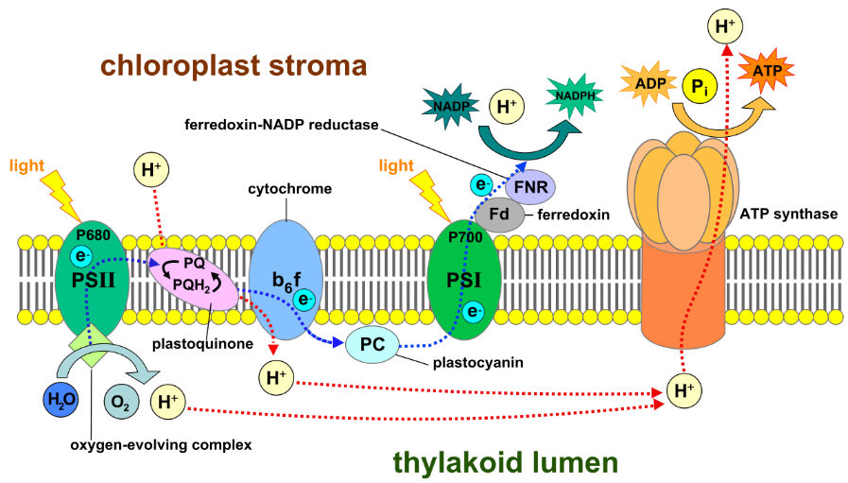
There are several accessory pigments in both eukaryotic and prokaryotic cells. Whereas chlorophyll a is a green pigment, the accessory pigments may also be green (chlorophyll b), or they may appear blue-green, yellow, orange, or brown. The familiar yellow and orange of hues autumn foliage are produced by those accessory pigments known as carotenoids. These pigments absorb wavelengths other than those absorbed by chlorophyll a, and thus increase the organism's total capacity for light absorption. You should be able to identify these pigments in the chromatogram you will he doing today. Through a process known as electron resonance, accessory pigments transfer their absorbed energy to the primary pigment. This transferred energy excites the primary pigment (chlorophyll a), which then gives up a high energy electron. By both direct absorption of light and transferred energy, the chlorophyll a is capable of driving the light reactions. As the light reactions take place in the thylakoids of the chloroplast, they produce chemical energy in the forms of NADPH and ATP that drive the dark reactions in the stroma. See a summary of the light reactions below (Figure 8).
Figure 8. Light reactions.
https://en.wikipedia.org/wiki/Light-dependent_reactions

DARK REACTIONS AND FORMATION OF GLUCOSE
These dark reactions are commonly called the Calvin cycle. This name refers to the physiologist Melvin Calvin, who first described these reactions in the 1940s and 1950s. The function of the Calvin cycle is to produce glucose, the carbohydrate that incorporates energy initially harvested from sunlight. The glucose molecules will
be used in many ways in the cells. For example, glucose is the starting point for the synthesis of numerous other sugars that are involved in metabolism. Hundreds of glucose molecules may be bonded to one another to form carbohydrate polymers, such as starch, that serve as energy storage. Other polymers of glucose, such as
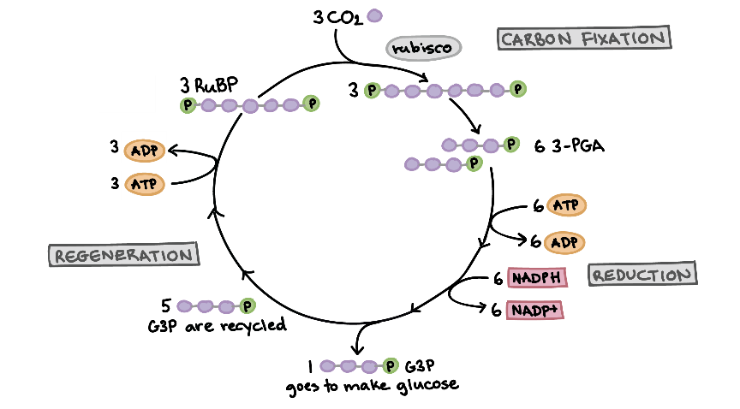
cellulose, are major structural molecules in cells. For every 6 CO₂ molecules used to create a carbohydrate in the Calvin cycle, 18 ATP and 12 NADPH molecules are needed from the light reactions. See Figure 9.

Figure 9. Calvin cycle.
https://www.khanacademy.org/science/biology/photosynthesis-in-plants/the-calvin-cycle-reactions/a/calvin-cycle

Please highlight all your answers with a yellow background or use a different color font that is easy to read.

ACTIVITY 1: PAPER CHROMATOGRAPHY
Chromatography is a procedure for separating dissolved substances from one another. A solution is made up of a solvent and one or more solutes. In plants, the solvent is water, and there are many kinds of solutes, such as sugars, mineral ions, amino acids, and pigments. We will use chromatography to separate different plant
pigments. In chromatography, the solutes are separated from one another according to both their solubility ( or lack of solubility) in different liquids and their adsorption to an inert material.

As the name suggests, paper (cellulose) is the inert adsorbent used in paper chromatography. The solution is applied as a narrow band approximately 2 cm from the lower edge of the strip or sheet of paper. This is identified as the origin of the chromatogram. The chromatographic paper is placed in a glass chromatography
jar. This jar contains the solvent system that will be used to separate the solutes in the applied solution. The origin should be above the surface of the solvent, or it will dissolve into the solvent in the bottom of the jar. The jar is sealed to maintain an internal atmosphere that is saturated with solvent molecules.

The solvent immediately begins to move up the paper. The solvent front can be observed as a wet boundary on the paper. As the solvent front passes through the origin, some of the pigment solutes will be dissolved in this moving solvent system. Depending upon both the degree of solubility of the solute in this solvent and the
affinity of the solute for cellulose, the solute will be carried upward a certain distance on the paper. If several solutes in the unknown solution have different affinities and solubilities, then they will be deposited at different sites on the paper. In this manner, it is possible to separate these unidentified solutes from one another.
The chloroplasts of most plants contain several different photosynthetic pigments, one primary pigment (chlorophyll a) and several accessory pigments (varies according to species). The purpose of the following activity will be to use paper chromatography to separate and identify the photosynthetic pigments contained within the chloroplasts of a magnolia leaf.

Caution: The 9 ether : 1 acetone solvent used in this procedure is flammable and quite noxious. The chromatography jars should be kept on the side counter or in a fume hood at all times. Do not move the jars. Used solvent should remain in the chromatography jars or properly collected in a waste jar by the lab instructor.

PROCEDURE
1. Obtain a sheet of chromatography paper. Hold the paper by its edges so that dirt and oil from your fingers will not get on the paper. Fold the paper lengthwise to form a crease in the paper. This will help reinforce the rigidity of the paper.
2. Obtain a fresh magnolia leaf from the side counter.
3. Place the leaf bottom-side down on the chromatography paper.
4. Place a ruler parallel to the bottom of the chromatography paper on top of the magnolia leaf. One side of the ruler should run parallel 2 cm above the bottom of the paper.
5. Using the edge of a coin or the tip of blunt forceps, rub 2-3 smooth, continuous lines across the leaf such that it leaves a solid green mark on the paper underneath. Press firmly but not too hard-you do not want to tear the leaf. The pigment line must be above the solvent level in the chromatography chamber.
6. Prepare a chromatography chamber with enough 9:1 ether:acetone solvent to completely cover the bottom of the chamber by about 1 cm. This step may have been done for you.
7. Place the pigmented chromatogram into the chamber and close the lid of the chamber. The origin must not be submerged in the solvent. Consult the lab instructor if the solvent level is not correct. Do not move the chamber once the paper is in place.
8. Allow the chromatogram to develop long enough for the solvent front to come within 2-3 cm of the top of the paper.
9. Remove the chromatogram from the chamber and allow it to air dry near an open window or in a fume hood. Replace the lid on the chromatography jar.
10. Once dry, turn off the room lights and shine the UV lamp on your chromatogram.
11. Do not dispose of the solvent in the jar. It should be reused by the next laboratory section.
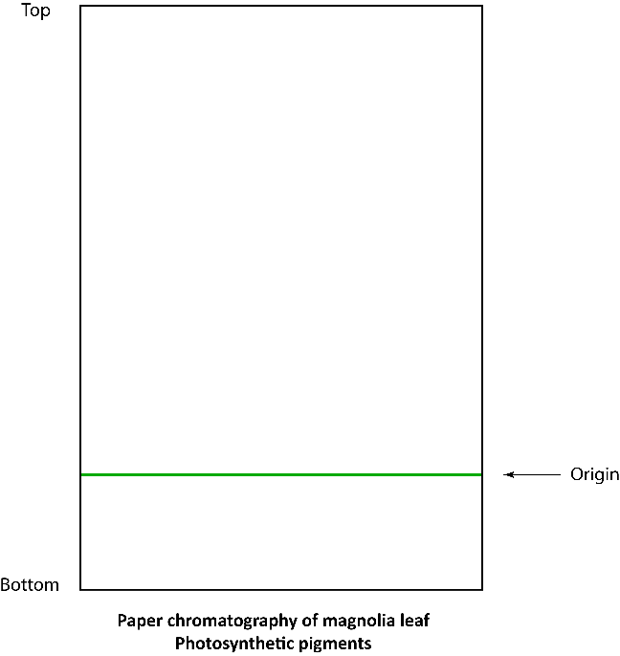
12. Draw your chromatogram results in the following diagram and identify each of the separated pigments.

ACTIVITY 2: LIGHT REACTION MEASUREMENTS
THE HILL REACTION
In 1937, the English biochemist Robert Hill demonstrated that when isolated chloroplasts were illuminated, artificial electron acceptors were chemically reduced. As recognition of his pioneering work, this use of isolated chloroplasts continues to be designated as the Hill reaction. In these oxidation-reduction reactions, oxygen gas
(0₂) also was produced. Hill's work was significant in providing the initial description of the light reactions of photosynthesis. Experiments based on this earlier work are useful in developing an understanding of the light reactions of photosynthesis.

In our experiment, we will isolate chloroplasts from spinach leaves such that we may use these organelles in our study of the Hill reaction. After we have isolated the chloroplasts, we will carefully break open these organelles in order to expose the internal thylakoids. When we illuminate these exposed thylakoids, the chlorophyll a molecules will release excited electrons. By using an artificial electron acceptor, dichlorophenol indole phenol (DPIP), we will be able to detect the activity of the light reactions. DPIP intercepts electrons before they are transferred to natural electron carriers in the thylakoid membranes. As the blue DPIP accepts electrons, it is
reduced chemically to a colorless form. By monitoring this color change under varying experimental conditions, we can study the effects of light quality on the rate of photosynthesis. You will be measuring transmittance, which will increase over time if photosynthesis is occurring. The faster the DPIP changes from blue to colorless,
the steeper your upward slope will be.

PROCEDURE
1. Expose the spinach to light (light prime) for 15-30 minutes. Leave the spinach in a plastic bag. Place the bag of spinach in the light of a lamp behind a heat sink. The spinach must look fresh. Limp spinach will not undergo photosynthesis.
2. Loosely fill the blender with the light-primed spinach until it is about ¾ full. Pour 0.5 M cold sucrose into the blender cup until the blender cup is about ½ full with liquid.
3. Blend the spinach with three short bursts of 10 seconds each.
4. Pour the blended mixture through a double layer of cheesecloth into a large beaker.
5. Fill two screw-top test tubes with the filtered suspension. Cover two of the tubes with foil and label "Thylakoids." Place these on ice.

These first five steps may have already been performed for you so that the sampl.es are ready to be used when you come into lab.

6. Refer to Table 1 below to prepare the blank and light treatment. Use a separate glass test tube for each of them. Do NOT add the thylakoid preparation to any tube until immediately before that tube is to be used in step 8.

Table 1.

Solutions | Blank | Light
Phosphate buffer | 1.0 mL | 1.0 mL
dH₂O | 3.0 mL | 3.0 mL
0.1% DPIP |  | 1.0 mL
Light | White** | White**
Thylakoids | 150 µL | 150 µL

**White light = sunlight or light from a provided lamp. White light includes all the wavelengths of the visible spectrum.

7. Obtain a cuvette for the blank and pour the contents of your blank tube to the cuvette fill line.
8. Place the blank in the spectrophotometer in the holder space labeled "B." The spectrophotometer should already be warmed up and set to 605 nm for you.
9. Take tube 1 and add the 150 μL of thylakoids. Gently swirl the tube to mix. Pour enough of the test tube contents into the cuvette to reach the fill line. Then place the cuvette into the appropriate sample cell in the spectrophotometer.
10. Immediately take the transmittance reading, following the directions at the spectrophotometer. You will keep using this cuvette and the blank for the entire seven minutes of the run. Remember to orient the cuvette in the same direction each time so that differences in the cuvette will not affect the readings.
11. Remove the sample cuvette from the spectrophotometer and stand it a distance of 12 inches in front of the appropriate light source (not the heat sink) for 30 seconds. There should be a heat sink between the cuvette and the light source.
12. Following the 30-second exposure to the light, place a small square of foil or Parafilm over the opening of the cuvette and invert the cuvette to mix the contents. Using a Kimwipe, clean the cuvette and then place it back in the spectrophotometer. Record the % transmittance reading in Table 2.
13. Repeat steps 10-12 for seven minutes for the sample cuvette.

List three factors that could possibly affect photosynthesis rate.
1.

2.

3.

NOW DESIGN YOUR OWN EXPERIMENT
Use the space below to write up your experimental question (hypothesis and prediction) and mini protocol. Your TA will let you know what types of treatments are available. You will need to run two additional experiments with two different variables. Before beginning your experiment, your group will need to get your TA's approval. Be prepared to explain why you chose these treatments. What is the main idea your experiment is testing and what do you expect your results to be?

Hypothesis:

Experimental Design:

14. Working with one sample/cuvette at a time, perform steps 7-12 for your two treatments. Remember to add the thylakoids just before you start a new treatment.
Do not dispose of the samples in your cuvettes until the end of the experiment.
Do the samples in each cuvette look different from when you started the experiment?

Do the samples in the cuvettes from different treatments look different from each other?

Explain why or why not for each sample. What specifically was causing this? And explain why or why not when you are comparing your two treatments.

15. Prepare a single graph that presents the results for all of the experimental treatments. Include trendlines and equations for each line on your graph specifying the slope.
16. Be prepared to report your results to the rest of the class and explain why you think you got those results.

Table 2. Transmittance readings for Hill reaction experiment. Write your specific treatments into the table.
White light |  | Treatment 1: |  | Treatment 2:
Time (sec) | Trans (%) | Time (sec) | Trans (%) | Time (sec) | Trans (%)
0 |  | 0 |  | 0
30 |  | 30 |  | 30
60 |  | 60 |  | 60
90 |  | 90 |  | 90
120 |  | 120 |  | 120
150 |  | 150 |  | 150
180 |  | 180 |  | 180
210 |  | 210 |  | 210
240 |  | 240 |  | 240
270 |  | 270 |  | 270
300 |  | 300 |  | 300
330 |  | 330 |  | 330
360 |  | 360 |  | 360
390 |  | 390 |  | 390
420 |  | 420 |  | 420

You will need to include this graph and data in your lab handout. You may also need this information to complete an assignment associated with this lab unit.

DISCUSSION QUESTIONS
1. One of the pigments in your chromatogram should fluoresce. Which pigment would this be? Why do we see fluorescence with the UV light?

2. How did the Hill reaction provide evidence for the light reaction processes?

3. Based on your graph, which treatment was most effective at driving photosynthesis? What would account for the differences in your three treatments? Were there any surprising results and can you explain them?

White Light:

Treatment 1:

Treatment 2:

ACKNOWLEDGEMENTS
Labquest Manual, Vernier http:/ /www2.vernier.com/manuals/labquest2_user_manual.pdf
NCSU, Biological Sciences, 2016. BIO 183 Introductory Biology II Laboratory

