BIO 183L – Take-Home Assignment 1 (10 points)
Experimental design

When scientists run experiments, the analysis of the data collected determines the success or failure of the experiment, so at first glance, it appears that data collection and proper statistical analysis are the most crucial part of the experimental process. However, we need to remember that without a carefully planned experimental design, useable data could not be collected and a correct analysis could not be performed. Hence, the design of an experiment is arguably the most important part of the research process.

In order to illustrate the importance of experimental design, let’s consider the following scenario:
A group of 4 BIO183 students decides to test the effect of human growth hormones (hGH) on the rate of cell division. The students’ hypothesis is that the presence of hGH would increase the rate of mitosis. In order to test their hypothesis the students collected skin, liver and muscle biopsies from a male mouse that was given to them. They then dissociated the cells from the various tissues through a commonly-used gentle cell dissociation process, and seeded 20 cells/well in a 96-well plate. The cells were then covered with growth medium and placed in an incubator.
A 96-well plate looks like this:
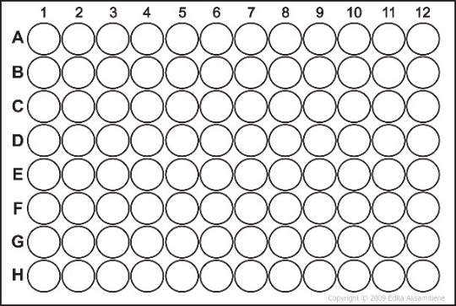
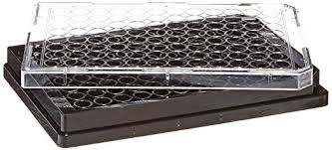

In their experiment, the students seeded columns 1-4 with skin cells, columns 5-8 with liver cells, and columns 9-12 with muscle cells. All wells were supplemented with 0.1ng/mL hGH, and the cells were allowed to grow for a week. Each day of the week during which the experiment was run, the students counted the number of skin, liver, and muscle cells present in the various wells, and at the end of the week, they generated the following graph:

Q. 1: From this graph, what can be said about the effect of hGH on murine cell proliferation?

Q. 2: Can you think of ways in which this experimental design could be improved?

After discussing their project with the rest of the class, it became clear to our students that they needed to incorporate a control group in their experiment. In order to achieve this, the students repeated their experiment by giving hGH to only half of their cells. Their 96-well dish now looked like the following:
Columns 1-2: 20 skin cells + culture medium only
Columns 3-4: 20 skin cells + culture medium + 0.1ng/mL hGH
Columns 5-6: 20 liver cells + culture medium only
Columns 7-8: 20 liver cells + culture medium + 0.1ng/mL hGH
Columns 9-10: 20 muscle cells + culture medium only
Columns 11-12: 20 muscle cells + culture medium + 0.1ng/mL hGH

At the end of the week, the following graph was generated:

The students were now able to determine that hGH does appear to enhance mouse skin, liver, and muscle cell proliferation.
Q. 3: From this new experiment, what can be said about the effect of hGH on murine cell proliferation?

Q. 4: What is still needed to improve the quality of this experiment?

Q. 5: Did the students have true replicates for each group of cells (skin/liver/muscle)? Explain…

After reflection, it became clear to these students that collecting cells from one single male mouse could not be sufficient to represent the whole murine population. In order to fix this issue, the students decided to collect samples from 5 males and 5 females. All the male samples were collected in yellow tubes, and all the female samples were collected in green tubes. All tubes were given to one member of the group who plated all male cells on the left side of the plate (columns 1-6), and all the female cells on the right part of the plate (columns 7-12).
Q. 6: Can you think of anything wrong with this approach? How would you improve the quality of this design?

In a final attempt to make their experiment scientifically sound, the students decided to repeat the last experiment while having one person collecting the samples in clear tubes and assigning them a random number (while keeping a record of which number was assigned to which sample), while another member of the group seeded the cells randomly in the plate. Each cell sample was split in 2 wells, with one well receiving hGH, and the other well receiving culture medium only. At this point, the students were confident that their project was bullet-proof, but after a few days, our students realized that all the cell in the periphery of the plate were growing slower the cells that had been plated in the center of the plate. Apparently, the evaporation of the medium was stronger in the outer wells of the plate, and this was stressing the cells plated in these well. After a little literature research, our students found out that this problem was well-known to the scientific community, and called an “edge effect.”
Q. 7: How would you suggest to design this experiment in order to avoid this edge effect?

What did we learn from this? For the bean beetle project that you will perform throughout this semester, you will have to carefully design your experiment in order to ensure that you can obtain meaningful data that can be analyzed and interpreted.
Q. 8: From what you learned in this assignment, what are 4 important components of a good experimental design that you need to follow in order to be able to collect meaningful data later in the semester?

①

②

③

④

