Laboratory I (Summer)

LEARNING OBJECTIVES
1. Design and implement an experiment using appropriate controls, duplicates, and measurable variables.
2. Collect data and maintain a lab notebook.
3. Communicate experimental protocol, results, and interpretation in oral and written form.

Please highlight all your answers with a yellow background or use a different color font that is easy to read.

ACTIVITY 1: EXPERIMENTAL DESIGN REVIEW

1. For the following scenario, put the correct response in the blanks provided.

A. Independent Variable B. Controlled Variable or Constant C. Experimental Group
D. Dependent Variable E. Control Group

The Northwood High School Biology class conducted an experiment to determine the effects of Brand X plant fertilizer on grass growth. Two plots of grass located in the same yard were used. Both plots received 10 hours of sunlight per day, one inch of water per week, and were maintained at 28° C
for a period of 30 days. Once every seven days, plot A received 3 grams of Brand X fertilizer dissolved in that day's water supply. Plot B did not receive any fertilizer throughout the experiment.

_____Plot B _____Plot A _____Amount of sunlight received

_____Grass growth _____Brand X fertilizer

2. For the following scenario, write the correct parameter next to the correct identifying term.

Scientists observed that white mice that were fed seeds appeared to grow more than mice fed their regular diet of leafy green and yellow vegetables. The scientists hypothesized that the protein in the seed was responsible for the growth. They designed an experiment to test this hypothesis. They divided 200 mice of the same age, size, health, and sex into two groups of 100 mice each. The mice were kept under identical conditions for 90 days. One group was given the normal low-protein diet of vegetables. The other group was given the new high protein diet of seeds. The mass of each mouse was recorded weekly for 90 days.
Independent Variable: _______________________________
Dependent variable: _______________________________
Controlled Variable or Constant: _______________________________
Control Group: _______________________________
Experimental Group: _______________________________
In the above scenario, are they collecting qualitative or quantitative data? _______________________________
Give an example of each type of data that is or could be collected from this experiment:
Qualitative: _______________________________
Quantitative: _______________________________
ACTIVITY 2: NATAL BEAN DISCRIMINATION BY BEAN BEETLES

During a regular semester, BIO183 students conduct a semester-long experiment, using bean beetles as a model organism. Unfortunately, we will not have the time to conduct such a long experiment this semester, but we can at least re-use some of the valuable aspects of designing an experiment and data collection of the bean beetle project by carrying out a quicker bacterial study. In this activity, you will set up and carry out a quick experiment with bean beetles. You’ll then graph and interpret data related to bean beetle behavior and reflect upon the experiment overall.

INTRODUCTORY INFORMATION ABOUT BEAN BEETLES:
Bean beetles (cowpea seed beetles), Callosobruchus maculatus, are agricultural pest insects of Africa and Asia. Females lay their eggs on the surface of beans (Family Fabaceae). Eggs are deposited (= oviposition) singly and several days after oviposition, a beetle larva (maggot) burrows into the bean. At 30°C, pupation and emergence
of an adult beetle occurs 21-30 days after an egg was deposited. Adults are mature 24-36 hours after emergence and they do not need to feed. Adults may live for 1-2 weeks during which time mating and oviposition occur. Since larvae cannot move from the bean on which an egg was deposited, the oviposition choice of a female determines the future food resources available to their offspring (Brown and Downhower 1988). As a result, it is the most critical choice a female makes for her offspring, because it will influence their growth, survival, and future reproduction (Mitchell 1975; Wasserman and Futuyma 1981). Although females can be induced to lay eggs (oviposit) on a wide range of bean species, very few bean species result in normal development and the successful emergence of adults. Some bean species have been shown to be toxic to Callosobruchus maculatus larvae (Janzen et al. 1977).
Additional information can be found at the following link (also on the laboratory website):
https://www.beanbeetles.org/handbook/#Introduction

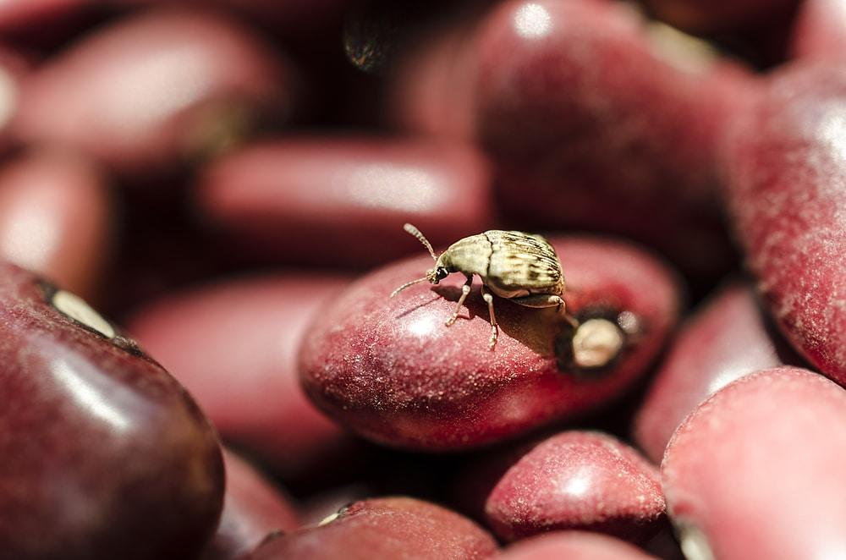

Figure 1. Bean Beetle eating mung bean

FEMALE BEAN BEETLE PREFERENCE
In this activity, students will perform a set of experiments to evaluate whether female bean beetles that were raised on Mung beans discriminate between two suitable species of beans. The term natal bean refers to the beans from which the beet beetle emerged.

Read the set of instructions below and write down a hypothesis stating whether or not you expect female bean beetles to discriminate between mung beans and adzuki beans.

Hypothesis:

Rationale supporting your hypothesis:

MATERIALS
Female bean beetles
Mung and adzuki beans
Paintbrush and blunt end tweezers for maneuvering beetles
Culture plates divided into three compartments (see picture below)

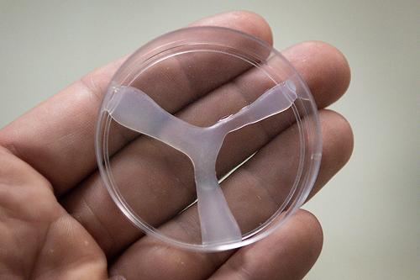

Figure 2. Culture plate divided into three compartments

METHODS
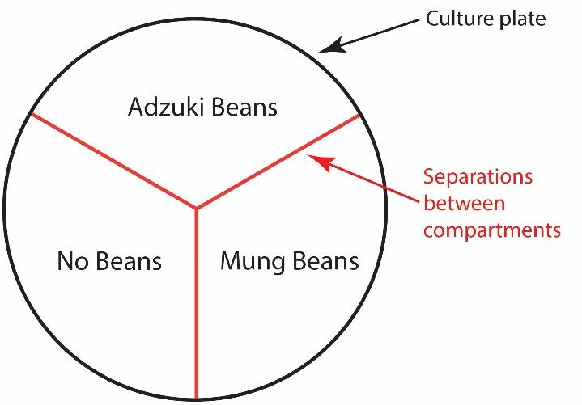
1. Place 10-20 adzuki beans in one compartment of your culture plate. Place 10-20 mung beans in a different compartment. Leave the third compartment empty.

2. Place a female bean beetle in the center of the dish. At the end of one minute record where the female was (which compartment).
3. Gently push the beetle back to the center with your paintbrush or pick the beetle up with your tweezers and place it in the center. Be careful not to injure your beetle.
4. Repeat steps 2 and 3 every minute for 15 minutes.
5. Fill out your data sheet and repeat the experiment.

DATA SHEET
Record your experimental data below:

Natal Bean: ____________________

Location at:
Attempt 1 |  | Attempt 2
1 minute |  | 1 minute
2 minutes |  | 2 minutes
3 minutes |  | 3 minutes
4 minutes |  | 4 minutes
5 minutes |  | 5 minutes
6 minutes |  | 6 minutes
7 minutes |  | 7 minutes
8 minutes |  | 8 minutes
9 minutes |  | 9 minutes
10 minutes |  | 10 minutes
11 minutes |  | 11 minutes
12 minutes |  | 12 minutes
13 minutes |  | 13 minutes
14 minutes |  | 14 minutes
15 minutes |  | 15 minutes

BEAN BEETLE DATA ANALYSIS

Mung Adzuki Empty
Random Expected Locations: 10 10 10

Actual Observed Locations: ______ ______ ______

1. Working in pairs, Graph the results from your whole table (both pairs of students) in Microsoft Excel and be ready to explain the reasoning behind your selection of a particular type of graph. See Appendix B on the laboratory website (under Resources) for additional info on the various graph types.

2. Did your observed locations differ from the expected locations?

3. If yes, explain why you think you got those results. Why do you think your beetle may have preferred one location over another?

4. What type of graph did you select?

5. Why is this the most appropriate type of graph for this data set?

6. How did your data compare other groups? to the overall class data?

7. How would you improve the design of this experiment?

ACTIVITY 3: Semester Long Bacterial Group Project

Before leaving lab today (Week 1), set up your Group Google Folder and add a Google doc to brainstorm ideas for the bacteria you’d like to investigate further. Everyone should add at least 1 idea BEFORE coming to the next. Share the folder with your TA.

Over the weekend your group will need to work on the ideas further. Your TA will be visiting each group during lab. Each Group will need TA approval for their topic. Different groups should not be investigating the same topic.

