Laboratory I

LEARNING OBJECTIVES
1. Design and implement an experiment using appropriate controls, duplicates, and measurable variables.
2. Collect data and maintain a lab notebook.
3. Communicate experimental protocol, results, and interpretation in oral and written form.

Please highlight all your answers with a yellow background or use a different color font that is easy to read.

ACTIVITY 1: EXPERIMENTAL DESIGN REVIEW

1. For the following scenario, put the correct response in the blanks provided.

A. Independent Variable B. Controlled Variable or Constant C. Experimental Group
D. Dependent Variable E. Control Group

The Northwood High School Biology class conducted an experiment to determine the effects of Brand X plant fertilizer on grass growth. Two plots of grass located in the same yard were used. Both plots received 10 hours of sunlight per day, one inch of water per week, and were maintained at 28° C
for a period of 30 days. Once every seven days, plot A received 3 grams of Brand X fertilizer dissolved in that day's water supply. Plot B did not receive any fertilizer throughout the experiment.

_____Plot B _____Plot A _____Amount of sunlight received

_____Grass growth _____Brand X fertilizer

2. For the following scenario, write the correct parameter next to the correct identifying term.

Scientists observed that white mice that were fed seeds appeared to grow more than mice fed their regular diet of leafy green and yellow vegetables. The scientists hypothesized that the protein in the seed was responsible for the growth. They designed an experiment to test this hypothesis. They divided 200 mice of the same age, size, health, and sex into two groups of 100 mice each. The mice were kept under identical conditions for 90 days. One group was given the normal low-protein diet of vegetables. The other group was given the new high protein diet of seeds. The mass of each mouse was recorded weekly for 90 days.
Independent Variable: _______________________________
Dependent variable: _______________________________
Controlled Variable or Constant: _______________________________
Control Group: _______________________________
Experimental Group: _______________________________
In the above scenario, are they collecting qualitative or quantitative data? _______________________________
Give an example of each type of data that is or could be collected from this experiment:
Qualitative: _______________________________
Quantitative: _______________________________
ACTIVITY 2: NATAL BEAN DISCRIMINATION BY BEAN BEETLES
During a regular semester, BIO183 students conduct a semester-long experiment, using bean beetles as a model organism. Unfortunately, we will not have the option of conducting such an experiment this semester, but we can at least re-use some of the valuable aspects of this project. In this activity, you will be asked to graph and interpret data related to bean beetle behavior, as if you had collected the data yourself.

INTRODUCTORY INFORMATION ABOUT BEAN BEETLES:
Bean beetles (cowpea seed beetles), Callosobruchus maculatus, are agricultural pest insects of Africa and Asia. Females lay their eggs on the surface of beans (Family Fabaceae). Eggs are deposited (= oviposition) singly and several days after oviposition, a beetle larva (maggot) burrows into the bean. At 30°C, pupation and emergence
of an adult beetle occurs 21-30 days after an egg was deposited. Adults are mature 24-36 hours after emergence and they do not need to feed. Adults may live for 1-2 weeks during which time mating and oviposition occur. Since larvae cannot move from the bean on which an egg was deposited, the oviposition choice of a female determines the future food resources available to their offspring (Brown and Downhower 1988). As a result, it is the most critical choice a female makes for her offspring, because it will influence their growth, survival, and future reproduction (Mitchell 1975; Wasserman and Futuyma 1981). Although females can be induced to lay eggs (oviposit) on a wide range of bean species, very few bean species result in normal development and the successful emergence of adults. Some bean species have been shown to be toxic to Callosobruchus maculatus larvae (Janzen et al. 1977).
Additional information can be found at the following link (also on the laboratory website):
https://www.beanbeetles.org/handbook/#Introduction

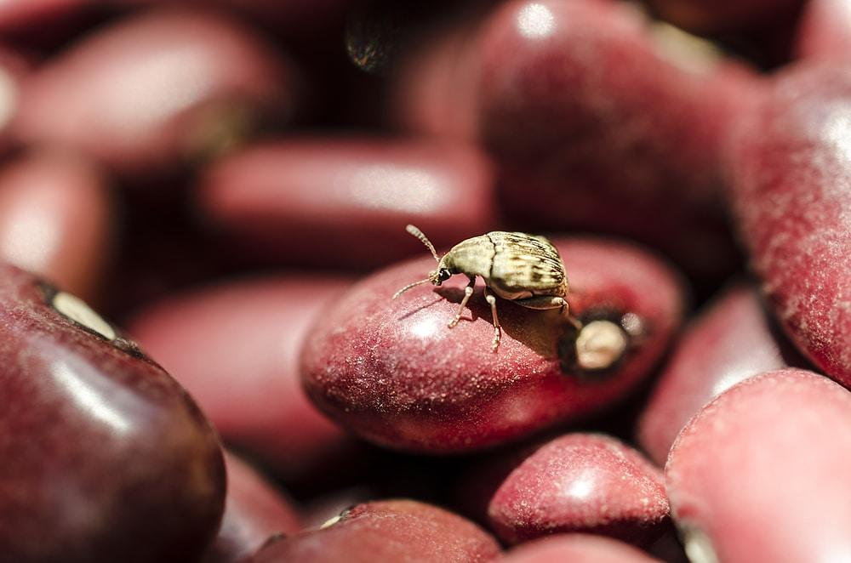

Figure 1. Bean Beetle eating mung bean

FEMALE BEAN BEETLE PREFERENCE
In this activity, students were asked to perform a set of experiments to evaluate whether female bean beetles that were raised on Mung beans discriminate between two suitable species of beans. The term natal bean refers to the beans from which the beet beetle emerged.

Pretend that you are the person performing this experiment. Read the set of instructions below and write down a hypothesis stating whether or not you expect female bean beetles to discriminate between mung beans and adzuki beans.

Hypothesis:

Rationale supporting your hypothesis:

MATERIALS
Female bean beetles
Mung and adzuki beans
Paintbrush and blunt end tweezers for maneuvering beetles
Culture plates divided into three compartments (see picture below)

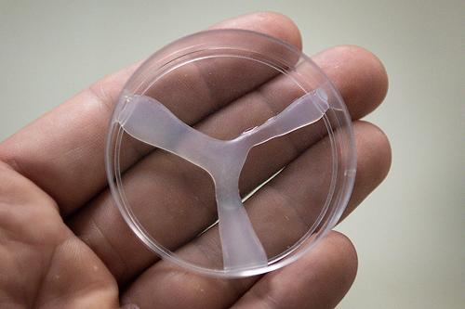

Figure 2. Culture plate divided into three compartments

METHODS
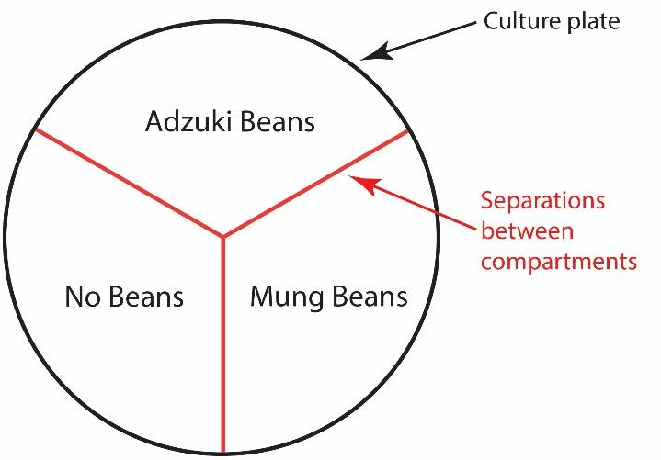
1. Place 10-20 adzuki beans in one compartment of your culture plate. Place 10-20 mung beans in a different compartment. Leave the third compartment empty.

2. Place a female bean beetle in the center of the dish. At the end of one minute record where the female was (which compartment).
3. Gently push the beetle back to the center with your paintbrush or pick the beetle up with your tweezers and place it in the center. Be careful not to injure your beetle.
4. Repeat steps 2 and 3 every minute for 15 minutes.
5. Fill out your data sheet and repeat the experiment.

DATA SHEET
For the purpose of this exercise, pretend that you collected the following data points

Natal Bean ____________________

Location at:
Attempt 1 |  | Attempt 2
1 minute | Adzuki | 1 minute | Empty
2 minutes | Adzuki | 2 minutes | Empty
3 minutes | Adzuki | 3 minutes | Adzuki
4 minutes | Adzuki | 4 minutes | Adzuki
5 minutes | Adzuki | 5 minutes | Adzuki
6 minutes | Empty | 6 minutes | Adzuki
7 minutes | Empty | 7 minutes | Adzuki
8 minutes | Mung | 8 minutes | Mung
9 minutes | Mung | 9 minutes | Mung
10 minutes | Adzuki | 10 minutes | Mung
11 minutes | Adzuki | 11 minutes | Mung
12 minutes | Mung | 12 minutes | Mung
13 minutes | Empty | 13 minutes | Empty
14 minutes | Mung | 14 minutes | Empty
15 minutes | Adzuki | 15 minutes | Mung

BEAN BEETLE DATA ANALYSIS

Mung Adzuki Empty
Random Expected Locations: 10 10 10

Actual Observed Locations: ______ ______ ______

1. Graph your results in Microsoft Excel and be ready to explain the reasoning behind your selection of a particular type of graph. See Appendix B on the laboratory website (under Resources) for additional info on the various graph types.

2. Did your observed locations differ from the expected locations?

3. If yes, explain why you think you got those results. Why do you think your beetle may have preferred one location over another?

4. What type of graph did you select?

5. Why is this the most appropriate type of graph for this data set?

6. How would you improve the design of this experiment?

ACTIVITY 3: Semester Long Group Review Paper Project

If you are completing the Online Module this week – your TA will be assign you to work with a group in your regular lab section. Be sure to contact your TA about this.

Before leaving lab today (Week 1), set up your Group Google Folder and add a Google doc to brainstorm ideas of a Pathogen you’d like to investigate further. Everyone should add at least 1 idea BEFORE coming to Lab Week 2. Share the folder with your TA.

There will be time during lab next week to work on the ideas further as a group. Your TA will be visiting groups in breakout rooms. By the end of lab Week 2, each Group will need TA approval for the topic. Different groups should not be investigating the same topic.

