DNA Fingerprinting

Please highlight all your answers with a yellow background or use a different color font that is easy to read.

LEARNING OBJECTIVES
1. Describe the structure and function of DNA.
2. Describe the procedure of agarose gel electrophoresis and its application to DNA separation.
3. Perform selective DNA digestion using restriction enzymes.
4. Explain the importance of PCR in DNA sample preparation.
5. Separate the DNA by electrophoresis and estimate the size of a DNA fragment.
6. Evaluate and interpret various scenarios by which DNA fingerprinting is used as a biotechnology tool to identify individuals and show whether individuals or animals are related to each other.

INTRODUCTION
This experiment introduces the basic concepts of DNA fingerprinting, a method used in various medical and forensics procedures, as well as in paternity determinations. This protocol will demonstrate the similarities and differences in organisms at the genetic level. The basic concept of any DNA fingerprinting protocol includes the extraction of DNA from any cell, the restriction or cutting of the DNA by enzymes called endonucleases, the amplification of the small amount of DNA collected, and the analysis of the resulting DNA fragments using agarose gel electrophoresis.
Two basic techniques exist that allow analysis of DNA. Polymerase Chain Reaction (PCR) is commonly used in molecular and genetic research. Restriction Fragment Length Polymorphism (RFLP) analysis is another technique used to compare differences and similarities between individuals at the genetic level. We will use the PCR technique in our investigation. Many forensic scientists, including those involved with criminal investigations, use PCR analysis in order to eliminate potential suspects related to a crime scene. For
our experiment, you will be given three DNA samples, consisting of DNA collected from a crime scene and DNA collected from two suspects. Your task will be to identify the true criminal, using the gel electrophoresis method.

SCENARIO – THE CRIME:
An extremely valuable molecular model that was made and used by famous scientists to figure out a key question in biology was going to be put up for auction. It was expected to sell for a huge sum. Two people offered early bids to purchase the model prior to the auction, but the science institute that owns the model thought that the prices these people offered were too low. In addition, when news of the model's auction was announced, a distant relative of one of the now-deceased scientists came forward and laid claim to the model, questioning the institute's right to sell it. The night before the model was to be taken to the auction house, the glass case housing the model was broken into and the model stolen. It appeared that whoever broke into the case was cut on the sharp edge of the broken glass. Although the thief tried to clean up the blood, a very small amount was left on the edge of the glass. There is footage from a security camera, but the image quality is
poor and the thief's face was covered. The crime investigators began by questioning the two people who had tried to buy the model before the auction as well as the scientist's relative who had claimed ownership. One of the two who made early offers had a solid alibi as to where she was during the time the model disappeared. The scientist's relative also had a solid alibi. However, the second early bidder appeared very nervous when the authorities were at his home. In addition, his build is similar to that of the person seen in the security video, and his hand has a large cut. The authorities also found that one of the employees of the institute, who also has a build like that of the person seen in the security video, was working late, and would have been present when the model was stolen. He also has a significant cut on his hand but claims to have gotten it from a broken windowpane he was replacing in his home. The investigators obtained a warrant and got blood samples from the two most likely suspects – the late-night employee and the nervous early bidder. The investigators will compare the DNA profile of each of these suspects with the pattern obtained using the DNA isolated from the blood left on the glass case.

THE POLYMERASE CHAIN REACTION
The polymerase chain reaction (PCR) is used to make many copies of a defined segment of a DNA molecule. To perform PCR, you first decide what DNA segment you wish to duplicate, or amplify. Then, you obtain two short single-stranded DNA molecules that are complementary to the very ends of the segment. Each of the single-stranded molecules must have a base sequence that is complementary to one specific location in only one strand of the target DNA, and each one must be complementary to only one end of the segment. These short, single-stranded molecules are the primers for PCR. To begin the chain reaction, a large number of primers is mixed with the target molecule in a test tube containing DNA polymerase enzyme, buffer, and many nucleotides. The DNA polymerase used in PCR reactions is able to withstand very high temperatures; the reason this characteristic is necessary to the reaction will become apparent later. The buffer maintains the conditions under which the enzyme will work. Nucleotides are the building blocks of DNA. This mixture is heated to almost boiling, so that the hydrogen bonds that hold the two strands of the parental DNA molecule together are disrupted and the two strands separate, or denature. Next, the mixture is allowed to cool. Ordinarily, the two strands of the target DNA region would eventually line up and re-form their base pairs. However, there are so many primers in the mixture that the short primers find their complementary sites on the target strands before the two target strands can line up correctly for base pairing. Therefore, a primer molecule base-pairs (hybridizes, or anneals) to each of the target strands. Now DNA polymerase enzyme adds nucleotides to the 3' end of each primer, using the bases on the target strand as a template. New complementary strands are made, with the 5' end of each being formed by a primer. In this manner, two double-stranded DNA fragments are formed where before there was only one. The cycle of denaturation, hybridization, and DNA synthesis is repeated many times. Each time, the number of DNA fragments in the mixture is doubled. When this process is repeated 30 times (a typical number of PCR cycles), more than a billion copies of the DNA from the region between the two primers are generated.
PCR AND DNA FINGERPRINTING
How is PCR used to generate a DNA fingerprint? First, remember that humans have about 3 billion base pairs of DNA, most of which are identical from one person to another. This is too much DNA to examine simply by cutting with restriction enzymes (RFLP method - restriction enzymes recognize and cut specific sequences of DNA) and comparing the resulting banding patterns on a gel. Those 3 billion base pairs generate too many fragments of too many different sizes. If you ran these digests on a gel, all that would be seen is a smear of DNA running the length of the gel. Without using more sophisticated techniques, you cannot identify and compare specific sequences in such smears. Fortunately, many of the differences between the DNA of one person and another are found at specific places along chromosomes. To generate a DNA fingerprint, scientists have found more efficient ways to look specifically at these regions where differences are found. PCR is one of the tools they use to examine these differences. For DNA fingerprinting, PCR is used to detect a specific type of difference. Human DNA contains end-to-end, or tandem, repeats of short DNA sequences (Short Tandem Repeats or STRs) at many places throughout the genome. Although the chromosomal locations and the base sequences of the repeats at a given site are the same from person to person, the number of the repeats/STRs at a given location varies highly from individual to individual. These repeats may be as short as three bases or may be 30 or more bases long.

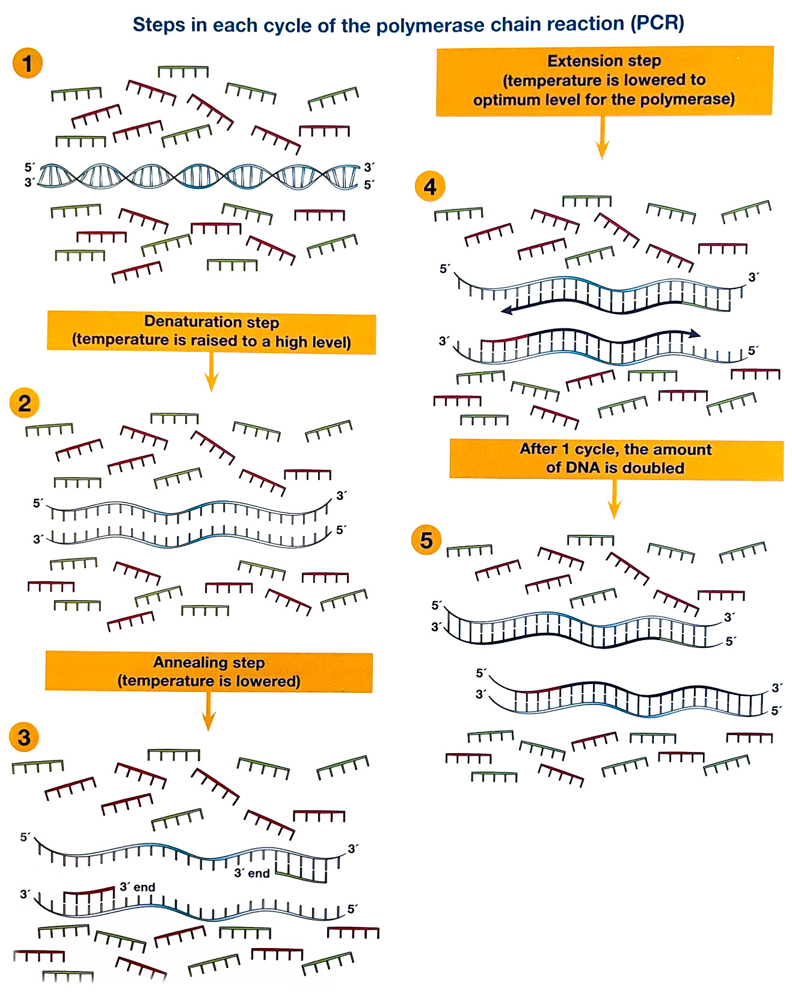
Figure 1: Brief explanation of the various steps of the Polymerase Chain Reaction (PCR) © University of Reading
AGAROSE GEL ELECTROPHORESIS
Electrophoresis separates DNA fragments according to their relative size. DNA fragments are loaded into an agarose gel, which is placed into a chamber filled with a conductive liquid buffer solution (Tris/ Acetic Acid/EDTA or TAE). See Figure 2.

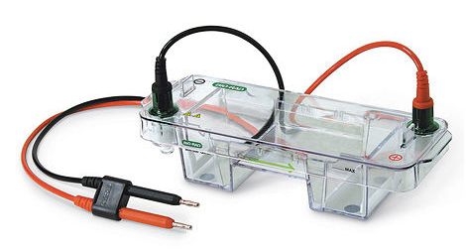
Figure 2. Electrophoresis chamber.

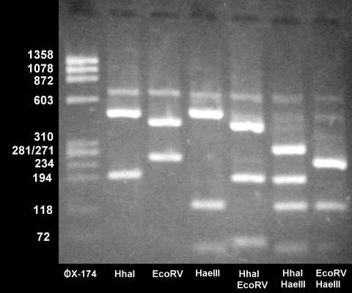

Figure 3. DNA restriction fragments in agarose gel.

Agarose is a natural substance that, upon being dissolved in liquid, will solidify into a matrix-like arrangement. This matrix creates channels through the gel in which small molecules can pass. A direct current is passed between wire electrodes at each end of the chamber, causing a current to pass through the gel from one end to the other. DNA fragments are negatively charged and, when placed in an electric field, will be drawn toward the positive pole and repelled by the negative pole. The matrix of the agarose gel acts as a molecular sieve through which smaller DNA fragments can move more easily than large ones. Over a period of time, smaller fragments will travel farther than larger ones. Fragments of the same size will stay together and migrate in single "bands" of DNA. Figure 3 shows the product after electrophoresis of Lambda DNA that has been digested with the HindIII restriction enzyme.

ACTIVITY 1: PRACTICE PIPETTING
Your lab instructor will show you how to use a micropipette (see Figure 4). It is very important that you pay close attention to this and that all people at your table practice this skill.
Be sure to always use a tip when pipetting. Pipetting can be difficult, particularly when pipetting such small portions. Use the yellow tips and the container of colored water or loading dye for practice.
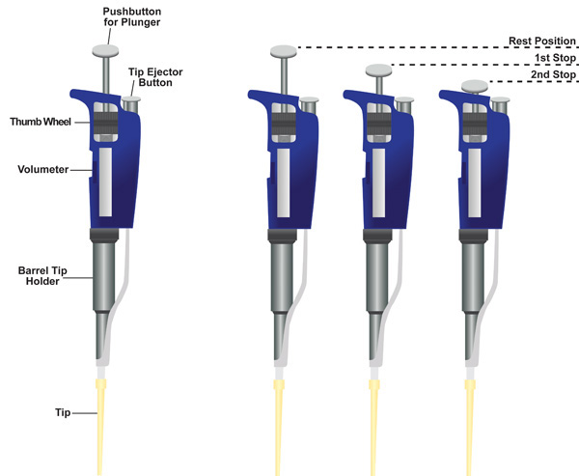
Practice adjusting the pipettor settings. Do not turn to a setting below or above its range. Use the practice loading dye to see what 5 μL, 10 μL, and 20 μL look like in the tip. It is important to be able to accurately measure each sample. Using too little sample will result in minimal digestion. Using too much sample will result in not having enough components to complete all of the tubes at your table.

Figure 4. Micropipettor.
https://www.jove.com/video/2754/aseptic-laboratory-techniques-volume-transfers-with-serological

ACTIVITY 2: PREPARATION OF THE 0.8% AGAROSE GEL AND ELECTROPHORESIS UNIT

PROCEDURE

1. Locate the following materials on the side counter of the laboratory prior to beginning this segment of the lab:
Electronic balance
Agarose (Bio-Rad)
2 clean spatulas
Weigh boats
500 mL plastic graduated cylinder
500 mL Erlenmeyer flask
Ix TAE electrophoresis buffer (with other chemicals)
Magnetic hot plate with stir bar
Insulated gloves

NOTE: You will need one 0.8% agarose gel for each setup today. Determine the amount of powdered agarose needed to make a 50 mL gel: __________ grams. To pour six gels for the class, how much powdered agarose should be used? __________ (in 300 mL of TAE buffer).

Show how you determined how you would make these agarose solutions:

2. The TA will add a magnetic stir bar to the flask and place the flask on a magnetic hot plate. Heat the solution to boiling while stirring. Boil the solution until all of the small translucent agarose particles are dissolved (approximately 15 minutes). CAUTION: Boiling molten agarose or the vessels containing hot agarose can cause SEVERE burns if allowed to contact the skin. Use extreme caution and wear protective glasses and insulated gloves at all times when handling hot agarose. Because the agarose can easily boil over, one person should constantly monitor the flask until it is removed from the hot plate.

3. Using an insulated glove, remove the flask from the hot plate and allow it to cool resting on a paper towel.

4. Alert your TA once the solution has cooled to 60° C. (At this temperature you should be able to handle the flask comfortably.)

5. You will need to set up your electrophoretic unit before you can pour the cooled agarose.

PREPARATION OF THE ELECTROPHORESIS UNIT
1. At your table locate the following electrophoretic equipment:
Gel casting stand
Gel tray
Gel well comb
Gel box
Box lid
Power supply

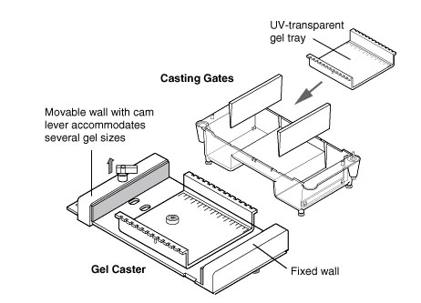
Clamp the gel tray securely into the casting stand (see Figure 6). Place the casting stand on a paper towel in the working tray on your table. Level the gel tray using a leveling bubble. Leveling can be accomplished by adjusting the three feet on the gel casting stand.

Figure 5. Agarose gel tray.
https://www.bio-rad.com/en-us/category/horizontal-electrophoresis-systems?ID=6712bcc6-458e-43f7-9d93-3cdacdc741ac

2. Insert a gel comb into the gel tray. The gel comb will form the wells in the hardened agarose gel. The comb will fit into the notches of the gel tray. Be sure the comb is set securely in the notch. Wearing gloves and safety glasses, pour ~40 mL of the cooled agarose solution into each tray. The depth of the agarose solution
should be about halfway up the comb teeth. NOTE: Allow extra agarose to solidify and dispose of in the biohazard waste container. Rinse the flask with distilled water and return it to the side counter to dry.

3. Allow the gel to solidify at room temperature for 15 minutes. NOTE: The gel will appear cloudy, or opaque, when ready to use. Be careful not to disturb the gel while it solidifies.

4. After the agarose gel has solidified (have your TA check the gel before proceeding), carefully remove the gel tray from the casting stand and remove the gel comb from the gel.

5. Place the tray into the electrophoresis unit so that the sample wells are at the cathode (black) end of the base. The DNA samples will migrate toward the anode (red) end of the base during electrophoresis.

6. Add 1x TAE buffer to the chamber containing the gel. Enough TAE should be added to completely cover the gel.

ACTIVITY 3: PREPARING THE DNA SAMPLES AND LOADING THE GEL

PROCEDURE
1. Pulse-spin the amplified DNA tubes for two seconds to force the liquid to the bottom of the tube. Be sure that all tubes are in a BALANCED arrangement in the rotor of the centrifuge. You may have to spin 2 tubes at a time.

2. After the pulse-spin, place the DNA samples in a foam rack until you are ready to load the gel.

3. Begin loading the gel in the order presented in #4 below. Be sure each person in your group loads one of the wells.

4. Using a separate tip for each sample, load the appropriate amounts into the wells of the gel in the following order:
Lane I-Blank
Lane 2-Blank
Lane 3-No DNA Control-20.0 µL
Lane 4-Early Bidder-20.0 μL
Lane 5-Employee-20.0 µL
Lane 6-Evidence from Glass Case-20.0 µL
Lane 7-Blank
Lane 8-Blank

ELECTROPHORESIS OF DNA SAMPLES

1. Alert your TA once all DNA samples are loaded into the gel and you are ready to run your gel.
2. Secure the lid on the gel box and connect electrical leads to the power supply. Set the power supply for 100V and the samples will electrophorese for 40 minutes. Be sure to check that you can see tiny bubbles rising from the wire electrodes when the power is running. Alert your TA if you don't see this occurring.
3. Check with your TA when you think your gel has finished running. Then, turn off the power on the power supply and disconnect the electrophoresis unit from the power supply; the lid may be removed.

ACTIVITY 4: STAINING AND DESTAINING THE GEL

STAINING THE SEPARATED DNA SAMPLES

1. Slide the gel off the casting tray into the plastic weigh boat at your table. Cover the gel with the Fast Blast blue stain. Leave the gel in stain for 2-3 minutes, but no more than three minutes. Pour the stain back into the Fast Blast beaker. It can be reused.

2. Transfer the gel into the plastic rinsing tray containing warm tap water. Gently swirl the tray for 10 seconds to rinse the gel. Discard the water and refill the tray with clean warm water. Gently swirl the tray once a minute for five minutes. Change the water a third time and swirl once again every minute for five minutes.

3. Place the gel in a new weigh boat. Initially the bands will be a little fuzzy, but will become sharper in about 10-15 minutes after the final rinse. You may want to use a white light box or your cell phone flashlight to better visualize the bands.

ACTIVITY 5: ANALYZING THE DNA PATTERNS

1. Make a rough sketch or insert a jpg picture of your gel in the space provided below. Label each lane with the content sample name.

2. During the down time in this lab, you will perform a paper simulation of DNA electrophoresis. Follow the direction on the lab website for the “Who Stole the Crown Jewels?” Activity. Include the completed paper simulation and answered questions along with this Handout when you turn in your DNA Lab Handouts for review.

DISCUSSION QUESTIONS
BIORAD GEL ANALYSIS – questions 1-5 refer to the electrophoresis activity.

1. Why was a blue loading dye added to the DNA samples before electrophoresis?

2. Based on your observations of the DNA fragment banding pattern of the crime scene and suspect DNA, who do you predict is the criminal?

4. Defend your choice by explaining the rationale behind it.

5. What limitations does DNA analysis have in criminal investigations?

